Kenya Certificate of Secondary Education 2019
233/2 CHEMISTRY -Paper 2
(Practical)
END TERM 1 2019 – Time 2 hours

Name ………………………………………… Index Number……………………/………………..

Signature ……………………………….. Date …………………/…….………/…………

INSTRUCTIONS TO CANDIDATES
- Write your name, school and index number in the spaces provided above.
- Sign and write the date of examination in the space provided above.
TRIAL 2
2019
- Answer ALL the questions in the spaces provided.
- Mathematical tables and silent electronic calculators may be used.
- All working must be clearly shown where necessary.
- This paper consists of 10 printed pages.Candidates should check to ensure that all pages are printed as indicated and no questions are missing

FOR EXAMINER’S USE ONLY
Question | Maximum score | Candidate’s score
1 | 04
2 | 16
3 | 10
4 | 10
5 | 10
6 | 11
7 | 13
Total score | 80

Turn over

Chemistry p2
2019

- Study the periodic table below and answer the questions that follow. The letters do not represent the actual symbols of the elements.
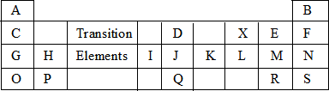
a) Name the chemical family to which the following elements belong
- C, G, O (½ mk)
…………………………………………………………
- B, F, N, S (½ mk)
………………………………………………………
b) Classify elements H and M as either metals or non-metals.
- H (½ mk)
………………………………………………………
- M
………………………………………………………... (½ mk)
  - c) State one use of element.
- A (1mk)
………………………………………………………………………………………………………………………………………………………………………………………………………
(ii) N (1mk)
…………………………………………………………………………………………………………………………………………………………………………………………………………….
d) Compare the atomic radius of G and H. (2mks)
…………………………………………………………………………………………………………………………………………………………………………………………………………….
e) Ionic radius of R is larger than its atomic radius. Explain. (2mks)
…………………………………………………………………………………………………………………………………………………………………………………………………………….

f) Write down the formula of the compound formed when element I reacts with element X. (1mk)
…………………………………………………………………………………………………………………………………………………………………………………………………………….

g) Identify the strongest oxidising agent. Explain. (2mks)
…………………………………………………………………………………………………………………………………………………………………………………………………………….

h) Write down the electron arrangement of:-
i) Element P (½ mk)
………………………………………………………………………………………………………

ii) Ion of E (½ mk)

………………………………………………………………………………………………………

i) Identify an element with a charge of +2. (½ mk)

………………………………………………………………………………………………………

j) Compare the first and second ionisation energies of element H. (2mks)
…………………………………………………………………………………………………………………………………………………………………………………………………………….

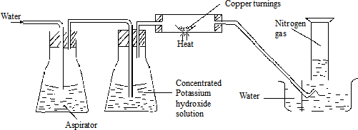
- Nitrogen gas can be obtained from air as shownbelow.

- What is the purpose of thefollowing
  - Potassiumhydroxidesolution? (1mk)
………………………………………………………………………………………………………………………………………………………………………………………………………….
(ii)Copper turnings (1 mk)
………………………………………………………………………………………………………………………………………………………………………………………………………………………………
- Why should water be pumped intotheaspirator? (1mk)
……………………………………………………………………………………………………………
………………………………………………………………………………………………………………

- Name another substance that can be used in place ofpotassiumhydroxide. (1mk)
……………………………………………………………………………………………………………………………………………………………………………………………………………………………

- The nitrogen gas obtained above is not pure. Identify one gaseous impurity inthegas. (1mk)
………………………………………………………………………………………………………………………………………………………………………………………………………………………………

- The flow chart below shows how pure nitrogen gas isobtained.

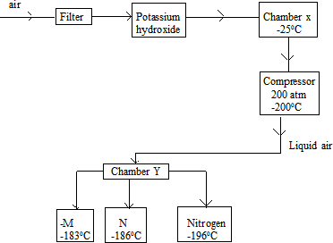

- What is the functions of the followingchambers?
Filter (1mk)
………………………………………………………………………………………………………………………………………………………………………………………………………………………………

ChamberX (1mk)
………………………………………………………………………………………………………………………………………………………………………………………………………………………………

- Name the process that takes place inchamber Y. (1mk)
……………………………………………………………………………………………………………………………………………………………………………………………………………………
- Identify
M- (½mk))
……………………………………………………………………………………………………………

N (½mk)
………………………………………………………………………………………………………………

g) State two uses ofnitrogengas. (2mks)
………………………………………………………………………………………………………………………………………………………………………………………………………………………………
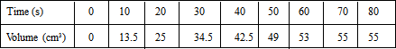
- 3.0.6g of Manganese (IV) oxide was placed in a flask and 25cm3 of hydrogen peroxide added. The volume of oxygen gas produced was recorded after every 10 seconds. The results obtained were recorded in the tablebelow.
  - Plot a graph of volume (cm3) againsttime(sec). (3mks)

  - From the graph, determine the volume of oxygengasproduced. (1mk)
………………………………………………………………………………………………………………………………………………………………………………………………………………………………

  - The experiment was repeated using more concentrated hydrogen peroxide.
On the same axis; sketch the curve thatwasobtained. (2mks)

  - Write an equation for catalytic decomposition ofhydrogenperoxide. (1mk)
………………………………………………………………………………………………………………………………………………………………………………………………………………………………

  - Give the test foroxygengas. (1mk)
………………………………………………………………………………………………………………

  - State two uses ofoxygengas. (2mk)
……………………………………………………………………………………………………………
- a) Other than neutralisation state any other method used to prepare salts. (1mk)
………………………………………………………………………………………………………………………………………………………………………………………………………………………………
b) Describe how to prepare sodium chloride starting with 1M sodium hydroxide. (3mks)
………………………………………………………………………………………………………………………………………………………………………………………………………………………………
………………………………………………………………………………………………………………………………………………………………………………………………………………………………

c) Write a balanced chemical equation to show effect of heat on calcium carbonate. (1mk)
………………………………………………………………………………………………………………………………………………………………………………………………………………………………
d) Distinguish between a strong base and a weak base. (2mks)
………………………………………………………………………………………………………………………………………………………………………………………………………………………………

e) i) Explain why permanent hardness cannot be removed by boiling. (2mks)
………………………………………………………………………………………………………………………………………………………………………………………………………………………………
ii) State one disadvantage of hard water. (1mk)
………………………………………………………………………………………………………………………………………………………………………………………………………………………………

f) Aluminium oxide reacts with both acids and alkalis. Name any other oxide that behaves like aluminium. (1mk)
………………………………………………………………………………………………………………………………………………………………………………………………………………………………

- a) A student wrongly categorised air as a compound and not as a mixture. Give two reasons as to why the student was wrong. (2mks)
………………………………………………………………………………………………………………………………………………………………………………………………………………………………

- The table below shows the results obtained when four solvents were used to separate a dye. Study the results and use them to answer the questions thatfollow.
Solvent Number of
A |  | Solute components  5
B |  | 1
C |  | 0
D |  | 2
i)
ii)  c) | - Identify the most suitable solvent for this separation. Give a reason for your answer. (2mks)  ……………………………………………………………………………………………………………………………………………………………………………………  - What does the result of the solvent C tell us about the dye? (1mk)  ……………………………………………………………………………………………………………………………………………………………………………………  - The chromatogram below was obtained from a plant extract. Use it to answer the questions that follow.
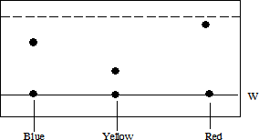
  - NamelineW (1mk)
………………………………………………………………………………………………………………………………………………………………………………………………………………………………
  - What does the dottedlinerepresent? (1mk)
………………………………………………………………………………………………………………………………………………………………………………………………………………………………
  - State with a reason the least soluble dye in themovingsolvent. (1mk)
………………………………………………………………………………………………………………………………………………………………………………………………………………………………

d) Below is a list of major component of crude oil and their boiling points.

Component Boiling point (0C)
Bitumen Above400
Lubricatingoil 350 -400
Petrol 40 -175
Gases Below40
(I)What is the name of the process by which the constituents of crude oil canbeseparated? (1mk)
………………………………………………………………………………………………………………………………………………………………………………………………………………………………

(II)Give one use of thegasescomponent. (1mk)
………………………………………………………………………………………………………………………………………………………………………………………………………………………………

(III)Give the order by which the components are obtained from the mixture, starting withthefirst. (1mk)
………………………………………………………………………………………………………………………………………………………………………………………………………………………………

- a) Candle wax is mainly a hydrocarbon. What isahydrocarbon? (1mk)
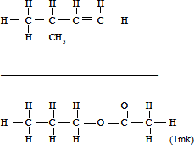
- Name the followingcompounds. i)

- Castor oil extracted from castor seeds is found to change the colour of acidified potassium managanate (VII).
- State thecolourchange. (1mk)
……………………………………………………………………………………………………………………………………………………………………………………………………………………

- Explain why castor oil reacts with acidified Potassium mangate (VII) to cause thecolourchange. (1mk
……………………………………………………………………………………………………………………………………………………………………………………………………………………

- Study the reaction scheme below and use it to answer the questions thatfollow.
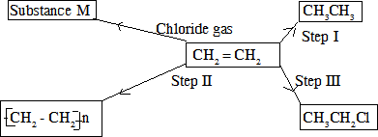

ii) Name the process in;
Step I (1mk)
……………………………………………………………………………………………………………………………………………………………………………………………………………………………

Step II (1mk)
………………………………………………………………………………………………………………………………………………………………………………………………………………………………

- State the reagent necessary for the processin
Step II (1mk)
………………………………………………………………………………………………………………………………………………………………………………………………………………………………

Step III (1mk)
………………………………………………………………………………………………………………………………………………………………………………………………………………………………

- Name the type of reaction taking place instep III (1mk)
……………………………………………………………………………………………………………………………………………………………………………………………………………………
- a)Define the following terms :
  - Atomicity (1 mark)
………………………………………………………………………………………………………………………………………………………………………………………………………………………………

  - Molargasvolume (1mark)
………………………………………………………………………………………………………………………………………………………………………………………………………………………………
  - i)StateGay-Lussac‟slaw. (1mark)
………………………………………………………………………………………………………………………………………………………………………………………………………………………………

ii) A sample of 10cm³ of hydrogen sulphide was burned in 40cm³ of oxygen. Calculate the volume and composition of residual gas (assume all volumes are measuredats.t.p)(2marks)
  - i) Calculate the mass of sodium carbonate contained in 200cm³ of 0.02M sodiumcarbonatesolution. (2marks)

ii) 0.239g of copper (II) oxide was placed in a conical flask. Calculate the volume of 0.1M solution of hydrochloric acid that would completely react with copper (II) oxide in the conical flask. (O = 16.0, Cu = 63.5, H = 1.0, Cl = 35.5)
(2marks)

(II)Find the mass of 5.2 x 10²³ atoms of sodium. (Na = 23.0, L = 6.023x10²³) (2marks

