233/2
CHEMISTRY
PAPER 2
THEORY
JULY / AUGUST 2019
2 HOURS

LARI SUB-COUNTY EXAMINATION

MARKING SCHEME
- (a) (i) Nitrogen ✓, Oxygen gas✓ 1 mk Reject - (Argon, Neon, Helium, Xenon, Krypton
(ii) I – To absorb CO_{2(g)} 1 mk
II – To absorb moisture/water vapour 1 mk
(b) (i) Cu powder glowed red hot and formed a black powder 1 mk
(ii) Oxygen 1 mk
(iii) 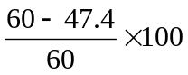✓ 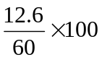✓ ½mk = 21% ✓½ mk (2 mks)
(c) Nitrogen 1 mk

(d) (i) Metal that is oxidized in place of iron since it is higher in the reactivity series than Iron,
thus preserving iron sheets
(ii) Galvanization 1 mk
(iii) Zinc reacts with oxygen in air to form an insoluble oxide layer which covers it and
protects it from further corrosion.
- (a) I 2, 1
J 2 , 8, 3
K 2 , 8, 7 (2½)
L 2, 8 , 8
M 2 , 8 , 8, 1
(b) I and M (any) 1 mk no any other correct answer
(c ) K and L 1mk (must be 2 to score)
(d) (i) J₂(CO₃)₃ 1mk must start with J
(ii) M_{(s)} + K_{2(g)} MK_{2(s)}

(e)
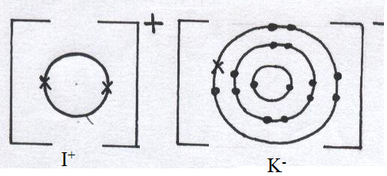

Correct distribution of electrons 1mk
Correct label 1mk
- I , J or M any one ½mk
It is electropositive hence metallic/a metal ½mk
- Filling electric bulbs to prevent oxidation of the filament
Arc welding
Filling florescent tubes
Filling advertisement tubes
In weather balloons any correct 2 1mk
- Presence of lone pairs of electrons
An empty orbital ½mk each
- (a) Potassium nitrate/ Sodium nitrate 1mk Reject Ammonium nitrate as it explodes
- On heating/Temperature above 100⁰C1mk
(C )Concentrated nitric (V) acid 1mk Reject if not concentrated
(d)KNO_{3(s)} + H₂SO_{4(l)} KHSO_{4(s)} + HNO_{3(g)}
Well balanced equation ½mk
Correct state symbols ½mk Reject if not balanced

- To reduce the intensity of light since it accelerates its decomposition. 1mk
- Brown fumes 1mk due to formation of nitrogen (IV) oxide½mk
Formation of a blue solution 1mk copper metal is oxidized to copper (II) nitrate solution ½mk

- Manufacture of Nitrate fertilizers
Plastics/plastic components
Explossives such as TNT
Purification of Gold Accept any 2 correct

- (a) Heat energy produced when one mole of a substance is completely burnt in oxygen 1mk
(b) (i) To provide a larger surface area in contact with copper (II) sulphate for faster reaction.
1mk
(ii) To ensure that all the Cu²⁺ are displaced from the solution. 1mk
(c) (i) 0.2 X 50 = 0.01 moles
1000
Correct operation ½mk
Correct answer ½mk Penalise -½mk for wrong or no units
(ii) Heat = MCΔT
= 50 X 4.2 X 8
= 1680J
= 1.68kJ Calculation 1mk, Correct answer 1mk penalize -½mk for wrong or no units
(iii) ΔH = 1.68 X 1 = -168kJ/mole
0.01
Correct operation 1mk
Correct answer 1mk Penalise -½mk for wrong or no units Note in the questions c) (i), (ii) and (iii) mark consequentialy

(d) Bond breaking H-H = 1 X 435 = 435
Cl – Cl = 1 X 243 = 243
Bond formation H – Cl = 2 X -431 = -862
ΔH = 435 + 243 – 862 = -184kJ

(e) ΔH₁ = ΔH₂ + ΔH₃ – ΔH₄
= (-394 X 4) + (-286 X 5) - -2567
= - 1576 – 1430 + 2567
= - 439kJ/mole 1mk penalize -½mk for wrong or no units

- (a) (i) E ½mk It has the highest electrode/reduction potential accept most electropositive/most reactive metal ½mk
(ii) 0.44 – 0.34 = 0.10V 1mk
(b)
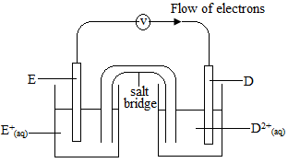Diagram 1mk
Correct labels 1mk
Correct direction of electrons 1mk
(c) (i) Electrode Y/ or Y ½mk H⁺ are discharged at it to form hydrogen gas/gas A which has a larger volume than oxygen gas/Gas B ½mk
(ii) It would increase/grow in size½mk Cu2+ are discharged at it to form Cu atoms which attach to it and causing it to increasing in size ½mk
(d) (i) 0.11 =0.09565 moles
92 correct operation 1mk
Correct answer 1mk -½mk for wrong or no units
(ii) Q = It
= 0.3 X 99 X 60
= 1782c
= 1X 1782
96500
= 0.018466F
(iii) 0.018466 X 1 = 1.93 =2F , n = 2
0.09565
Operation ½mk correct answer ½mk
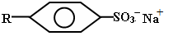
- (a) Structure

Type Soapless detergent 1mk
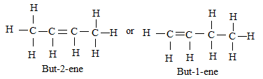
(b) Existance of compounds with same molecular formular but different structural formulae 1mk
(c )
Open structure1mk
correct name 1mk

(d) Gas jar A the purple filter paper remained purple because ethane is saturated hence does not reduce acidified potassium manganate (VII) 1mk
Gas jar B the purple filter paper turned white because ethene is unsaturated hence reduces acidified potassium manganate (VII) ions to Mn²⁺ which is colourless 1mk

(e)(i) K - Ethane
X – Potassium ethoxide
Y – Ethanoic acid
T – sodium ethanoate
½mk each X 4 = 2mks
(ii) A- Use of conc. Sulphuric (VI) acid as a catalyst
B – Addition of water at room temperature
C – Temperature of 180⁰c/5atm pressure
D – Temperature of 180⁰c /Nickel catalyst
½mk each X 4 = 2mks
(iii) C - Nickel catalyst/temperature of 180⁰c/5atm pressure
D – Nickel catalyst/temperature of 180⁰c 1mk each
(iv) It is non biodegradable
Produces poisonous gases when burnt any 1 correct 1mk
- (a) GRAPH
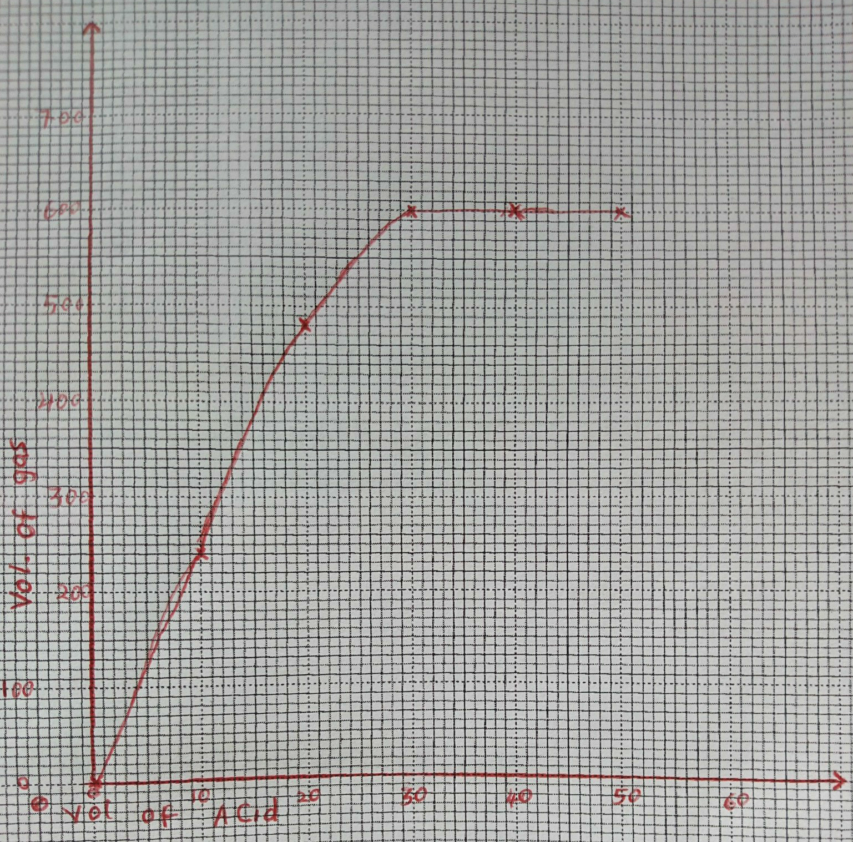

Graph marking points Scale 1mk Correct vertical scale and labeled ½mk
Correct horizontal scale and labeled ½mk
Plotting All 6points correctly plotted 1mk
Atleast 5 correctly plotted ½mk
4 and below correctly plotted 0mk
Smooth curve 1mk penalize fully if curve is dotted
(b) H₂SO_{4(aq)} + Mg_{(s)} MgSO_{4(aq)} + H_{2(g)} Balanced ½mk
Correct state symbols 1mk
(c) (i) Value read from the graph. Must be evidence of having used the graph (1mk)
(ii) Value read from the graph. Must be evidence of having used the graph (1mk)
(d) (i) Rate of reaction would be slower ½mk magnesium ribbon offers a smaller surface area in contact with the acid hence lower frequency of effective collisions ½mk.
(ii) Rate of reaction would be faster ½mk. 3M sulphuric (VI) acid is of higher concentration. The H⁺ ions are crowded. There is higher frequency of effective collisions causing a faster rate of reaction. ½mk
(e) moles of gas produced = 600 = 0.025moles 1mk
24000
Mole ratio Mg : H₂ = 1 : 1 ½mk
Moles of Mg = 0.025 moles ½mk
Rmm of Mg = 1 X 0.6 = 24 1mk
24000
Penalise -½mk for units if present

- Pale brown colour intensifies/pale green colour fades 1mk
Hydrochloric acid increases in concentration Backward reacction is favoured/equilibrium shifts
to the left causing formation of iron (III) chloride 1mk.

