233/3

CHEMISTRY

PAPER THREE MARKING SCHEME

(Theory)

FORM FOUR EXAM END TERM 1 2019

233/3

CHEMISTRY

PAPER 3 MARKING SCHEME.

**Table 1**

|  |  |  |  |
| --- | --- | --- | --- |
|  |  |  |  |
| Final burette reading(cm3) |  |  |  |
| Initial burette reading (cm3) |  |  |  |
| Volume of acid used (cm3) |  |  |  |

1. - Complete table award ✓ (1mk)

- Decimal consistency ✓ (1mk)

- Accuracy  0.1 ✓ (1mk)

- School value ✓ (1mk)

Average volume ✓ (½ mk)

= 24.5 cm3✓ (½ mk)

1. i) ✓ (½ mk)

=1M ✓ (½ mk)

✓ (½ mk)

= 0.025 moles ✓ (½ mk)

ii) 

Mole ratio of NaOH : HCL

1: 1 ✓ (½ mk)

 Moles of HCL (aq)= 0.025 moles✓ (½ mk)

iii) ✓(½ mk)✓ (½ mk) ✓ (½ mk)

|  |  |  |  |
| --- | --- | --- | --- |
|  |  |  |  |
| Final burette reading (cm3) |  |  |  |
| Initial burette reading(cm3) |  |  |  |
| Volume of solution B used (cm3) |  |  |  |

**Table II**

Complete table ✓ (1mk)

Decimal consistency ✓ (1mk)

Accuracy ✓ (1mk)

School value ✓ (1mk)

1. Average volume✓ ( ½ mk)

=28.3 cm3✓ (½ mk)

* 1. ✓ (½ mk)

e) i) ✓ (½ mk)

=ans e (i)✓ (½ mk)

ii) ✓ = a ans (1mk)

1. ✓ (½ mk)100gdm-3✓ (½ mk)
2. ans in (f) –ans e (ii) ✓ (½ mk)=ans(g) ✓ (½ mk)

✓ (½ mk) = (Final answer) ✓ (½ mk)

N/B : Use school based values.

2 a)

|  |  |  |  |
| --- | --- | --- | --- |
| SOLUTION | Volume of solution S3 in they beaker (cm3) | Volume of water added  (cm3) | Time taken for cross to be invisible(t) (see) |
| A |  |  |  |
| B |  |  |  |
| C |  |  |  |
| D |  |  |  |
| E |  |  |  |

* Complete table✓ (1mk)
* Trend (increasing time)✓ (1mk)
* School value ✓ (1mk)

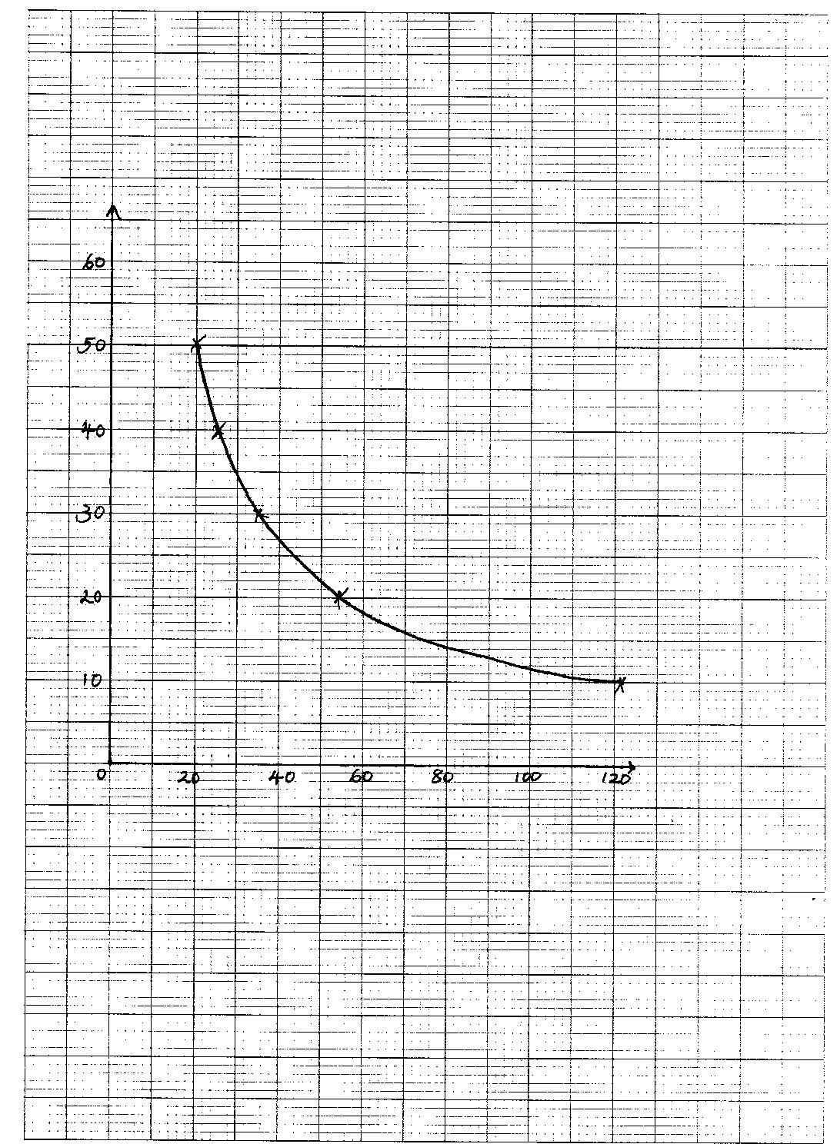

1. b) As the concentration decreases ,the time increases ✓ (1mk)

c) To keep the column of solution constant through the experiment ✓ (1mk)

1. a) Observation Inferences

A colourless gas with

a pungent chocking smell NH4+ ions present.✓(½ mk)

is produced ✓ (½ mk)

gas turns red litmus

paper blue ✓ (½ mk)

b) Observation Inferences

D dissolves in water forming – D is a soluble salt coloured ions absent

a colourless solution ✓(½mk) (Fe2+,Cu2+,Fe3+) ✓ (½ mk)

Observation Inferences

c) i) White ppt is formed✓(1mk) SO42- ions present ✓(1mk)

ii)

Observation Inferences

A white ppt is formed, ✓(½mk) SO42- ions confirmed ✓(½mk)

Which persist on warming ✓(½mk)

Observation Inferences

1. A white ppt is formed ✓ (½mk)which dissolves in excess.✓(½mk) - NH4+ ions present ✓(½mk)

A colourless gas with a pungent✓(½mk) - Zn2+ ions present✓(½mk)

chocking smell is produced on warming

The gas turns red litmus paper blue✓(½mk)

(iv)Observation Inferences

- A white ppt is formed ✓

which dissolves in excess Zn2+ ions confirmed.✓(½mk)

(½mk)

d) (i) Observation Inferences

Dissolves in distilled water✓ short chain R – OH group present✓

(½mk) (½mk)

Observation Inferences

(ii)

No effervescence ✓(½mk) H+ ions are absent ✓(½mk)

(iii) Observation Inferences

The colour change from R – OH present✓ (1mk)

Orange to green✓ (1mk)