LARI SUB COUNTY EXAMINATIONS 2019

233/3

CHEMISTRY

PAPER 3

MARKING SCHEME

1. a) Table 1 (4mks) – distributed

as follow

Complete table (1mk)

- All three titrations done (1mk)

- Only one titration done. ( 0mk)

**Penalties**

Wrong arithmetics

Unrealistic values

Inverted table

**Decimal place**  (1mk)

- Conditions and penalties

- Penalize ½ mk inconsistency in use of decimals in the 1st and 2nd row only.

- If two decimals place are used , the 2nd d.p must be o or .5 otherwise penalize fully.

**Accuracy** (1mk)

Compare any of students valves with s.v if within ± 0.1 (1mk)

within ± 0.1 (1mk) otherwise Penalise fully

Principle of averaging (1mk)

- 3 titrations done consistent average (1mk)

- 2 titrations don consistent average (1mk)

- 3 titration – 2 consistent averaged (0mk)

- 2 titration inconsistent averaged (0mk)

Final answer

Conditions and penalties

- Compare the students average with S.V

If within ± 0.2 award (1mk)

Penalise fully

- Arithmetic error committed in working out the average then work out the correct average and award accordingly

- Pick any two values that are consistent average and award accordingly if it advantages the student.( This applies when inconsistent values are entered and averaged.

b)



operation 1mk correct answer 1mk penalize -½mk for wrong or no units

c) 2HCl(aq) + Na2CO3(aq) 2NaCl(aq) + H2O(l)

d) (i)



(ii) 0.0025 X 250 = moles

Average volume

(iii) Moles in (iii) above X 1000 = molarity with correct units

50

A Table A all values input 2mks

Trend Time must be increasing with decrease in concentration 2mks

Decimal for time 2dp .00 - .99 1mk

For moles calculation mark independently as in the table below

B For correct calculation of moles 1mk each total of 4mks

Note for experiment 1 no calculation just correct transfer of molarity from previous calculation for 1mk

|  |  |  |  |  |
| --- | --- | --- | --- | --- |
| Experiment No. | 1 | 2 | 3 | 4 |
| Calculation | Direct transfer of value from (d) (iii) above | Value in (d)(iii) X 8  10 | Value in (d)(iii) X 6  10 | Value in (d)(iii) X 4  10 |

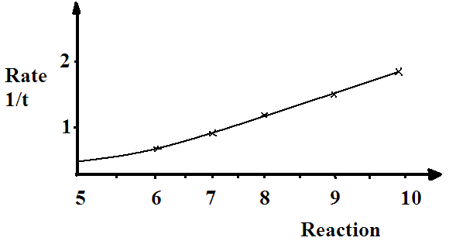

C) Graph scale Axes and label 1mk

Correct plotting 1mk

Smooth line/curve 1mk

D) value red from the graph

E) Rate of reaction decreases as the concentration of the acid decreases 1mk

Decrease in concentration decreases the frequency of effective collisions reducing the rate of reaction. 1mk

2.

|  |  |  |
| --- | --- | --- |
|  | Observations | Inferences |
| 2 (a) | Green solid forms a brown residue that remains brown on cooling, colourless gas formed that turns moist red litmus blue. Blue litmus remains lue. Colourless liquid collects at the mouth of the test tube. ½mk each X 4 | NH4+ , Fe2+ or Fe3+ present all 3 correct 1mk  2 correct ½mk  1 correct 0mk |
| (b) | Solid dissolves completely to form a pale green solution 1mk. | Fe2+ present 1mk |
| (b) (i) | Green precipitate that persists in excess 1mk | Fe2+ present 1mk |
| (b) (ii) | Green precipitate that persists in excess 1mk | Fe2+ present 1mk |
| (b) (iii) | White precipitate formed 1mk | SO42- or Cl- present 1mk |
| (b) (iv) | White precipitate formed 1mk | SO42- present 1mk |
|  |  |  |