**NAME:**______________________________**INDEX NO:**__________________

**SCHOOL:**____________________________________**DATE**:______________

**CHEMISTRY THEORY**

**SEPT/OCTOBERE 2021.**

**TIME: 2 HOURS.**

**KENYA CERTIFICATE OF SECONDARY EDUCATION**

**AMUKURA PARISH**

**FORM TWO**

**Instructions to Candidates.**

a) Write your name, school and class in the spaces provided.

b) All working must be clearly shown.

c) Mathematical tables and electronic calculators may be used.

d) Answer all the questions.

Candidates must answer all questions in ENGLISH

**FOR EXAMINER’S USE ONLY**

|  |  |  |
| --- | --- | --- |
| QUESTION | MAXIMUM SCORE | CANDIDATES SCORE |
| 1-14 | 80 |  |

1. The diagrame bellow shows the heating curve of a pure substance.

Sturdy it and and answer the questions that follow

 Z

X

time in minutes

1. What physical changes are taking place at points **X** and **Z**?(2mks)

..............................................................................................................................................................……………………………………………………………………………………

1. Explain what happens to the melting point of the substance when sodium chloride is added. (2mks)

…………………………………………………………………………………………………………………….…………………………………………………………………………………………………………………………………………………………………………………..…………

1. (a) State **two** differences between luminous flame and non-luminous flame (2mks)

……………………………………………………………………………………………………………………..………………………………….………………………………………………………………………………….………………………………………………………………………

(b)It is advisable to set a Bunsen burner to luminous flame prior to an experiment. Explain (2mks

…………………………………………………………………………………………………………………………………………………………………….………………………………………...…………………………………………………………………………………….......................................................................................................................................................................................

3. The apparatus below were used by a student to study the effect of heat on hydrated copper II sulphate.

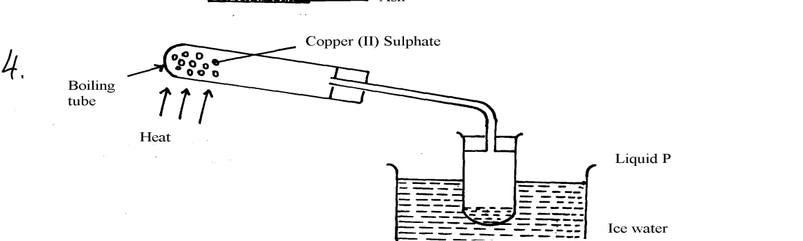

1. Name liquid P (1mk)

………………………………………………………………………………………………………

1. What is the role of ice cold water (1mk)

………………………………………………………………………………………………………

1. What observation is made in the boiling tube (1mk)

………………………………………………………………………………………………………

4. Given a mixture of lead (II) oxide, ammonium chloride and sodium chloride, describe how this mixture can be separated to obtain a sample of each (3mks)

………………………………………………………………………………………………………………………………………………………………………………………………………………………………………………………………………………………………………………………

………………………………………………………………………………………………………

5. (a) Flower extracts can be used as Acid-base indicators. Give **two** limitations of such indicators (2mks)

…………………………………………………………………………………………………………………………………………………………………………………………….………………………………………………………………………………………………………………………

(b) The diagram below shows spots of pure substances **A, B**, and **C** on chromatograph paper. Spot **D** is that of a mixture

After development **A, B**, and C were found to have moved 9cm3, 4cm3 and 7cm3

Respectively. D separated into two spots which have moved 7cm3 and 9cm3:-



On the diagram:-

1. Label the baseline and solvent front (2mks)

1. Show the position of all the spots after development (3mks)

………………………………………………………………………………………………………

III Identify the substances present in mixture D (2mks)

…………………………………………………………………………………….………………………………………………………………………………………………………………………

6. A beekeeper found that when stung by a bee, application of a little solution of sodium hydrogen carbonate helped to relieve the irritation of the affected area. Explain (2mks)

………………………………………………………………………………………………………………………………………………………………………………………………………………………………………………………………………………………………………………………

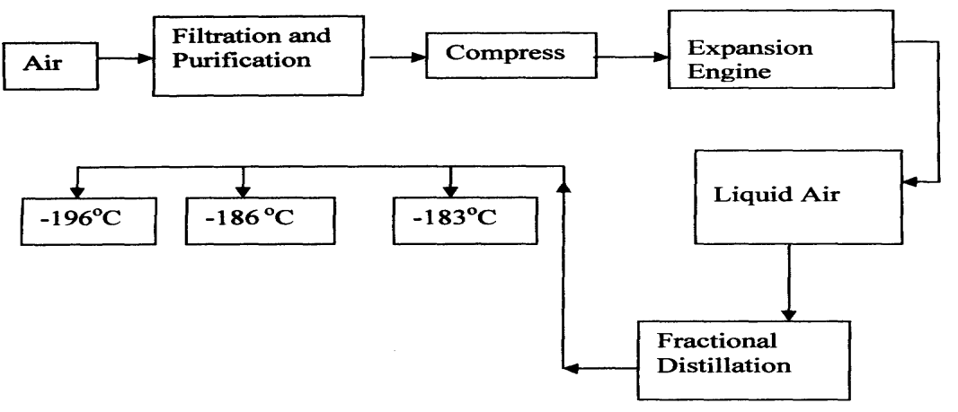7. Oxygen is obtained on large scale by the fractional distillation of air as shown on the flow chart

1. Identify the substance that is removed at the filtration stage (1mk) ………………………………………………………………………………………………………………………………………..…………………………………………………………………………………………………………………………………………..
2. Explain why Carbon (IV) oxide and water are removed before liquefaction of air (1mks)

………………………………………………………………………………………………………………………………………………………………………………………………

………………………………………………………………………………………………

1. Identify the component that is collected at -186°C (1mk)

………………………………………………………………………………………………

8. Hydrogen can be prepared by reacting zinc with dilute hydrochloric acid.

1. Write an equation for the reaction.(1mk)

……………………………………………………………………………………………………..

1. Name an appropriate drying agent for hydrogen gas. (1mk)

………………………………………………………………………………………………………

1. Explain why copper metal cannot be used to prepare hydrogen gas.(2mks)

………………………………………………………………………………………………………

………………………………………………………………………………………………………

………………………………………………………………………………………………………

1. Hydrogen burns in oxygen to form an oxide.
2. Write an equation for the reaction. (1mk)

………………………………………………………………………………………………………

………………………………………………………………………………………………………

1. State **two** precautions that must be taken before the combustion begins and at the end of the combustion. (2mks)

……………………………………………………………………………………………………………………………………………………………………………………………………………………………………………………………………………………..………………………………………………………………………………………………………………………………………

1. Give **two** uses of hydrogen gas. (2mks)

………………………………………………………………………………………………………………………………………………………………………………………………………………………………………………………………………………………………………………………………………………………………………………………………………………………………

1. Element **Q** reacts with dilute acids but not with cold water. Element **R** does not react with dilute acids. Elements **S** displaces element **P** from its oxide. **P** reacts with cold water. Arrange the four elements in order of their reactivity, starting with the most reactive. (3mks)

…………………………………………………………………………………………………………………………………….………………………………………………………………………………………………………………………………………..…………………………………………………………………………………………………………………………………………..

9. In an experiment a gas jar containing some damp iron fillings was inverted in a water trough containing some water as shown in the diagram below. The set-up was left undisturbed for three days. Study it and answer the questions that follow

1. 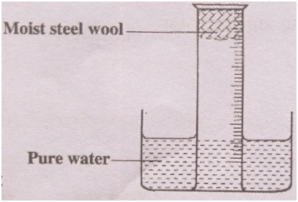a.Why were the iron filings moistened? (1mk) ..........................................................................................................................................................................................................................................................................................................
2. State and explain the observation made after three days (3mks).

……………………………………………………………………………………………………………………………………………………………………………………………………………………………………………………………………………………………………………………

1. State **two** conclusions made from the experiment. (2mks)

………………………………………………………………………………………………………………………………………………………………………………………………………………………………………………………………………………………………………………………

1. Draw a labelled set-up of apparatus for the laboratory preparation of oxygen using Sodium Peroxide (3mks)
2. State t**wo** uses of oxygen(2mkls)

................................................................................................................................................................................................................................................................................................

10.

(a) Element X is found in period 3 and group IV. It consists of two isotopes 28X and QX.

A sample of X was found to consist of 90% of 28X.If the relative atomic mass of X is 28.3, work out the number of neutrons in QX (3mks)

1. Draw the atomic structure of element X using Dots(.) or Crosses(X) diagram (1mk)

11.The grid below is part of the periodic table. The elements are not represented by their actual symbols. Use the information to answer the questions that follow

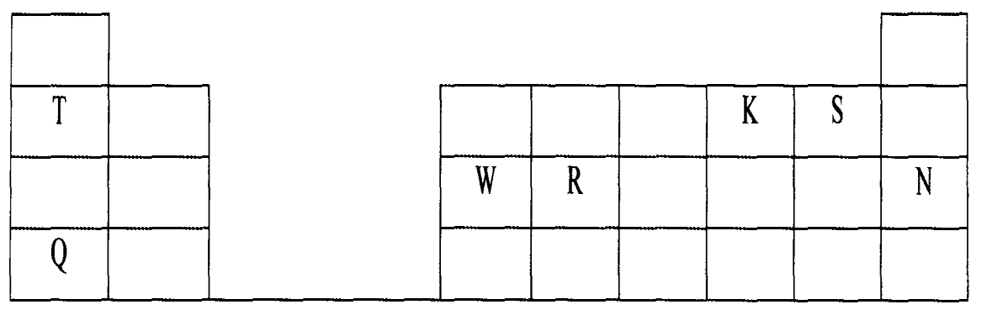

(i) Which is the most reactive …………………………………………………………………………………………………………………………………………………………………………………………………..................

(I) Non — metal?(2mks).

……………………………………………………………………………………………………………………………………………………………………………………………………………..

Explain

……………………………………………………………………………………………………………………………………………………………………………………………………………………………………………………………………………………………………………………

(II) Metal? (2mks)

………………………………………………………………………………………………………………………………………………………………………………………………………………

Explain

………………………………………………………………………………………………………………………………………………………………………………………………………………………………………………………………………………………………………………………

1. Name the family to which elements **T** and **Q** belongs.(1mk)

…………………………………………………………………………………………………………………………………………………………………………………………………………………………………………………………………………………………………………………….

1. Write the formula of the compound formed when **W** reacts with **S**. (1mk)

………………………………………………………………………………………………………………………………………………………………………………………………………………………………………………………………………………………………………………………

1. Explain why element **N** doesn’t form compounds with other elements. (2mks)

……………………………………………………………………………………………………………………………………………………………………………………………………………………………………………………………………………………………………………………………………………………………………………………………………………………………….

1. Compare the atomic radii of **T** and **Q.** Explain.(2mks)

………………………………………………………………………………………………………………………………………………………………………………………………………………………………………………………………………………………………………………………………………………………………………………………………………………………………

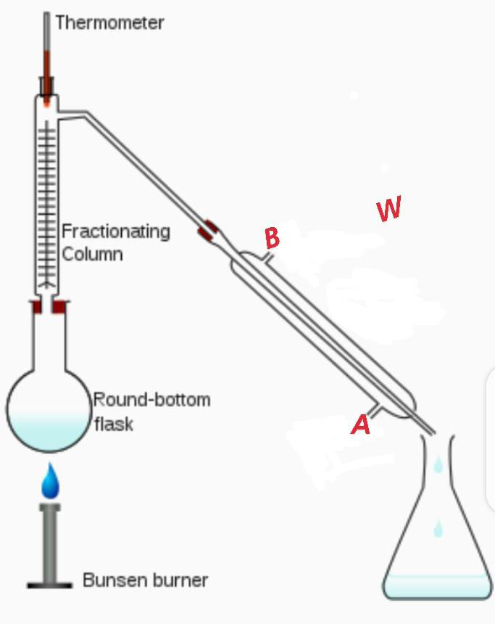12. A student left some crushed fruit mixture with water for some days. He found the mixture had fermented. He concluded that the mixture was contaminated with water and ethanol with boiling point of 100oC and 78 oC respectively. The set-up of apparatus below are used to separate the mixture.

1. What is the purpose of the thermometer in the set-up?(1mk) …………………………………………………………………………………………………………………………………………………………………………………
2. At which end of the apparatus **W** should tap water be

connected?(1mk)

……………………………………………………………………………………………………………………………………………………………………………………………………………….

1. Which liquid was collected as the first distillate? Explain (2mks)

…………………………………………………………………………………………………………..…………………………………………………………………………………………………..

1. What is the name given to the above method of separating mixture?(1mk)

…………………………………………………………………………………………………………….………………………………………………………………………………………………

1. State **two** applications of the above method of separating mixtures (2mks)

…………………………………………………………………………………………………………………………………………………………………………………………………………………………………………………………….………………………………………………………...

1. What properties of the mixture make it possible for the component to be separated by the above methods? (2mks) . ………………………………………………………………………………………………………………………………………………………………………………………………………………………………………………………………………………

13. An oxide of element G has the formulae of G2O3.

a) state the valency of the element G(1mk) ……………………………………………………………………………………………………………………………………………………………………………………………………………………………………………………………………………………………………………………………………

b).in which group of the periodic table is the element G. explain. (2mks) ……………………………………………………………………………………………………………………………………………………………………………………………………………………………………………………………………………………………………………………………………

14. The atomic number of element P is 11 and that of Q is 8

a)write down the possible formula of the compound formed between P and Q. (1mk) …………….……………………………………………………………………………………………………………………………………………………………………………………………………………………………………………………………………………………………………………………..…………………………………………………………………………………………………………………………………………………………………

b) In which period do element P belong. Explain (2mks

…………………………………………………………………………………………………………………………………………………………………………………………………………………………………………………………………………………………………………………………………….