GATITU SECONDARY SCHOOL
gatitusecondary@gmail.com
COMPUTER STUDIES – OPENER – 2014 – 30MKS
NAME…………………………………………ADM#..........FORM……… |T3
- Identify the devices shown below: (6mks)
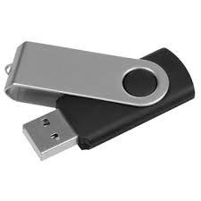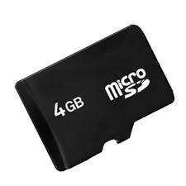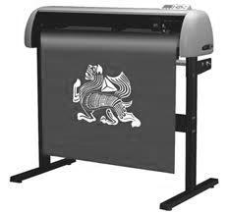

1……………………………. 2……………………………… 3………………………. 4…………………………..
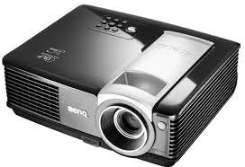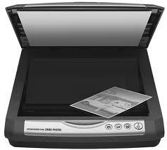

5……………………….. 6……………………………….

- Complete the tree structure shown below (6mks)
Storage
Devices
Primary
Secondary
Example:
1………………………………………..
2……………………………………….. .
Example:
1………………………………………..
2…………………………… ………..
3………………………………………..
Example:
1……………………………………………..
Fixed
Removable

- The school bursar has just called you to advise her on purchase of a school printer that could be used to produce report forms at the end of each term for the 400+ students in your school. (6mks)
- Which printer would you advice and why?
……………………………………………………………………………………………………………………………………………………………………………………………………………………………………………………………………………………………………………………………………………………………………………………………………………………………………………………………………………………………………………………………………………………………………………………………………………………………………………………………………………………………………………………………………………………………………………………………………………………………………………………………………………………………..
- State four other factors one should consider before purchasing a printer (6mks)
………………………………………………………………………………………………………………………………………………………………………………………………………………………………………………………………………………………………………………………………………………………………………………………………………………………………………………………………………………………………………………………………………………………………………………………………………………………………………………………………………………………………………………………………………………………………………………………………………………………………………………………………………………………………
- State at least one device that can be used to perform the following tasks (6mks)
- Capture video data into the computer? ………………………………………………………………………..
- Capture hardcopy directly into the computer? …………………………………………………………..
- Capture voice data into the computer? ……………………………………………………………………….
- Signaling whether the computer is on or off? ………………………………………………………….
- Output voice from the computer? ……………………………………………………………………..
- Convert softcopy into hard copy? ……………………………………………………………………..
- True or False? (6mks)
- Pixel stands for picture elements? ………………………………………………………………………………….
- CRT monitor is a flat screen monitor? …………………………………………………………………….
- The speed of a computer is measured in bytes? ………………………………………………………..
- The printer is an input device? ………………………………………………………………………………….
- There are two types of RAM, Static and Dynamic? ………………………………………………………..
- EPROM is Read only, its contents cannot be changed? …………………………………………..

