MOKASA II PRE-MOCKS TERM II 2019
451/1
FORM FOUR
COMPUTER STUDIES
PAPER 1

MARKING SCHEME
(1) Fourth generation fifth generation
• high memory capacity - very high memory
• cost high - very cost
• support task operation one after a tia .. - support parallel processing
• not based logical inference operation - make use of artificial intelligence
• make little use of artificial intelligence

(2) Accept
• computer aided instruction (CAM)
• computer assisted learning (CAL)
• e-learning

(3) Booting is the starting up of computer by loading up instruction from the memory

b) cold -starting a computer when power is originally off
warm - restarting a computer when power is originally on.

(4) Tab key is movement of the cursor at a given set intervals of five spaces at end the cursor position

b) home key moves the cursor to the beginning of the current line.

(5) Web designer develops and maintains websites and their serve while a web master is responsible for all technical aspect of a websites e.g performance issues such as access and approving sites contents, access rights of contents etc.

b) parallel cables transmits data faster but in a short distance unlike serial slow but transmit data in long distance.

(6).
(a) is a unit of a computer, instruction.

(b)
• buffers
• registers
• cache memory

(c) Logical files – viewed in terms of data items it contains and detail of what processing operation is performed on them.
Physical files viewed in terms of how data is:

7 a) 11101.11
11111.11 +
111101.10
=(61.5)₁₀

b) 1111.11
1101.01 –
10.01=(2.5)₁₀

8. a) Search engine are special websites that maintain a list of hyperlinks that
enables to transverse from one hyperlink to another when they find a new material.

- Examples of search engine are
  - goggle
  - hotmail
  - yahoo

Start

Enter salary, sales

Experiences Yes

Bonus =

salary x 10

No

Sales  50,000 Yes

No Bonns 1 = sales *
25/100

Yes Sales
25,000

Bonus = sales
* 10/100 No

Bonus = sales *
15 / 100

Gross salary = salary + bonus + bonus 1 + bonus 2 + bonus 3

Print Gross salary ,Bonus,

Bonus 1,
Bonus 2,
Bonus 3

No Exit

Yes
Stop

- Start

Q15(b)

Enter salary, sales

Experience Yes

Bonus = Salary x 10

No

Sales Yes
50,000 >

Bonus =sales 25/100

No

Sales
Yes 25,000<

No
Bonus 3 = sales

* 10/100 Bonus 2 = sales

* 15/100

Stop

a) i) Repeat.. until
ii) For .. Do
- If .. Then.. Else

- In (i) the condition is tested at the end of loop and hence loop statement is executed once (ii) the condition is tested at the entry of the loop and the program exists if the condition is evaluated to false.

10. a) = sum (A2:C2)

b) D2 = 1095

11.
- CAM – Assembly in engineering products / vehicles
- CAD- designing engineering product and archectural drawings / electrical circuit board, motherboard , textile pattern design.

- Convenience /cost / fast

- – Use of passwords / sign in or login.
  - Restriction to unauthorized access

- – Job creation
  - Cultural effect
- Easy access of information
- sex abuse/

15 a) i) diagrammatic representation of an algorithm
ii) Steps defining on how to solve a problem
iii) Step defining of solving a problem which is close to real programming language.
b)

c) i) is a set of data items of the same type grouped together using identifiers.
ii) Properties of arrays.
  - arrays can be of any dimension
  - arrays can be of a character / integer
  - array can be puckered where character are packed.

16a) i) information system is arrangement of people, data process and information that
work together to support and improve operation activities e.g. business and decision making.
ii) Purpose of information system
  - Support and enhance information processing and communication.
  - Help in decision making by collecting operation data analysis, report generation.
  - Enhances sharing of information
iii)
  - New opportunity
  - Problems
  - Directives
iv
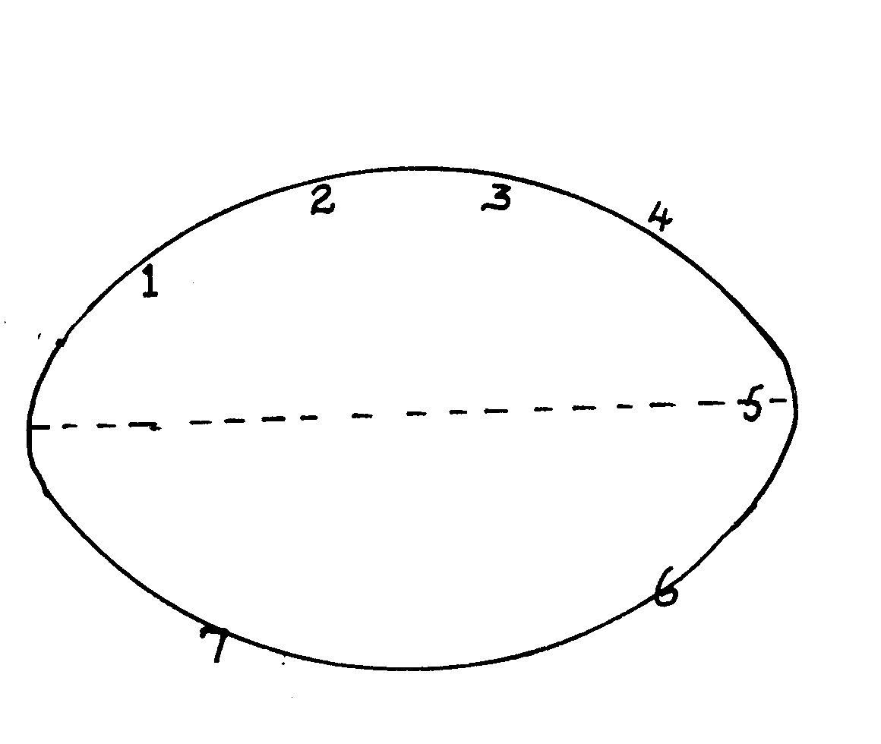
System operation

System development

1- problem recognition and definition
2- information gathering
3 requirement specification
4 system design
5 system construction (coding)
6 implementation and testing
7 review and maintenance

b) i) system entropy - is a system decay naturally overtime.

  - changes in technology, new management policies, changes in new requirement

17. a) i) electronic device used in retail store to input and output data at the point
where a sales are transacted

ii) advantages of EPOS
• ensure correct prices are used at the check out cover.
• faster in data processing
• efficient
• enhances better control of business as stock is controlled

iii) Super market ,big companies
b)
• communication media
• network software
• communication devices
• data signals
c) i)
• twisted pair cables
• coaxial cables
• fibre optical cables
ii)
• Microwave
• Satellite
• Radio transmission

d) ` advantages
• flexible in operation
• can cover in a large geographical area
• can access a remote areas via satellites

disadvantages
• it is relatively difficult to establish and configure
• the initial cost is very high
18. a) i) Software engineer
• develop system and application software
• develop user and technical documentation for new software
• maintain and update the software to meet day to day requirement
  - Computer trainer.
• train people on how to use computers
• develop training reference materials
• guide learners on how to use and acquire knowledge through research.
• Prepare learners with ICT examinations
b) effect of ICT on
i) job opportunities
• job creation i.e. new jobs are created
• job replacement i.e. replacing of computer illiterate people / workers
• displacement of jobs that were formerly manual
ii) environment
• energy
• consumption
• paper consumption
• radiation
• pollution
  - Automated production
• assembly of vehicles in plants
• oil refineries
• food processing
• increased production
• creation of unemployment
- Sequential – records are stored and accessed in a particular order sorted using a key field.
Whereas indexed sequential uses both method random and sequential records are arranged in key sequence and position marked with indexes

19. a) i) cheque processing /survey
ii) marking of examination /bank
b) i) byte – group of 8 bits
ii) nible – group of 4 bits
- • tables
• forms
• reports
• queries
• macros
• modules

- • numbering
• bulleting
• spacing
• alignment
• indentation
- i) 00010110
- (0010 1001)
- i) data processing technique where data processing is divided into groups
physically located at different sites but connected to a central location.
ii) advantages:
 Errors easily corrected
 Better reliability
 Low cost
Enhanced security
 System failure does not affect others
 Encourages effective decision making
- Disadvantages / problems
 users have to be trained
 standards are difficult to maintain
 requires extra cost i.e. expensive
 there are programming techniques with micro- computers and mini- computers

