NAME…………………………………………..ADM. NO…………
DATE……………………….CLASS………………………………
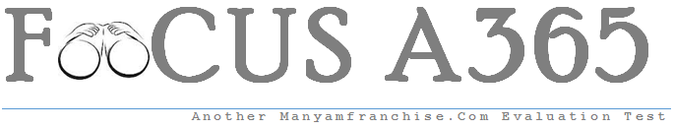KENYA CERTIFICATE OF SECONDARY EDUCATION
END OF TERM TWO EXAMINATIONS 2017
C.R.E PP1
TIME: 2½ HOURS

INSTRUCTIONS TO CANDIDATES

ANSWER ANY FIVE QUESTIONS IN THE ANSWER SHEETS PROVIDED.

Answer any five questions in the answer sheet provided
- a) Name the five books of the Bible which are referred to as Pentateuch (5mks)
b) Write down five teachings about marriage from the Biblical stories of creation (10mks)
c) Give five reasons why Christians read the Bible (5mks)

- a) State seven promises that God made to Abraham (7mks)
b) Give eight reasons why circumcision was important to the Jews (8mks)
c) State five consequences of breaking taboos in Traditional African communities (5mks)

- a) Describe the characteristics of False prophets in the old Testament (7mks)
b) State the Teachings of prophet Amos about the day of the Lord (8mks)
c) How can Christians assist the church leaders to perform their duties effectively? (5mks)

- a) Give six reasons why Jeremiah was not willing to accept the call of God to become a prophet (6mks)
b) Explain four evils condemned by prophet Jeremiah during the Temple sermon (8mks)
c) State six ways in which church leaders communicate God’s message to people in Kenya today (6mks)

- a) From the call of Jeremiah identify eight qualities of God. (Jeremiah 1) (8mks)
b) Give six characteristics of the new covenant foreseen by Jeremiah (6mks)
c) Give six ways in which Christians assist victims of disasters (6mks)

- a) Outline six rituals performed during the birth of a baby in Traditional African communities (6mks)
b) Give six reasons why children are important in Traditional African communities (6mks)
c) List eight duties of diviners in Traditional African communities (8mks)

