MWAKICAN EXAMS TERM 1 2016
FORM 3 BIOLOGY P3 MARKING SCHEME

- You are provided with a specimen labelled Q and hydrogen peroxide.
- What part of the plant is specimen Q? (1mk)

Stem tuber

- Cut two equal cubes whose sides are about 1cm from specimen Q. place one of the cubes into a boiling tube labelled A. Crush the other cube using pestle and mortar. Place the crushed material in another boiling tube labelled B. To each boiling tube add 4ml of hydrogen peroxide.
- Record your observations (2mks)
Test tube A: Bubbling occurs but less than B

Test tube B: A lot of bubbling occurs

- Account for the results in b)(i) above (2mks)

A lot of bubbling in B because crushing increases the surface area for enzymatic activity

- Write an equation for the break down of hydrogen peroxide (1mk)
2H₂O_{2(aq)} 2H₂O + O₂ _{(g)}

- Peel half of specimen Q and crush in a mortar. Use the reagent provided to test for the various food substances in the extract obtained from the crushed material. Record the procedure, observation and conclusion in the table below (9mks)

Food Substance | Procedure | Observation | Conclusion
Starch | Put 2cm3 of extract Q in a test tube. Add 2 – 3 drops of iodine solution | Colour changes to blue black | Starch present
Protein | Put 2cm3 of extract Q in a test tube. Add 1cm3 of sodium hydroxide followed by a few drops of copper sulphate. Shake | No colour change | Protein absent
Reducing sugar | Put 2cm3 of extract Q in a test tube. Add an equal amount of Benedict solution. Heat | Colour changes to yellow/orange/brown | Reducing sugars/simple sugars present

- The photograph below represents the lower and upper jaw of a mammal. Study it and answer the questions that follow.
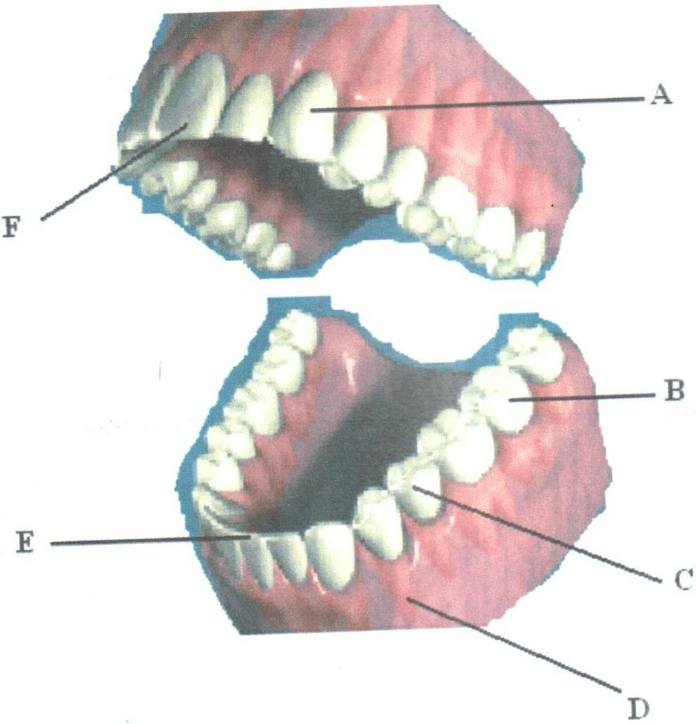

- Name the parts labelled (5mks)
A –Upper canine
B – Molar
C – Premolar
D – Gum
F – Upper incisor
- Name one observable structural difference between B and C (1mk)
B has a wider grinding surface than C

- i) Draw and label the external structure of part labelled B (3mks)

- i) Define the term “dental formula” (1mk)

A formula that shows the arrangement of different types of teeth and their numbers in half of the upper and lower jaws of an animal

ii) Write the dental formula from the diagram above (1mk)

I $\frac{2}{2}$ C $\frac{1}{1}$ PM $\frac{2}{2}$ M $\frac{3}{3}$

- Suggest the mode of feeding in the above animal (1mk)

Omnivorous

- Name one common disease that affect part labelled D (1mk)

Periodontal disease

- What class of food is digested in the cavity shown in the diagram? (1mk)

Starch

- You are provided with the photographs below labelled A, B, C, D, E, F, G and a dichotomous key. Use them to answer questions that follow.
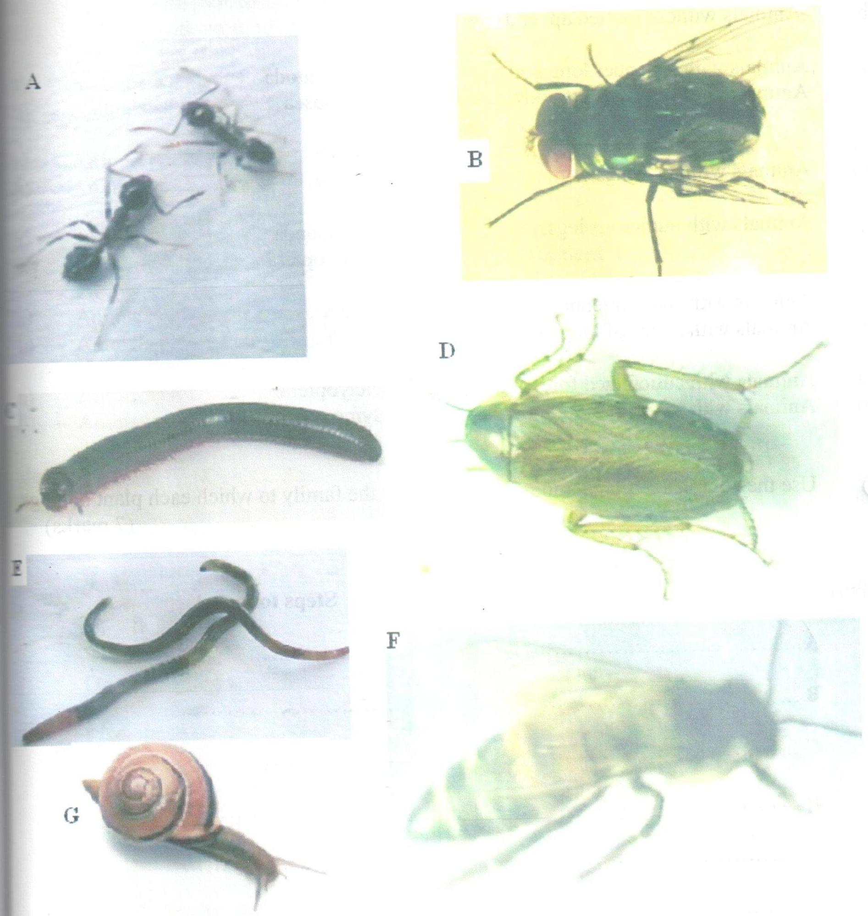

- Fill the missing information in the dichotomous key below (2mks)

1 (a) Animals with jointed appendages ……………………go to 3
(b) Animals without jointed appendages ………………...go to 2

2 (a) Animals with a slender long body ……………………Nematoda
(b) Animals with a thick short body ……………………..Mollusca

3 (a) Animals with wings ………………………………..go to 5
(b) Animals without wings ………………………………go to 4
4 (a) Animals with numerous legs ……………………….Myrioponda
(b) Animals with 3 pairs of legs ………………………Hymenoptera

5 (a) Animals with short antenna …………………………Diptera
(b) Animals with a pair of long antenna ………………..go to 6

6 (a) Animals with cuticulized fore wings ………………..Dictyoptera
(b) Animals with a pair of membranous wings………….Hymenoptera

- Use the completed dichotomous key to identify the family to which each plant belongs (7mks)
Identity Steps followed

A 1a, 3b, 4b Hymenoptera
B 1a, 3a, 5a Diptera
C 1a, 3a, 4a Myrrapoda
D 1a, 3a, 5b, 6a Dictyoptera
E 1b, 2a Nematoda
F 1a, 5b, 6b Hymenoptera
G 1b, 2b Mollusca

- Name two features that are used to classify B as phylum arthropoda.(2mks)

    - Segmented body
    - Paired limbs

