NAME…………………………………………………..…INDEX NO……………………………..
DATE:……………………………………….
SIGN
MWAKICAN JOINT EXAMINATION FORM 4
232/2
CHEMISTRY
PAPER 2
THEORY
END OF TERM ONE EXAMINATION
2 HOURS
Instructions to candidates.
- Write your name and index number in the spaces provided above.
- Sign and write the date of examination in the spaces provided above.
- Answer all the questions in the spaces provide.
- KNEC mathematics tables and silent electronic calculators may be used.
- All working must be clearly shown where necessary.
- This paper consists of printed 10 pages.
- Candidates should check the question paper to ascertain that all the pages are printed as indicated and that no questions are missing.
- Candidates should answer the questions in English.

FOR EXAMINERS USE ONLY
QUESTIONS | MAXIMUM SOCRE | CANDIDATES SCORE
1 | 13
2 | 13
3 | 12
4 | 10
5 | 11
6 | 12
7
TOTAL SCORE | 80

- (a)Name the method that can be used to obtain pure iron(III) chloride from a mixture of iron(III) chloride and sodium chloride.(1mk)

(b) A student was provided with a mixture of sunflower flour, common salt and a red dye. The characteristics of three substances in the mixture are given in the table below.
substance | Solubility in water | Solubility in ethanol
Sunflower flour | Insoluble | Insoluble
Common salt | Soluble | Insoluble
Solid red dye | soluble | soluble
The student was provided with ethanol and any other materials needed.
Describe how the student can separate the mixture into its three components.(3mks)

(c)The diagram below shows a part of a periodic table .The letters do not represent the actual symbols of elements .Use the diagram to answer the question that follow.
 |  |  |  |  |  |  |  |  | Q
R |  |  |  |  | T
 |  |  | N |  | V |  | W
Y |  |  |  |  |  |  | X
- Explain why the oxidizing power of W is more than that of x.(2mks)

- How do the melting points of R and T compare? Explain.(2mks)

- Select an element that could be used
- In weather balloons(1mk)

- For making a cooking pot.(1mk)

(d) (i) Classify the substances water, iodine ,diamond and candle wax into elements and compound.(2mks)
Element | Compound

(ii) Give one use of diamond.

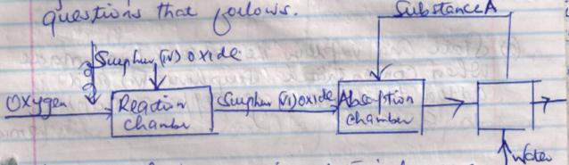
- The flow chart below shows some of the processes involved in larger scale production of sulphuric (vi) acid. Use it to answer the questions that follow.

- Describe how oxygen is obtained from air in large scale.(3mks)

- (i) Name substance A.(1mk)

(ii)Write an equation for the process that takes place in the absorption camber.(1mk)

- Vanadium (V) oxide is commonly used catalyst in the contact process.
- Name another catalysts which can be used for this process.(1mk)

- Give two reasons why vanadium (v) oxide is the commonly used catalyst.(2mks)

- State and explain the observation made when concentrated sulphur(vi) acid is added to crystals of copper (II) sulphate in a beaker.(2mks)

- The reaction of concentrated sulphuric (VI) acid with sodium chloride produces hydrogen chloride gas. State the property of concentrated sulphuric (VI) acid illustrated in this reaction.(1mk)

- Name two types of sulphuric (vi) acid.(2mks)

- At 25˚ C 50g of potassium nitrate were added to 100g of water to make a saturated solution.
- What is meant by saturated solution.(1mk)

- The table below gives the solubility of potassium nitrate at different temperatures.
Temp˚c | 12 | 20 | 28 | 36 | 44 | 52
Solubility g/100g of water | 22 | 31 | 42 | 55 | 70 | 90

- Plot a graph of the solubility of potassium nitrate (vertical axis) against temperature.(3mks)

- Use the graph.
- Determine the solubility of potassium nitrate at 15˚ c.(1mk)

- Determine the mass of potassium nitrate that remained un dissolved given that 80g of potassium nitrate were added to 100cm³ of water and warmed to 40˚C.(2mks)

- Determine the molar concentration of potassium nitrate at 15˚ C.(Assume there is no change in density of water at this temperature).
(K=39.0 N=14.0 O = 16.0)3mks)

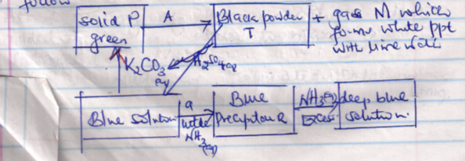
- (i) Study the chart below and answer the questions that follow.

- Name substance
- P (1mk)

- Colourless gas M (1mk)

- Write an ionic equation for the reaction producing solid p..(1mk)

- (i) Write the chemical formula of the complex ion in solutions.(1mk)

(Ii) In the preparation of carbon (iv) oxide in the laboratory dilute hydrochloric acid was added to marble chips (CaCO₃) as shown in the diagram below.

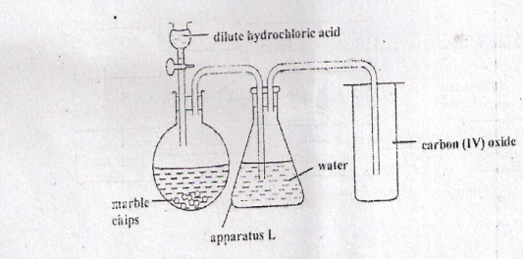

- What observation is made when the acid is added to the marble chips.(1mk)

- Why is dilute hydrochloric acid preferred to dilute sulphuric (vi) acid in the above reaction.(2mks)

- Explain why the gas was passed through water in apparatus L.(1mk)

- Calcium hydroxide is used to test carbon(iv) oxide but not sodium hydroxide .Explain(2mks)

- (a)The combustion of propane can be represented by the following equation.
C₃H_{8(g)} + 50_{2(g)} 3CO_{2(g)} + 4H₂O_{(L)}
- Define the molar enthalpy of combustion of a compound.(1mk)

- Use the thermo chemical equations below to answer the following question.
- C_{(graphite )} + O_{2(g)} CO₂ H ₁=-393.5 Kj Mol⁻¹
- H_{2(g)} + ½ O_{2(g)} H₂ O _{(L)} H₂ = - 285.8 Kj mol ⁻¹
- 3C + 4H ₂ C₃ H₈ H₃ = 103.7 kg mol⁻¹
(b) (i) Name the type of enthalpy change represented by H₂.(1mk)

- Draw an energy level diagram for the reaction represented by equation 1.(3mks)

- Calculate the molar enthalpy of combustion of propane.(3mks)

- The enthalpy information of ethanol (CH₃ CH₂ OH) is 3239 KjMol⁻¹.Use the bond energies given below to calculate the bond energy of formation of O-H.
C-C = -346 KJ mol⁻¹
C-H=-414 kJ mol-¹
C-O = -360 KJ mol⁻¹ (3mks)

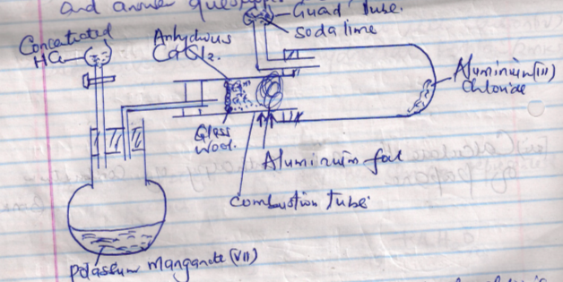
- (a)The diagram below shows a set up in a experiment to prepare chlorine gas and react it with aluminum foil. Study it and answer questions that follow.

- In the experiment, concentrated hydrochloric acid and potassium manganate (VII) were used to prepare chlorine gas. State two precautions that should betaken in carrying out this experiment.(2mks)

- Write a balanced equation for the reaction that took place in the round bottom flask.(1mk)

- Write the formula of another compound that could be used instead of potassium manganate(VII).(1mk)

- Explain why it is necessary to allow the acid to drip slowly onto potassium manganate (VII) before the aluminium foil is heated.(1mk)

- Write a balanced chemical equation for reaction taking place in combustion tube.(1mk)

- State the property of the formed in the combustion tube that makes it possible for it to be collected in the receiver.(1mk)

(b) A student set-up apparatus as shown to prepare and collect dry ammonia gas
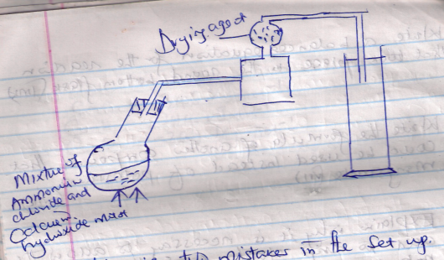

- Identify two mistakes in the set-up.
(I)Mistake

Reason

(II)Mistake

Reason

- Name a suitable drying agent of Ammonia(1mk)

- Write a balanced chemical equation for the formation of ammonia gas.(1mk)

- Describe a chemical test for ammonia gas.(1mk)

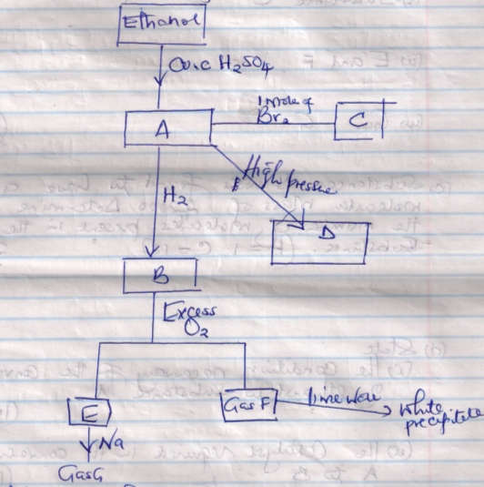
- Study the flow chart below and answer the questions that follow.

- Identify substances
A
B
F
G 4mks
- Write down the equation for the formation
i. Substance C
ii.E and F
iii.Gas G 3mks

- Substance D was found to have a molecular mass of 42000.Determine the number of molecules present in the substance (H=1=12) 2mks

- State ;
- The condition necessary for the conversion of ethanol to substance A.(1mk)

- The catalyst required in the conversion A and B.(1mk)

