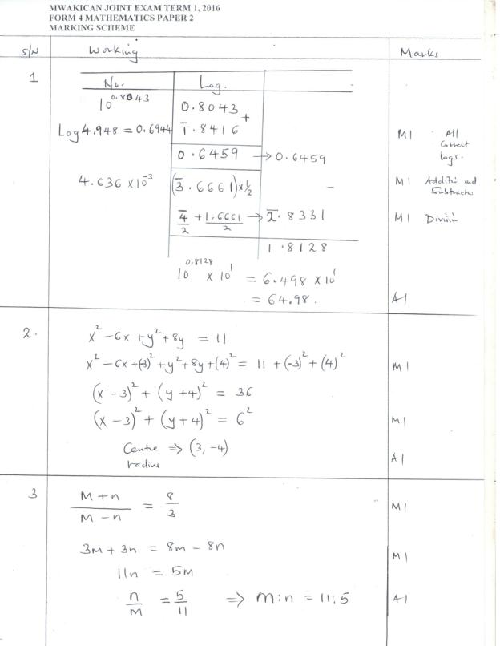

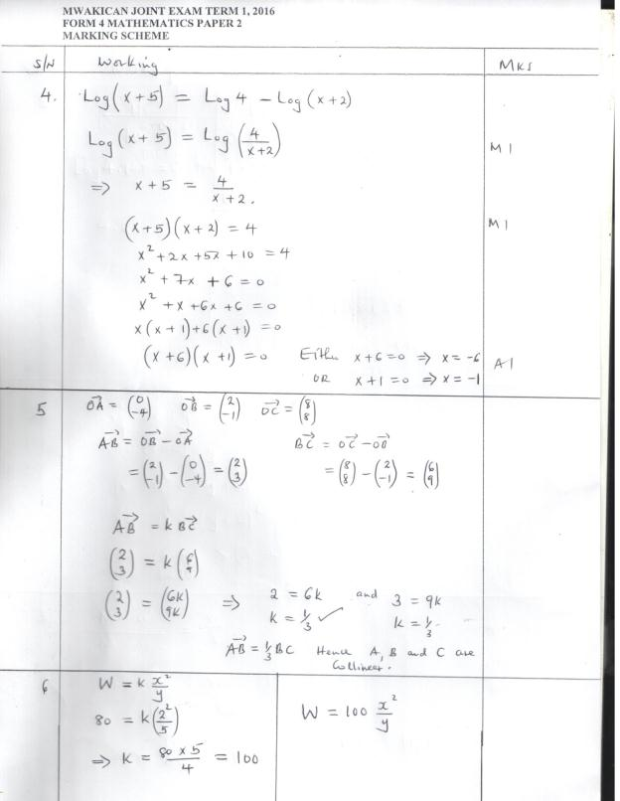

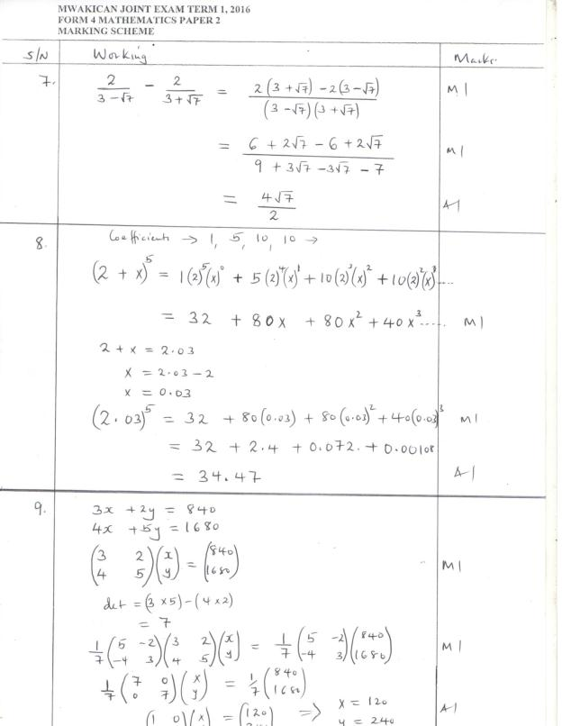

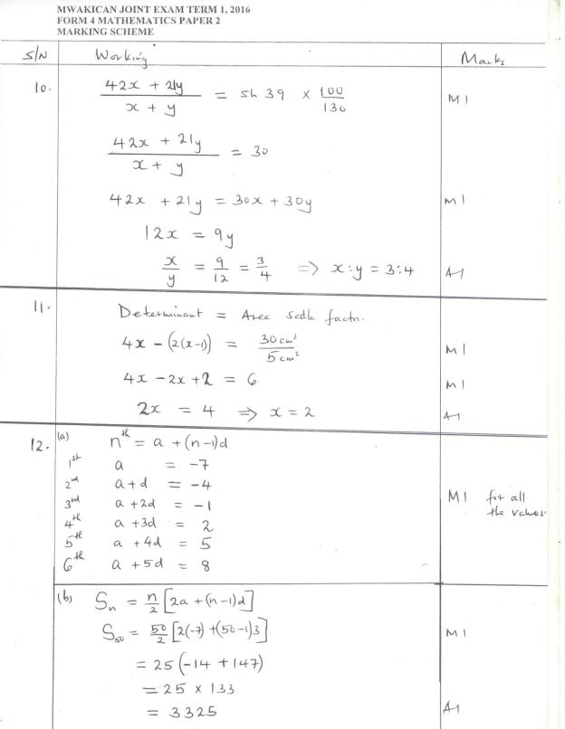

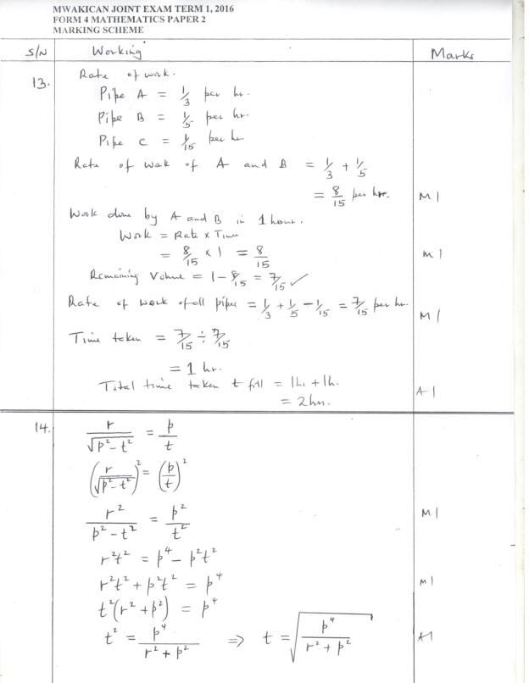

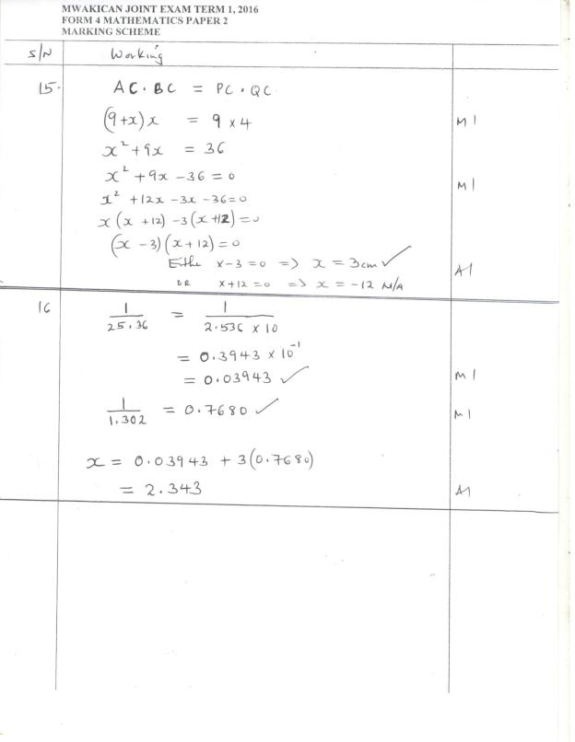
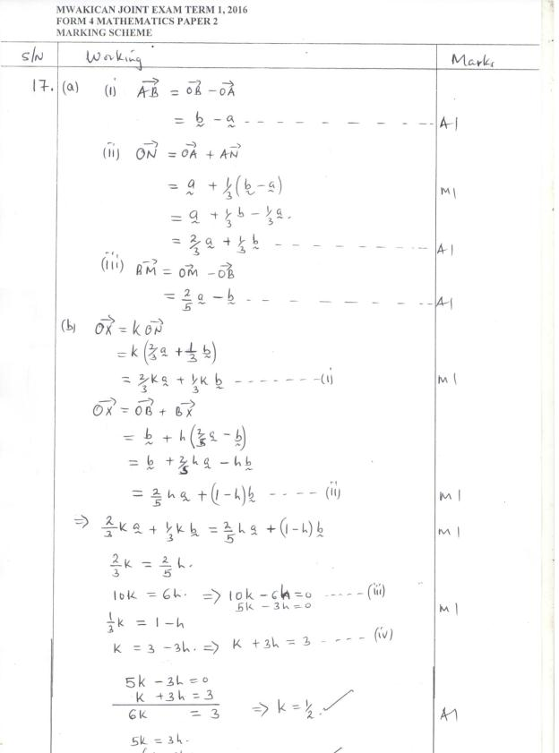

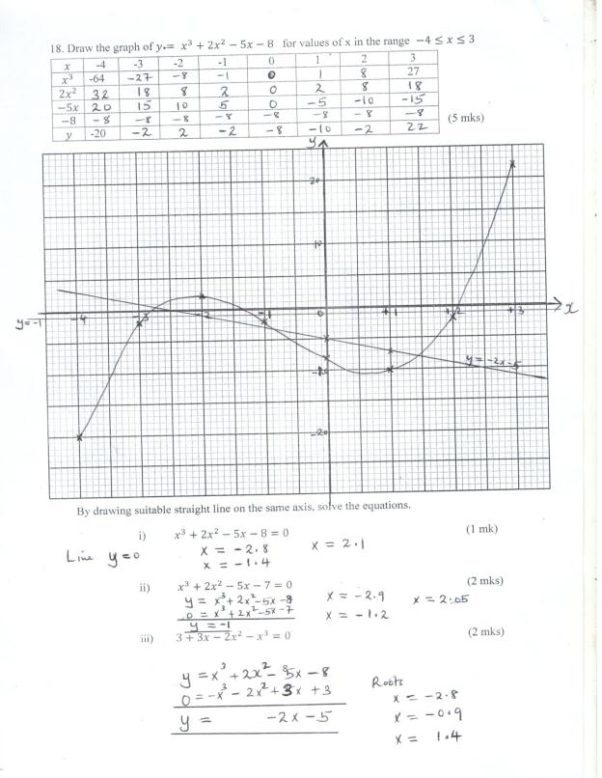

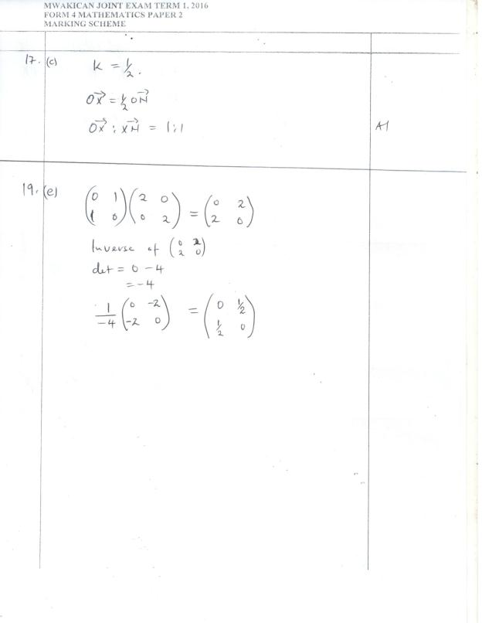

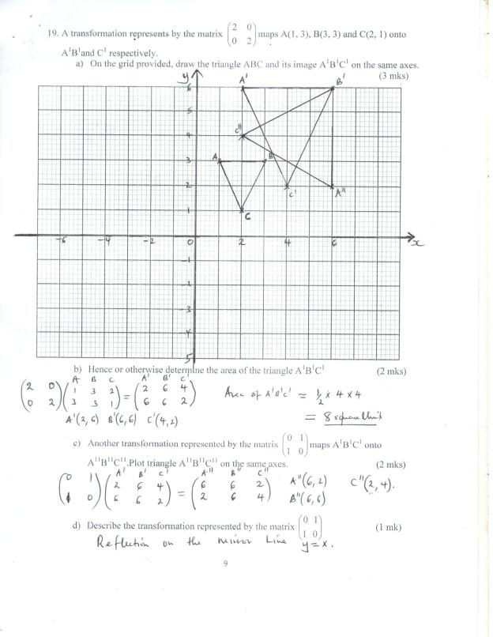

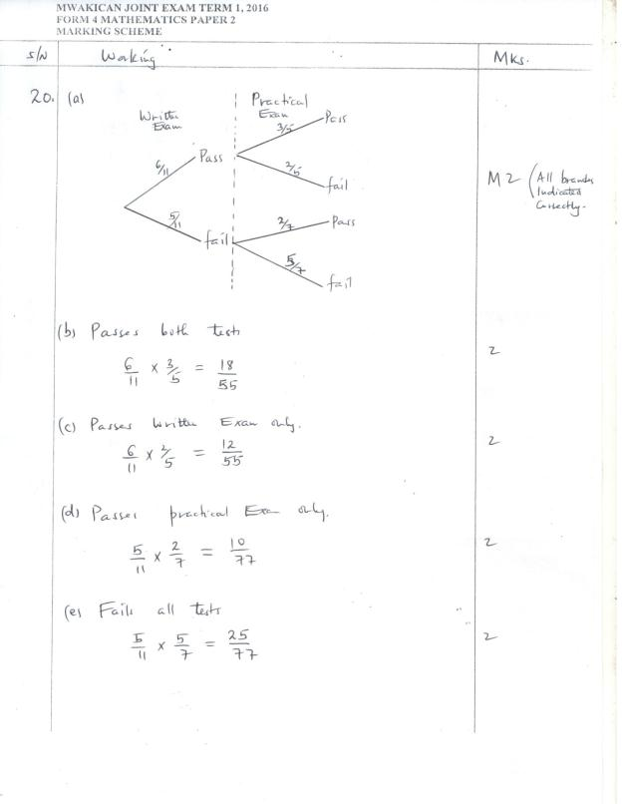

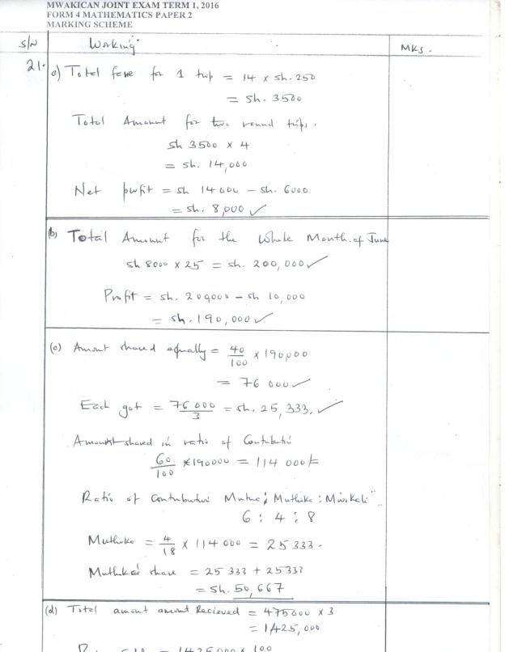

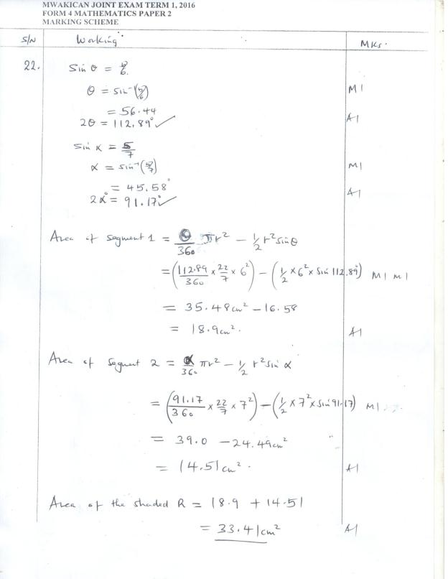

23.(a) AC = $\sqrt{5^{2}+7^{2}}$
(b) VO = $\sqrt{{13}^{2}-{4.301}^{2}}$
= 12.27
(c) BD = AC = 8.602
BO = $\frac{1}{2}$x8.602 = 4301
∠VBO = θ
Cos θ = $\frac{4.301}{13}$ = 0.3308
θ = Cos⁻(0.3308) = 70.68
(d) VM = $\sqrt{{MO}^{2}-{VO}^{2}}$ = $\sqrt{{2.5}^{2}+{12.27}^{2}}$
= $\sqrt{156.8029}$
= 12.52
∠VMO = d
Cos d = $\frac{2.5}{12.52}$ = 0.1997
d = Cos-1(0.1997) = 78.48⁰
24.(a) DCE = EDF (∠s in alternate segment)
= 42⁰
- BCE = BDF (∠s in the same segment)
$\frac{180-48}{2}$= 42⁰
= 24⁰
- DCB = DBF (∠s in alternate segment)
DBF = $\frac{180-48}{2}$ (AB =D)
= 66⁰
- CED = CBD (∠s in the same segment)
CBD = 180 – (60 + 60)(∠s on straight line)
CED = 54⁰
- BEF = BCD (ext. angle = opp. interior angle)
= 24 + 42
= 66⁰

