**NAME…………………………………………………..ADM. NO……………CLASS……………**

**DATE…………….**

**121/2**

**MATHEMATICS**

**PAPER 2**

**APRIL, 2016**

**TIME: 2½ HOURS**

**MWAKICAN JOINT EXAMINATION (MJET) - 2016**

**Kenya Certificate of Secondary Education**

**MATHEMATICS**

**PAPER 2**

**TIME: 2½ HRS.**

**INSTRUCTION TO CANDIDATE’S:**

1. *Write your* ***name****,* ***admission number****,* ***class*** *and* ***date*** *in the spaces provided above.*
2. *This paper consists of* ***two*** *Sections; Section* ***I*** *and Section* ***II****.*
3. *Answer* ***ALL*** *the questions in Section* ***I*** *and any* ***five*** *questions from Section* ***II****.*
4. *All answers and working must be written on the question paper in the spaces provided below each question.*
5. *Show all the steps in your calculation, giving your answer at each stage in the spaces provided* ***below*** *each question.*
6. *Marks may be given for correct working even if the answer is wrong.*
7. *Non-programmable silent electronic calculators and KNEC Mathematical tables* ***may be*** *used, except where stated otherwise.*
8. *Candidates should check the question paper to ascertain that all the pages are printed as indicated and that no questions are missing.*
9. *Candidates should answer the questions in English*

**FOR EXAMINER’S USE ONLY:**

**SECTION I**

|  |  |  |  |  |  |  |  |  |  |  |  |  |  |  |  |  |
| --- | --- | --- | --- | --- | --- | --- | --- | --- | --- | --- | --- | --- | --- | --- | --- | --- |
| 1 | 2 | 3 | 4 | 5 | 6 | 7 | 8 | 9 | 10 | 11 | 12 | 13 | 14 | 15 | 16 | TOTAL |
|  |  |  |  |  |  |  |  |  |  |  |  |  |  |  |  |  |

**SECTION II**

|  |  |  |  |  |  |  |  |  |
| --- | --- | --- | --- | --- | --- | --- | --- | --- |
| 17 | 18 | 19 | 20 | 21 | 22 | 23 | 24 | TOTAL |
|  |  |  |  |  |  |  |  |  |

|  |
| --- |
| GRAND TOTAL |
|  |

**SECTION I: (50 MARKS)**

**Answer all the question in this section in the spaces provided.**

1. Use logarithm tables only correct 4 d.p to evaluate: (4 mks)
$$\frac{{10}^{0.8043} × \log{4.948}}{\sqrt{0.004636}}$$

2. Find the centre and radius of a circle with equation:

χ² + y² - 6χ + 8y – 11 = 0 (3 mks)

1. If (M + n): (M – n) = 8: 3. Find the ratio M: n. (3 mks)
2. Find the values of x that satisfies the equation

Log(x + 5) = log 4 – log (x + 2) (3 mks)

1. The co-ordinates of the points A, B and C are (0,-4), (2, -1) and (8, 8) respectively. Use vector method to show that the points are collinear. (3 mks).
2. W varies directly as the cube of x and inversely as y. Find W in terms of x and y given that

W = 80 when x = 2 and y = 5. (3 mks)

1. Without using mathematical tables, simplify in the form  (3 mks)

 - 

1. Expand ( 2 + x)5 in ascending powers of x up to the term in x3. Hence approximate the value of (2.03)5 to four significant figures. (3 mks)
2. A clothes dealer sold 3 skirts and 2 trousers for sh. 840. He also sold 4 shirts and 5 trousers for Ksh. 1680. Form a matrix to represent the above information ; hence find the cost of

1 shirt and 1 trouser. (3 mks)

1. Mumbua bought two grades of rice, grade A and grade B. She bought grade A at Sh. 42 per kg and grade B at Sh. 21 per kg. If she sold the mixture of the two grades at Sh. 39 per kg making a profit of 30%, at what ratio should she mix the two grades? (3 Marks)
2. In a transformation, an object with an area of 5 cm2 is mapped onto an image whose area is 30 cm2. Given that the matrix of the transformation is $\left[\begin{matrix}x & x – 1 \\ 2 & 4\end{matrix}\right]$ find the value of x.

(3 mks)

1. The first term of an arithmetic sequence is -7 and the common difference is 3.
2. List the first six terms of the sequence; (1 mk)

1. Determine the sum of the first 50 terms of the sequence. (2 mks)
2. Pipe A can fill an empty water tank in 3 hours while pipe B can fill the same tank in 5 hours. When the tank it can be emptied by pipe C in 15 hours. Pipe A and B are opened at the same time when the tank is empty. If one hour later pipe C is also opened. Find the total time taken to fill the tank. (4 mks).
3. Make t the subject of the formula (3 Marks)

$\frac{r}{\sqrt{P^{2}-t^{2}}}$ = $\frac{P}{t}$

1. The figure below shows a circle centre O. AB and PQ are chords intersecting externally at a point C. AB = 9cm, PQ= 5cm and QC = 4cm. Find the length of BC. (3mks)

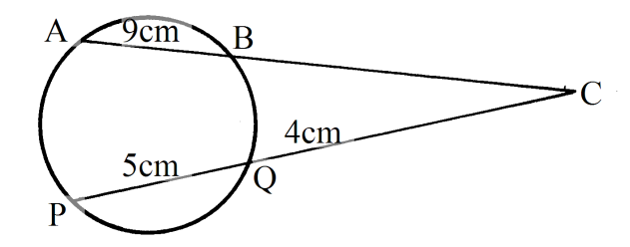

1. Using table of reciprocals of numbers, find the value of x if (3 Marks)

x = $\frac{1}{25.36}$ + $\frac{3}{1.302}$

**SECTION II (50mks)**

**Answer only *five* questions in this section in the spaces provided.**

1. OAB is a triangle in which  M is a point on OA such that

OM: MA = 2: 3 and N is another point on AB such that AN: NB = 1: 2. Lines ON and MB intercept at X.

O

A

B

N

M

X

1. Express the following vectors in terms of 

~

~

1. AB (1 mk)

**~**

1. ON (2 mks)

**~**

1. BM (1 mk)

~

1. If OX = k**ON** and BX = hBM express **OX** in two different ways. Hence or otherwise find the values of h and k. (5 mks)

~

~

~

~

~

1. Determine the ratio OX: XN. (1 mk)
2. Draw the graph of $y= x^{3}+2x^{2}-5x-8$ for values of x in the range $-4≤x≤3$

(5 mks)

|  |  |  |  |  |  |  |  |  |
| --- | --- | --- | --- | --- | --- | --- | --- | --- |
| $$x$$ | -4 | -3 | -2 | -1 | 0 | 1 | 2 | 3 |
| $$x^{3}$$ | -64 |  |  |  |  |  |  | 27 |
| $${2x}^{2}$$ |  |  |  |  |  |  |  |  |
| $$-5x$$ |  |  |  |  |  |  |  |  |
| $$-8$$ |  |  |  |  |  |  |  |  |
| $$y$$ | -20 |  |  |  |  |  |  |  |



By drawing suitable straight line on the same axis, solve the equations.

* + - 1. (1 mk)
      2. (2 mks)
      3. $3+3x-2x^{2}-x^{3}=0$ (2 mks)

1. A transformation represents by the matrix maps A(1, 3), B(3, 3) and C(2, 1) onto A1B1and C1 respectively.
2. On the grid provided, draw the triangle ABC and its image A1B1C1 on the same axes. (3 mks)



1. Hence or otherwise determine the area of the triangle A1B1C1 (2 mks)
2. Another transformation represented by the matrix maps A1B1C1 onto A11B11C11.Plot triangle A11B11C11 on the same axes. (2 mks)
3. Describe the transformation represented by the matrix  (1 mk)
4. Determine the matrix of the single transformation which maps A11B11C11 onto ABC. (2 mks)
5. An examination involves a written and a practical test. The probability that a candidate passes the written test is $\frac{6}{11}$. If a candidate passes a written test then the probability of passing the practical test is $\frac{3}{5}$, other wise it would be $\frac{2}{7}$.
6. Illustrate this information on a tree diagram (2 mks)
7. Determine the probability that a candidate
8. Passes both tests ( 2 mks)
9. Passes the written test only (2 mks)
10. passes the practical test only (2 mks)
11. Fails all test (2 mks)
12. Three partners Mutua, Muthoka and Mwikali contributed Sh. 600,000, Sh. 400,000 and Sh. 800,000 respectively to start a business of a matatu plying Mbumbuni – Machakos route. The matatu carries 14 passengers with each paying Sh. 250. The matatu makes two round trips each day and ever full. Each day Sh. 6000 is used to cover running costs and wages.
13. Calculate their net profit per day. (2 mks)
14. The matatu works for 25 days per month and is serviced every month at a cost of KSh.10, 000. Calculate their monthly profit in June. (1 mk)
15. The three partners agreed to share 40% of the profit equally and 60% to be shared in the ratio of their contribution. Calculate Muthoka’s share in the month of July (4 mks)
16. The matatu developed mechanical problems and they decided to sell it through an agent who charged a commission of 5% on selling price. Each partner received Ksh. 475,000 from the agent after he had taken his commission. Determine the price at which the agent sold the matatu. ( 3 mks)
17. Two circles with centres O1 and O2, have radii 7cm and 6cm respectively. The two circles intersect at P and Q and the length of the common chord PQ is 10cm.

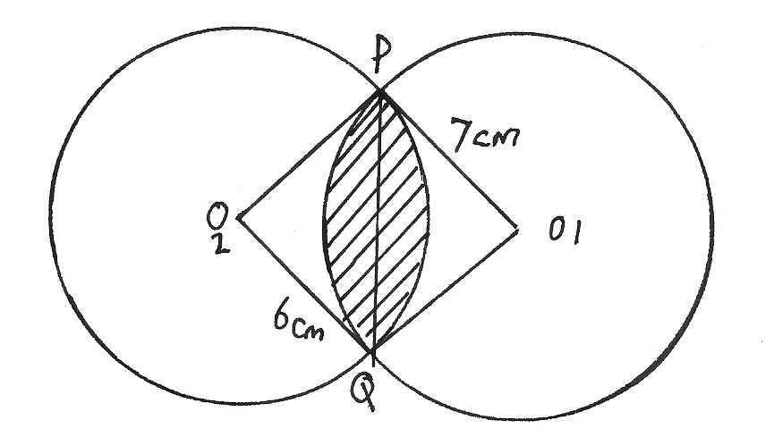

Calculate the area of the shaded region in the above diagram to 4 significant figures.

(10 mks)

1. The figure below is a right rectangular based pyramid VABCD where AB = 5cm, BC = 7cm, VC = 13cm and O is a point on the base of the pyramid vertically below V.

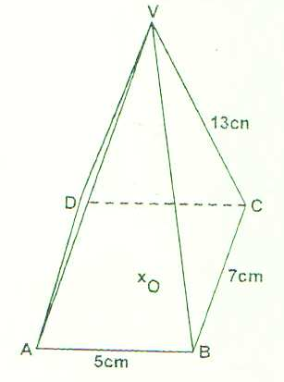

Calculate

1. AC (2 Marks)
2. VO, the height of the pyramid. (2 Marks)
3. the angle between the edge VB and the plane ABCD. (3 Marks)
4. the angle between the planes VBC and ABCD. (3 Marks)
5. In the figure below, AT and AD are tangents to the circle at B and D respectively. DEF is a straight line, 600, FAD = 480 and ADF = 420

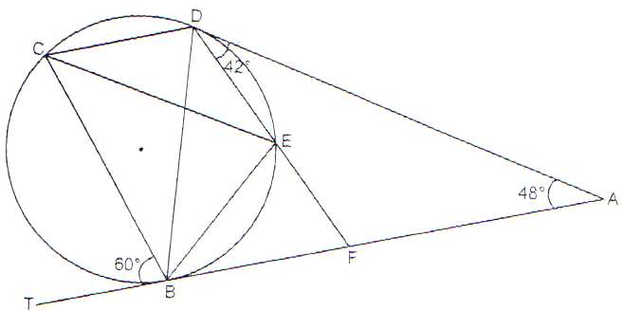

Calculate giving reasons, the value of:

1. < DCE (2 marks)
2. <BCE (2 marks)
3. <DCB (2 marks)
4. <DEC (2 marks)
5. <BEF (2 marks)