MJET EXAMINATIONS
FORM 4 PHYSICS PAPER 2
MARKING SCHEME.

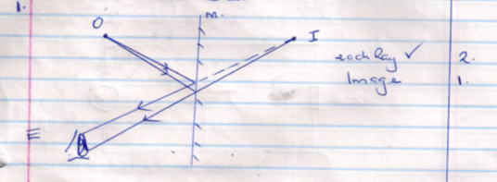

- The conductor is attracted since it has a opposite charges.

- Q=it

= 0.5 x 6 x60
=180 c. 2mks

- A- south pole B –North pole 1mk
- Increasing the number of turns on the coil 2mks
Increasing the size of the current.
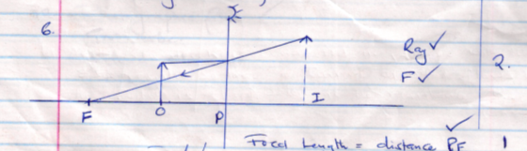

Focal length = distance P.F

- =$\frac{v}{f}$
F= $\frac{1}{1}$=$\frac{1}{0.2}$=5HZ
$\frac{2m/s}{5}$ = 0.4m.

- $\frac{vt}{2}$

d₁=$\frac{320x2}{2}$ = 320

d₂=$\frac{320 x7}{2}$ =1120

d=1120+320=1440m.

- H = Pt =1.5 x 1000 x 6 60
= 540000J

- -Must have equal or nearly equal amplitude.
- must have the same wavelength ,frequently.

- Radiowaves,visible light UV light, Gamma

- G.m tube
Cloud chamber etc.

SECTION B: 55MARKS.
- (a) An electromagnetic is a magnet that attains its magnetism as a result of flow of electric current.
(b) (i) Q- split ring $ρ$ - carbon brushes+
(ii) CD moves downwards or AB moves upwards.

When the switch is closed current flows in direction ABCD .By left hand rule AB moves upwards while CD moves downwards.
The two part exchanges the brushes and AB moves downwards while CD moves upwards. The process continues and there is continuous rotation of the coil.

(iii) Increasing the size of the current
- Using a stronger magnet
- Increasing the number of turns on the coil.
- (a) Capacitance is the change per unit volt.
(b) (i) Series ,c=$\frac{4x5}{4+5}$ = $\frac{20}{9}$ = 2.22 $F$

(ii) Total charge Q = CV= 5.22 x 10⁻⁶ x 10
= 2.22 x 10⁻⁵ c
Q_{3a} F = 3x10⁻⁶ x 10 = 3.0 x 10⁻⁵ c
Q₅$μ$ F = (5.22-3) x 10⁻⁵ = 5.22 x 10^{-J}

Or any other alternative method.

- (a) Refractive Index is the ratio of the sine of incidence to the sine of angle of refraction for a given pair of media.
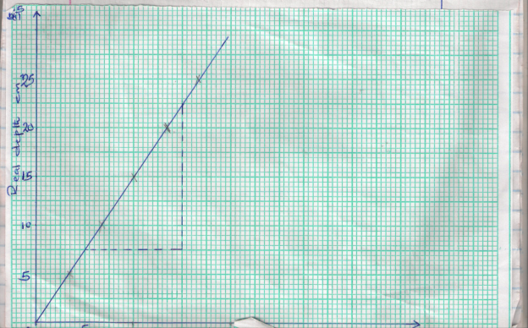

(b) (i) Refractive Index = $\frac{22.5-7.5}{15-5}$ = $\frac{15}{10}$ = 1.5.

(c) 1.6 sin $θ$= 1 sin 90˚
Sin $θ$ $\frac{1}{\begin{aligned}1.6 \\ \end{aligned}}$ or n=$\frac{1}{\sin{c}}$ c=$θ$

= 0.625
$θ$=

- (a)(i)

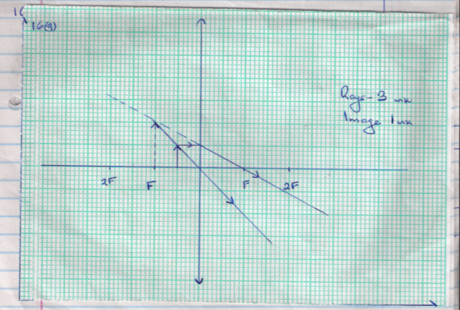

(ii) Image distance = 2x5=10cm
(iii) Magnification =$\frac{v}{u}$
=$\frac{10}{5 }$ = 2

(b) (i) (I)
$\frac{1}{f }$ = $\frac{1}{u}$ + $\frac{1}{v}$

$\frac{1}{5}$= $\frac{1}{20}$ + $\frac{1}{v}$

$\frac{1}{v }$= $\frac{1}{5}$ - $\frac{1}{20}$

= $3/{20 }$
V=${20}/3$ = 6.67 cm
Magnification = $v/{u }$= ${20}/3$ ÷ 20
= $1/3$= 0.33

(ii) The image is
- Diminished
- Real
- (a)(i) e.m.f= 1.5v
(ii) v= 1R
1.2 = I x 3
I = $\frac{1.2}{3}$ = 0.4 A

(iii) E= v +Ir
1.5 = 1.2 + 0.4r
0.4r = 0.3
r=$\frac{0.3}{0.4}$ = 0.75olms

(b) External resistant =(R + 3)ohms
E= IR + Ir
1.5 = 0.15 x (R + 3) + 0.15 x 0.75
1.5= 0.15R +0.45 + 0.1125
1.5 = 0.15 R + 0.5625
0.15 R= 0.9375
R = 6.25 ohms

