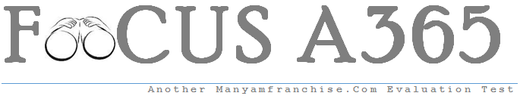

Gatitu Mixed Secondary School
Form 2 | Term 3 | 102 - Kiswahili | 03-Oct-15 | End Term

