MWAKICAN JOINT EXAMINATION
FORM 2 TERM 1 2016
ENGLISH 101
NAME…………………………………………………………………………..ADM NO:………………………
INSTRUCTION TO CANDIDATES:
- Write your name and your admission number in the spaces provided above.
- Answer all questions in the spaces provided
- Correct spellings and grammatically correct sentences must be used.ungrammatical constructions will be penalized.
- Your work must be neat
This paper consists of six sections:
A WRITING (20MRKS)
B:COMPREHENSION (20MRKS)
C:CLOZE TEST (10MRKS)
D:ORAL SKILLS (10MRKS)
E:ORAL LITERATURE (20MRKS)
F:GRAMMAR (20MRKS)
TOTAL (100MRKS)

ALL THE BEST.

A:WRITING (20MRKS)
Write a composition ending with the following words;
“……..it was then that I realized I had ruined my life by associating with the wrong friend

B:COMPREHENSION (20MRKS)
Read the passage below and answer the questions that follow
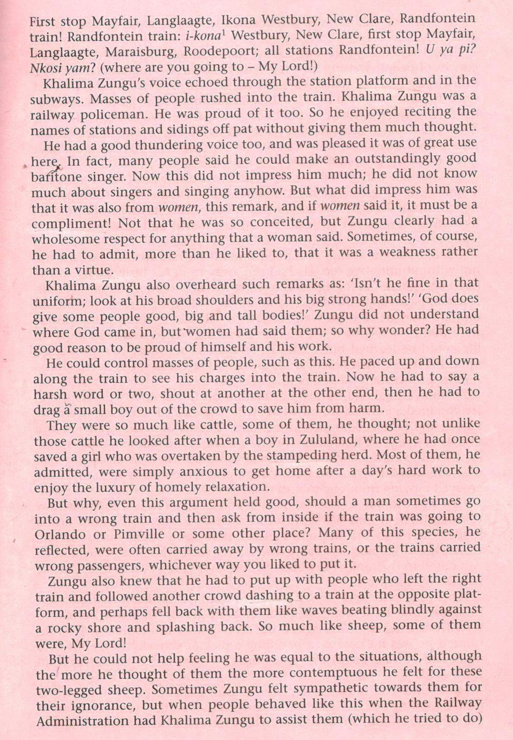

- What was khalima zungu’s occupation?(1mrk)
- Khalima zungu rarely appreciated whenever he was told that he could make a good baritone singer; But if the remark came from a woman ,he would be impressed.Give two reasons for this(2mrks)
- In point form,give any four compliments that people gave about khalima zungu (4mrks)
- Where did khalima zungu grow up?(1mrk)
- Identify any two incidents that indicate that khalima zungu has rescued people(2mrks)
- Identify the irony in paragraph seven of the passage(2mrks)
- All times,people would leave the right train and get into a wrong one;What was the cause of this according to khalima?(2mrks)
- Describe khalima zungu’s attitude(feelings)towards the train users(2mrks)
- Give the meaning of the following words as used in the passage(3mrks)
i)Compliment
ii)Stampeding
iii)Virtue
10.Give an appropriate title to this passage(1mrk)
C:CLOZE TEST (10MRKS)
Fill in the blank spaces using the most appropriate word
Jill was walking to her class slowly.She was worried (1)……………………….the History test she would have to (2)…………………………that morning.As she was reaching the classroom a piece of paper suddenly fluttered down and (3)……………………. Near her feet.As jill glanced down at the paper,her heart nearly (4)………………………a beat.It was the History test paper complete (5)………………….answers!
Jill’s very first thought was not to (6)…………………..anyone about what she found.She would memorize (7)…………………the answers and do extremely (8)………………………..in the test.After some hard thinking ,however,she knew that it would be a very dishonest thing to do.Besides,it would not be (9)…………………..to her classmates.(10)…………………..the end,jill returned the paper to her history teacher,miss james.

D.ORAL SKILLS (10MRKS)
a) Read the poem below and answer the questions that follow.
BODYHOOD DREAMS By Rea Armattoe
They have thought as young men think of love,fame and glory.
They have found as old men find life’s talesstale and hoary.
They have hoped as children hope.
To pick life’s pleasant gains.
And now they walk with bowed heads.
Like drenched men form rains.
- Identify any two pairs rhyming words in the poem(2mrks)
- Describe the rhyme scheme of the poem (2mrks)
- Apart from rhyme,identify one other sound pattern in the poem(2mrks)
b)Underline the silent letter in the following words(4mrks)
- Grandson
- Duvet
- Mnemonic
- Isle
E.ORAL LITERATURE(20MRKS)
Read the following narrative and answer the questions that follow.

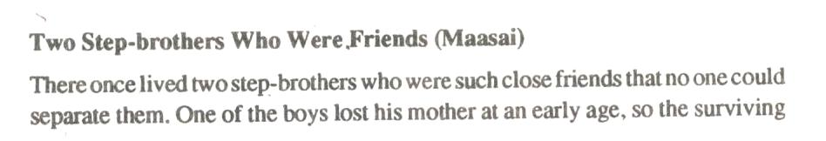

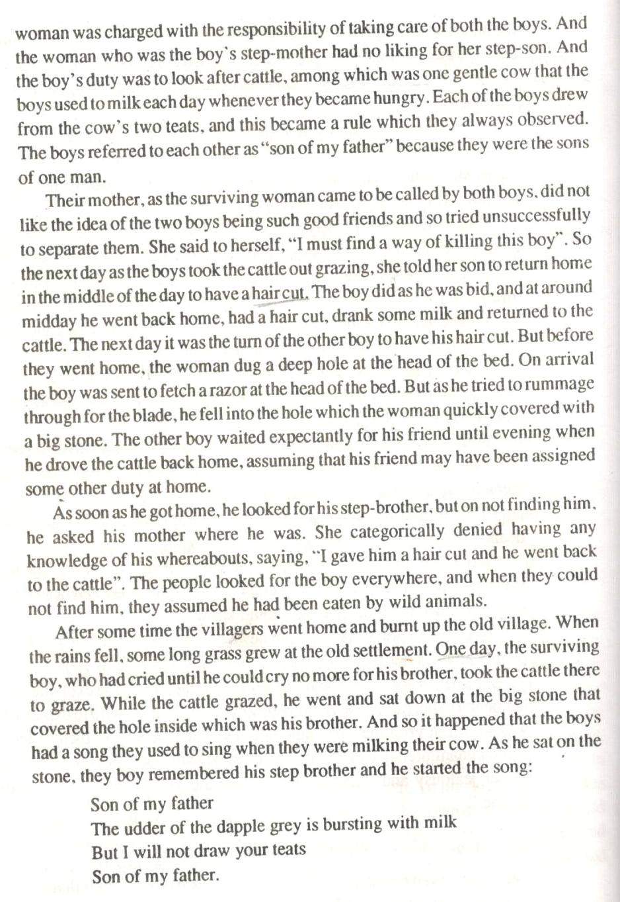
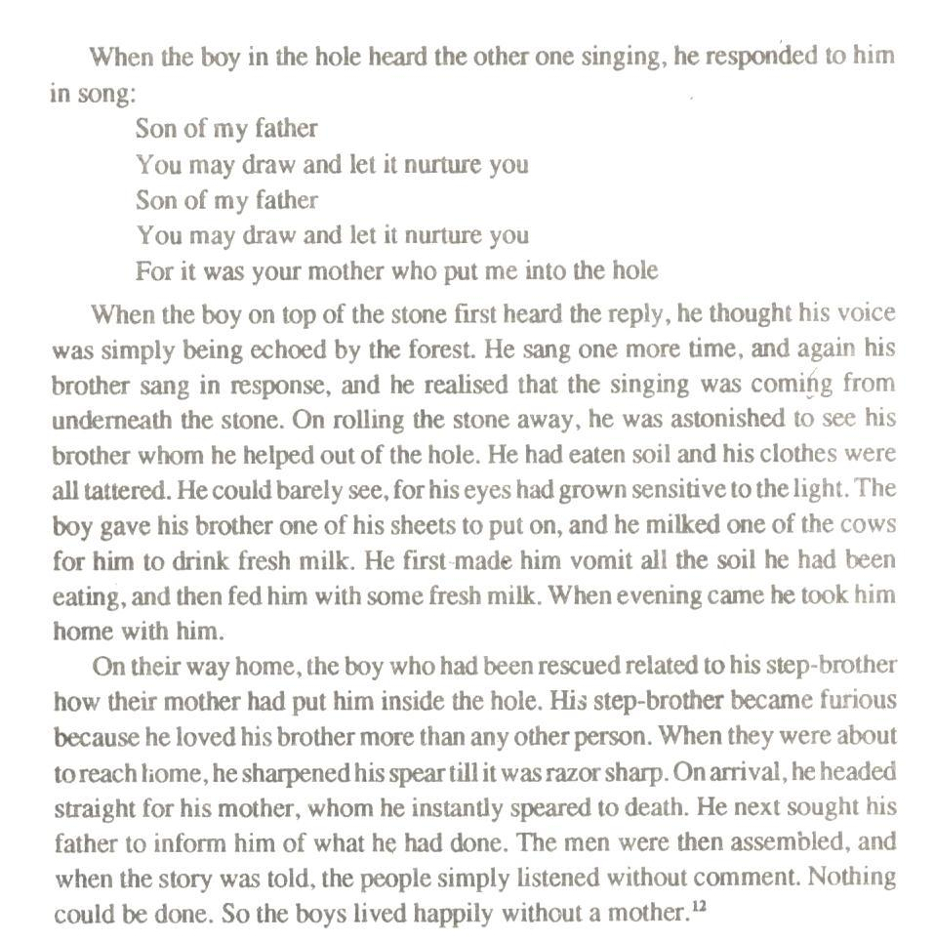

Two step-brothers who were friends
- Classify the above narrative (2mrks)
- Identify one economic activity practiced by the people in the community where the narrative was collected from(2mrks)
- Identify and illustrate three features of oral narration from the narrative(6mrks)
- Identify and illustrate one character trait for each of the following(4mrks)
- The mother of the two boys.
- The boy who rescued the brother.
- Identify one social practice of the people in the narrative(2mrks)
- Identify and explain any two problems you think the researcher artist might have faced while
collecting the narrative from the community(4mrks)

F.GRAMMAR(20MRKS)
1.Fill in the blank spaces using the correct collective nouns
- The unruly …………………………stoned the motorist who had caused the accident.
- The whole maize crop was devoured in a few days by the ………………………..of locusts.
- The tourists happily watched a …………………….of lions in the orphanage.
2.Choose the correct pronoun from the brackets.
- ……………………(we/us)and the other members of the a thletics team will organize for a tournament.
- It was………………..(she/her)who won the prize.
- Charity gave wangari and ……………………(i/me)her promise.
- Evans and ……………………….(he/him)harvested the maize.
3.Fill in the blank spaces with the correct form of the word in the brackets.
- The accused is yet to be proven ………………………(guilt)
- The ……………………………boy startled the cat.(mischief)
- Mwangi was glad for having been invited to the interview by the staff at the …………………….was not very helpful.(receive)
- Having ………………………………….in the sun wounded for a long time,the patient needed to be taken to a well equiped hospital(lay)
- The father was so unhappy with the son that he ……………………….him(inherit)
4.Convert the following sentences into plural.
- The commander-in- chief is my friend
- The window cleaner works well.
- Bring me the matchbox.
5.Fill in the blank spaces so as to complete the phrasal quantifiers in the sentences.
- I did not get the first……………………..of news because of the baby’s cries.
- His new house needs atleast two …………………………..of furniture.
- The student needs a new…………………….of shoes.
6.Add a question tag (2mrks)
i)you kept quiet.
ii)Jane is your friend.

