Name ……………………………………..…………… Index No……………..............….….………
School …………………………………………………. Candidate’s Signature ………...……..……
Date: ………………………….……………

MWAKICAN FORM 3 JOINT EXAMINATION – 2016 TERM I
KENYA CERTIFICATE OF SECONDARY EDUCATION

101/1
ENGLISH
Paper 1
Time: 2 Hrs

INSTRUCTIONS TO CANDIDATES
- Write your name and index number in the spaces provided above.
- Sign and write the date of examination in the space provided.
- Answer ALL the questions in this question paper.
- All the answer must be written in the spaces provided in this question paper.

FOR EXAMINERS USE ONLY
QUESTION | MAXIMUM SCORE | CANDIDATE’S SCORE
1 | 20
2 | 10
3 | 30
TOTAL SCORE | 60

- Functional writing
You are waiting to join college after your K.C.SE examination. While reading a newspaper, you see an advertisement for a post of a clerk typist in the County Government of Kirinyaga. Write an application letter in response to the advertisement. (20 mks)
......................................................................................................................................................................................................................................................................................................................................................................................................................................................................................................................................................................................................................................................................................................................................................................................................................................................................................................................................................................................................................................................................................................................................................................................................................................................................................................................................................................................................................................................................................................................................................................................................................................................................................................................................................................................................................................................................................................................................................................................................................................................................................................................................................................................................................................................................................................................................................................................................................................................................................................................................................................................................................................................................................................................................................................................................................................................................................................................................................................................................................................................................................................................................................................................................................................................................................................................................................................................................................................................................................................................................................................................................................................................................................................................................................................................................................................................................................................................................................................................................................................................................................................................................................................................................................................................................................................................................................................................................................................................................................................................................................................................................................................................................................................................................................................................................................................................................................... ......................................................................................................................................................................................................................................................................................................................................................................................................................................................................................................................................................................................................................................................................................................................................................................................................................................................................................................
............................................................................................................................................................................................................................................................................................................................................................
………………………………………………………………………………………………………………………………………………………………………………………………………………………………………………………………………………………………………………………………………………………………………………………………………………………………………………………………………………………………………………………………………………………………………………………………………………………………………………………………………………………………………………………………………………………………………………………………………………
………………………………………………………………………………………………………………………………………………………………………………………………………………………………………………………………………………………………………………………………………………………………………………………………………………………………………………………………………………………………………………………………………………………………………………………………………………………………………………………………………………………………………………………………………………………………………………………………………………
………………………………………………………………………………………………………………………………………………………………………………………………………………………………………………………………………………………………………………………………………………………………………………………………………………………………………………………………………………………………………………………………………………………………………………………………………………………………………………………………………………………………………………………………………………………………………………………………………………………………………………………………………………………………………………………………
………………………………………………………………………………………………………………
………………………………………………………………………………………………………………………………………………………………………………………………………………………………………………………………………………………………………………………………………………………………………………………………………………………………………………………………………………………………………………………………………………………………………………………………………………………………………………………………………………………………………………………………………………………………………………………………………………………………………………………………………………………………………………………………
………………………………………………………………………………………………………………
………………………………………………………………………………………………………………………………………………………………………………………………………………………………………………………………………………………………………………………………………………
- Cloze Test
Read the passage below and fill in each blank space with an appropriate word.
Most of us just fall ________(1) bed without a great ____________ (2) of thought. But what you do right before bed has a real ___________(3) on your mood the next day. And so successful people tend to have bedtime ___________(4) that give them a head start in the morning.
Get into that habit by _______________(5) when you need to wake up in the morning, work out from experience how many hours sleep you need, and count back the many hours that is so you know when to get ready for bed.
Make _____________(6) a regular bedtime, and have a relaxed and _______________(7) bedtime routine, because both tend to ensure a good night’s sleep.
You don’t have to stick to business or inspirational reading. You can catch up on news stories, skim the techie blogs or browse Twitter, or even read novels, science or philosophy.
_______________(8) on your day before you settle down for the night. Think _____________(9) what went well, what you’re glad about and enjoyed, what progress you’ve made and what you’ve ____________(10). So that you end the day in a positive, grateful mood.

- (a) Read the poem below and answer the questions that follow;
Nothing Gold can stay
Nature’s first green is gold,
Her hardest hue to hold,
Her early leaf’s a flower;
But only so an hour,
Then leaf subsidies to leaf.
So eden sank to grief,
So dawn goes down to day.
Nothing gold can stay.
(By Robert Frost)

Questions
- Identify 2 pairs of rhyming words. (2 mks)

- How has rhythm been achieved in the poem. (2 mks)

- Which words would you stress in line 7 and why? (2 mks)

(b) Read the following piece of art and answer the questions that follow.
Politeness for politeness doesn’t burn one’s mouth.
- Name the above genre and give it meaning. (2 mks)

- Give the situation in which this sub-genre can be used. (2 mks)

- Identify aspects of alliteration used in the above genre. (2 mks)

(c) (i) Give another word that is pronounced the same as the one given below. (5 mks)
- Furs –

- Bales –

- Elicit –

- Yaw –

- Descent –

(ii) Identify the silent letter in each of the following words. (2 mks)
- Castle –

- Poignant –

- Deafening –

- Rendezvous –

(d) Why would speakers pause in mid sentences or at the end? (2 mks)

(e) Read the following dialogue and answer the questions that follow.
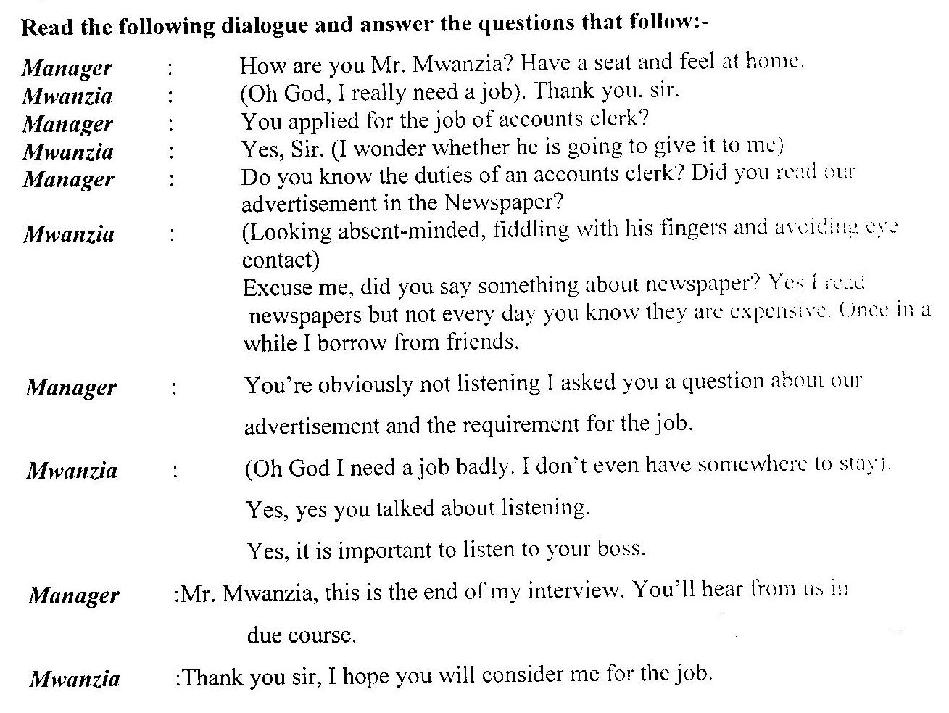

- Identify the shortcomings in Mr. Mwanzia’s Listening Skills. (2 mks)

- Identify the specific Listening Skills Mr. Mwanzia could have used during the interview. (2 mks)

(f) Imagine you have been invited to speak about the role of youth in community leadership at the animal get together party of your youth group:
- Mention the things that you would do to ensure that your speech is successful. (2 mks)

- Mention three non-verbal cues you would use to make the speech effective. (3 mks)

