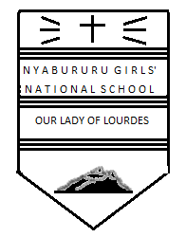

DATE DONE…………………………………………..

INVIGILATOR………………………………………..

DATE RETURNED……………………………………

DATE REVISED…………..…………………………..

101/3
FORM 3 ENGLISH
CAT 1 TERM 3 2017
TIME: 2 ½ HOURS

INSTRUCTIONS
- Answer all the questions in this paper.
- Each of your answers must not exceed 450 words.
- All answers to be written in the answer sheets provided.

FOR EXAMINER’S USE ONLY

QUESTIONS | MAX. SCORE | CANDIDATE’S SCORE
1 | 20
2 | 20
3 | 20
Total Score | 60

1. Imaginative Composition (Compulsory) (20 Mks)

Either
(a) Write a composition beginning with the following words: As I got closer to my home that night, I realized that the commotion and noise I had heard on getting off the bus came from my elder brother’s house.

Or

(b) Write a composition to illustrate the saying, “love is blind”

2. Compulsory text – Novel, “The River and the Source” by Margaret Ogola.
(20 Mks)
“Women are the pillars of the society”. Using illustration from Margaret Ogola’s novel, The River and the Source, Write an essay to support this statement.

3. “Margaret Ogola has used various stylistic devices in an admirable and pleasant way to communicate her message.” Write an essay highlighting any four devices drawing illustrations from the River and the Source. (20mks)

