Date done
Invigilator
Date returned
Date revised
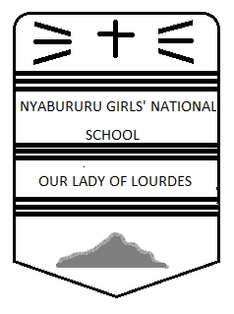
FORM 1 GEOGRAPHY
CAT 1 TERM 3, 2017
TIME: 2 HOURS

Instructions
- Write your name, stream and class number in the spaces above.
- Answer all the questions in the spaces provided below each question.

PAGE | 2 | 3 | 4 | 5 | 6 | 7 | 8 | TOTAL
MARKS

Answer all questions in the spaces provided
- (a)Name any two areas studied under practical geography. (2mks)
……………………………………………………………………………………………………………………………………………………………………………………………………………………………………………………………………………………………………………...
(b)The diagram below represents the interrelationship between geography and other disciplines.
GEOGRAPHY

Name the disciplines marked A, B, C and D.
A…………………………………………. (1mk)
B…………………………………………. (1mk)
C………………………………………….. (1mk)
D………………………………………….. (1mk)
(c) i. What is environment? (2mks) ………………………………………………………………………………………………………………………………………………………………………………………………………………………………………………………………………………………………………………
ii. Identify the type of environment where each of the following aspects fall under:
- Climate …………………………………………………………………………… (1mk)
- Drainage…………………………………………………………………………. (1mk)
- Settlement……………………………………………………………………… (1mk)
- Industry………………………………………………………………………….. (1mk)
2. (a) Define the Solar system. (2mks) ……………………………………………………………………………………………………………………………………………………………………………………………………………………………………………………………………………………………………………..
(b)Name two planets without satellites. (2mks) …………………………………………………………………………………………………………………………………………………………………………………………………………………………………………………………………………………………………………
(c) Describe the Nebula cloud theory. (4mks) ………………………………………………………………………………………………………………………………………………………………………………………………………………………………………………………………………………………………………………………………………………………………………………………………………………………………………………………………………………………………………………………………………………………………………………………………………………………………………………………………………………………………………………………………………………………………………………………………………………………………………………………………………………………………………………………………………………
(d) State three reasons why the interior of the earth is still very hot yet it was formed millions of years ago. (3mks) ………………………………………………………………………………………………………………………………………………………………………………………………………………………………………………………………………………………………………………………………………………………………………………………………………………………………………………………………………
(e) Differentiate between a meteor and a meteorite. (2mks) ………………………………………………………………………………………………………………………………………………………………………………………………………………………………………………………………………………………………………………
(f) State any three effects of rotation of the earth. (3mks)
………………………………………………………………………………………………………………………………………………………………………………………………………………………………………………………………………………………………………………………………………………………………………………………………………………………………………………………………………
(g)The diagram below shows the structure of the earth. Use it to answer questions that follow.

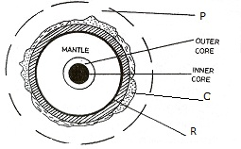
- Name the parts labelled;
P……………………………………………………………… (1mk)
Q………………………………………………………………. (1mk)
R………………………………………………………………. (1mk)
- Name the four layers that make up Z (4mks)
……………………………………………………………………………………………………………………………………………………………………………………………………………………………………………………………………………………………………………………………………………………………………………………………………………………………………………………………………………………………………………………………………………………………………………………………………………………………..
h) State two ways in which the knowledge of the interior of the earth is studied. (2mks) ………………………………………………………………………………………………………………………………………………………………………………………………………………………………………………………………………………………………………………
(i) State the latitudes over which the sun is overhead at midday on ;
- 21st June…………………………………………………………........ (1mk)
- 22nd December……………………………………………………… (1mk)
- 21st March…………………………………………………………….. (1mk)
3. (a) Define weather. (2mks) ………………………………………………………………………………………………………………………………………………………………………………………………………………………………………………………………………………………………………………
(b)Give any four factors influencing weather. (4mks) ………………………………………………………………………………………………………………………………………………………………………………………………………………………………………………………………………………………………………………
………………………………………………………………………………………………………………………………………………………………………………………………………………………………………………………………………………………………………………
(c) Name three main processes through which the atmosphere is heated. (3mks) ……………………………………………………………………………………………………………………………………………………………………………………………………………………………………………………………………………………………………………………………………………………………………………………………………………………………………………………………………..
(d) State three characteristics of the I.T.C.Z. (3mks) ………………………………………………………………………………………………………………………………………………………………………………………………………………………………………………………………………………………………………………………………………………………………………………………………………………………………………………………………………
(e) i) Give reasons why the Stevenson screen is;
- Painted white. (1mk)
…………………………………………………………………………………………………………………………………………
- Has a system of wooden louvres. (1mk) …………………………………………………………………………………………………………………………………………
- Is raised to a height of about 121cm above the ground. (1mk)
……………………………………………………………………………………………………………………………………………
(ii) Name two instruments kept in the Stevenson screen. (2mks) ………………………………………………………………………………………………………………………………………………………………………………………………………………………………………………………………………………………………………………
4. (a)State three conditions necessary for the formation of dew. (3mks) …………………………………………………………………………………………………………………………………………………………………………………………………………………………………………………………………………………………………………………………………………………………………………………………………………………………………………………………………......
(b) Use the diagram below to questions that follow.

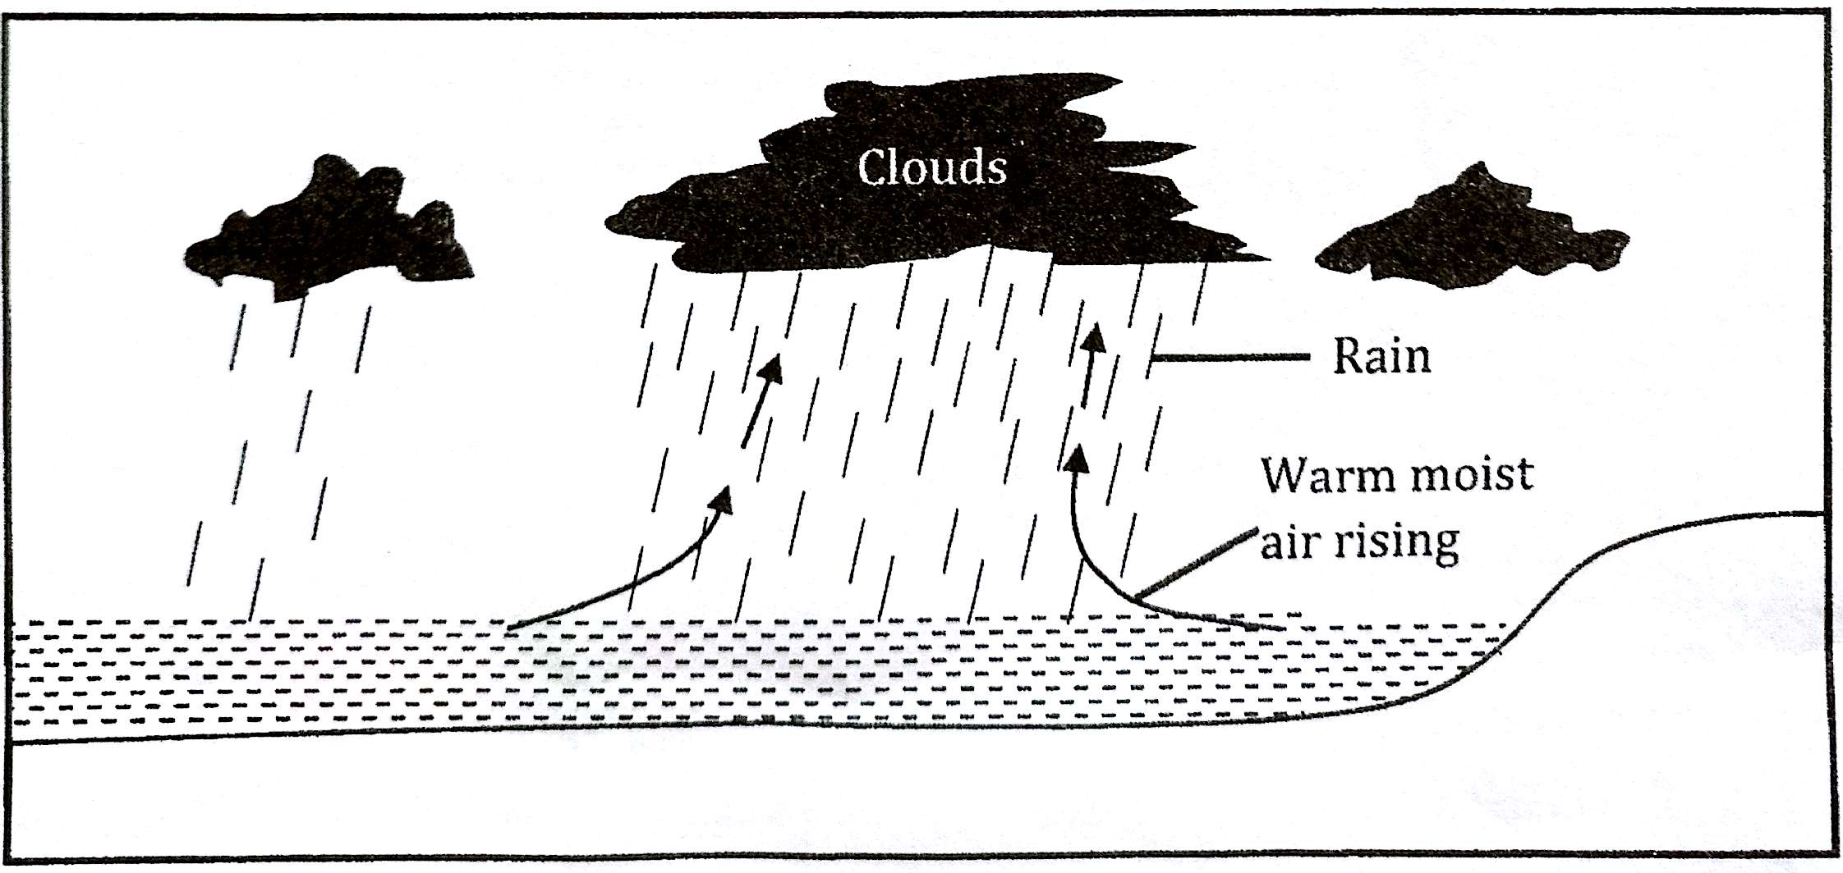
i) Name the type of rainfall represented above. (1mk)
……………………………………………………………………………………………………………………………………………………
ii) Describe how the type of rainfall named in (I) above is formed. (4mks) ………………………………………………………………………………………………………………………………………………………………………………………………………………………………………………………………………………………………………………………………………………………………………………………………………………………………………………………………………………………………………………………………………………………………………………………………………………………………………………………………………………………………………………………………………………………………………………………
iii) State any two characteristics of the rainfall type named. (2mks)
………………………………………………………………………………………………………………………………………………………………………………………………………………………………………………………………………………………………………………
(c) Name the rain bearing clouds. (2mks) ………………………………………………………………………………………………………………………………………………………………………………………………………………………………………………………………………………………………………………
(d) i) state three characteristics of an air mass. (3mks) ……………………………………………………………………………………………………………………………………………………………………………………………………………………………………………………………………………………………………………………………................................................................................................................................................

ii) Name three types of air masses. (3mks)
………………………………………………………………………………………………………………………………………………………………………………………………………………………………………………………………………………………………………………………………………………………………………………………………………………………………………………………………………
(e) The diagram below represents a local wind. Use it to answer questions that follow.
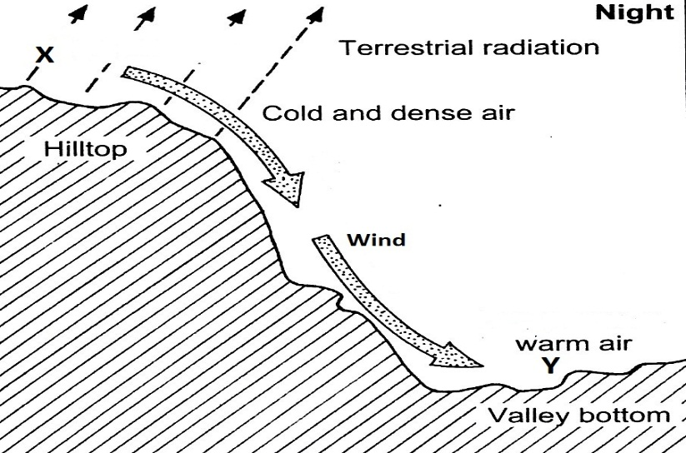
- Name the type of wind represented. (1mk)
………………………………………………………………………………………………………………………………………………
ii) Name the zones marked;
Zone X……………………………………………………………………………………………… (1mk)
Zone Y……………………………………………………………………………………………. (1mk)
iii) Apart from the wind mentioned above, name any three other types of local winds. (3mks) ……………………………………………………………………………………………………………………………………………………………………………………………………………………………………………………………………………………………………………………………………………………………………………………………………………………………………………………………………..
5. (a) What is weather forecasting? (2mks) ………………………………………………………………………………………………………………………………………………………………………………………………………………………………………………………………………………………………………………
(b) State three significances of weather forecasting to human activities. (3mks) ………………………………………………………………………………………………………………………………………………………………………………………………………………………………………………………………………………………………………………………………………………………………………………………………………………………………………………………………………

(c) Give three reasons why data observed in a school weather station may be inaccurate. (3mks)
………………………………………………………………………………………………………………………………………………………………………………………………………………………………………………………………………………………………………………………………………………………………………………………………………………………………………………………………………
6. (a) Define the following terms;
i) Statistics (2mks) ………………………………………………………………………………………………………………………………………………………………………………………………………………………………………………………………………………………………………………
ii) Statistical methods. (2mks) ………………………………………………………………………………………………………………………………………………………………………………………………………………………………………………………………………………………………………………
(b) State any three significances of statistics in the study of geography. (3mks)
……………………………………………………………………………………………………………………………………………………………………………………………………………………………………………………………………………………………………………………………………………………………………………………………………………………………………………………………………..
(c) Name two methods of;
i) Collecting data. (2mks) ……………………………………………………………………………………………………………………………………………………………………………………………………………………………………………………………………………………………………………..
ii) Recording data. (2mks)
………………………………………………………………………………………………………………………………………………………………………………………………………………………………………………………………………………………………………………

