Date done
Invigilator
Date returned
Date revised
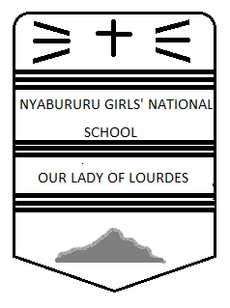
FORM 2 GEOGRAPHY
CAT 1 TERM 3, 2017
TIME: 2 HOURS

Instructions
- Write your name, stream and class number in the spaces above.
- Answer all the questions in the spaces provided below each question.

PAGE | 2 | 3 | 4 | 5 | 6 | 7 | 8 | TOTAL
MARKS

Answer all questions in the spaces provided
- (a) Name two types of environment. (2mks)
……………………………………………………………………………………………………………………………………………………………………………………………………………………………………………………………………………………………………
(b) Identify the branches of Geography in which the following are studied:

(i) Map work……………………………………………………………………………………………………… (1mk)
(ii) Vegetation…………………………………………………………………………………………………… (1mk)
(iii) Agriculture……………………………………………………………………………………………….... (1mk)
(iv) Fishing ……………………………………………………………………………………………………….. (1mk)
(v) Trade…………………………………………………………………………………………………………… (1mk)

2. (a) Give four reasons why it is important to study geography. (4mks)
……………………………………………………………………………………………………………………………………………………………………………………………………………………………………………………………………………………………………
……………………………………………………………………………………………………………………………………………………………………………………………………………………………………………………………………………………………………
(b) List three theories of the origin of the earth. (3mks)
………………………………………………………………………………………………………………………………………………………………………………………………………………………………………………………………………………………………………………………………………………………………………………………………………………………………………………………
(c) State any four proofs that the earth is spherical in shape. (4mks) ………………………………………………………………………………………………………………………………………………………………………………………………………………………………………………………………………………………………………………………………………………………………………………………………………………………………………………………………………………………………………………………………………………………………………………………………………………………………

(d) Name three terrestrial planets within the solar system. (3mks) ………………………………………………………………………………………………………………………………………………………………………………………………………………………………………………………………………………………………………………………………………………………………………………………………………………………………………………………
(b)Give the angle of inclination of the earth : (2mks)
- (i) From its orbit
……………………………………………………………………………………………………………………………………………………….
(ii)From its axis
……………………………………………………………………………………………………………………………………………………….
(c) Give four effects of rotation of the earth. (4mks)
……………………………………………………………………………………………………………………………………………………………………………………………………………………………………………………………………………………………………………………………………………………………………………………………………………………………………………………………………………………………………………………………………………………………………………………………………………………………….
4.(a) Define weather. (2mks)
………………………………………………………………………………………………………………………………………………………………………………………………………………………………………………………………………………………………………………
(b)State any three conditions necessary for the siting of a weather station. (3mks)
……………………………………………………………………………………………………………………………………………………………………………………………………………………………………………………………………………………………………………………………………………………………………………………………………………………………………………………………………...

(c)Study the diagram below and answer the questions that follows:

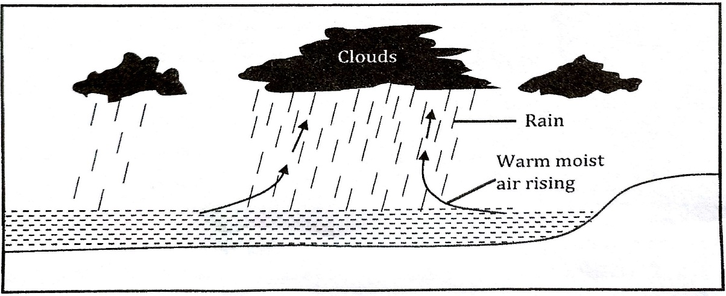
(i) Identify the type of rainfall drawn above. (1mk)
……………………………………………………………………………………………………………………………………………………….
(ii) Apart from the rainfall identify above name two other types of rainfall. (2mks)
………………………………………………………………………………………………………………………………………………………………………………………………………………………………………………………………………………………………………………
(d)Name two low- level clouds. (2mks)
………………………………………………………………………………………………………………………………………………………………………………………………………………………………………………………………………………………………………………
(e)Give three characteristics of the Inter-Tropical Convergence Zone (ITCZ). (3mks)
………………………………………………………………………………………………………………………………………………………………………………………………………………………………………………………………………………………………………………………………………………………………………………………………………………………………………………………………………
5. (a) List three types of maps. (3mks)
………………………………………………………………………………………………………………………………………………………………………………………………………………………………………………………………………………………………………………………………………………………………………………………………………………………………………………………………………
(b)State any four characteristics of minerals. (4mks)
………………………………………………………………………………………………………………………………………………………………………………………………………………………………………………………………………………………………………………………………………………………………………………………………………………………………………………………………………………………………………………………………………………………………………………………………………………………………
(c) Name two examples of hypabyssal rocks. (2mks)
………………………………………………………………………………………………………………………………………………………………………………………………………………………………………………………………………………………………………………
(d) Highlight four factors influencing exploitation of minerals in Kenya. (4mks)
……………………………………………………………………………………………………………………………………………………………………………………………………………………………………………………………………………………………………………………………………………………………………………………………………………………………………………………………………………………………………………………………………………………………………………………………………………………………...
(e) State three uses of soda ash in Kenya. (3mks)
………………………………………………………………………………………………………………………………………………………………………………………………………………………………………………………………………………………………………………………………………………………………………………………………………………………………………………………………………
(f) State three problems associated with mining in Kenya. (3mks)
………………………………………………………………………………………………………………………………………………………………………………………………………………………………………………………………………………………………………………………………………………………………………………………………………………………………………………………………………
6. (a) State any three cause of earth movements. (3mks)
………………………………………………………………………………………………………………………………………………………………………………………………………………………………………………………………………………………………………………………………………………………………………………………………………………………………………………………………………
(b)Name any two types tectonic plate boundaries (2mks)
………………………………………………………………………………………………………………………………………………………………………………………………………………………………………………………………………………………………………………

(c)Outline any three evidences supporting the continental drift theory. (3mks)
………………………………………………………………………………………………………………………………………………………………………………………………………………………………………………………………………………………………………………………………………………………………………………………………………………………………………………………………………
7. (a) Define faulting. (2mks)
………………………………………………………………………………………………………………………………………………………………………………………………………………………………………………………………………………………………………………
(b) Apart from a fault scarp, identify any other two features resulting from faulting. (2mks)
………………………………………………………………………………………………………………………………………………………………………………………………………………………………………………………………………………………………………………
(c)The diagram below shows features formed as a result of folding.
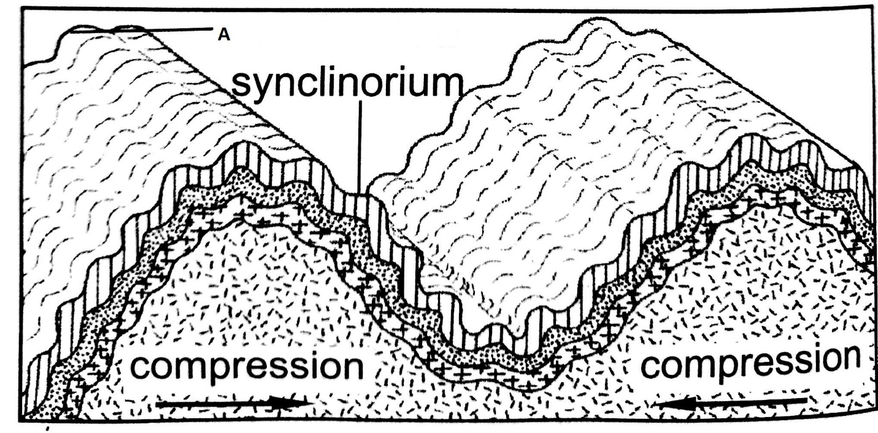
- Identify the type of fold labelled A. (2mks)
……………………………………………………………………………………………………………………………………………………….
(ii) Apart from the fold named in (i) above, name two other types of fold (2mks)
………………………………………………………………………………………………………………………………………………………………………………………………………………………………………………………………………………………………………………
(d) Students from Nyabururu Girls carried out a field study on folding in the area near the school.
(i)Formulate three objectives of their study. (3mks)
………………………………………………………………………………………………………………………………………………………………………………………………………………………………………………………………………………………………………………………………………………………………………………………………………………………………………………………………………
(ii) Give three reasons why a pre-visit would have been important. (3mks)
………………………………………………………………………………………………………………………………………………………………………………………………………………………………………………………………………………………………………………………………………………………………………………………………………………………………………………………………………

(iii)State three importance of carrying out the field study. (3mks)
………………………………………………………………………………………………………………………………………………………………………………………………………………………………………………………………………………………………………………………………………………………………………………………………………………………………………………………………………
8. (a) Identify any three intrusive features of vulcanicity. (3mks)
………………………………………………………………………………………………………………………………………………………………………………………………………………………………………………………………………………………………………………………………………………………………………………………………………………………………………………………………………

(b) Name two types of photographs. (2mks)
………………………………………………………………………………………………………………………………………………………………………………………………………………………………………………………………………………………………………………
9. The table below shows items exported from country Z.
EXPORTS | WEIGHT IN TONNES
Maize  Coffee  Oil cakes  Spices | 12600  9990  1560  750
TOTAL | 24900

(a)On the graph paper provided draw a divided rectangle 15cm long to represent the export items for country Z. (8mks)

(b) Give any three advantages of using a divided rectangle in representing data. (3mks)
………………………………………………………………………………………………………………………………………………………………………………………………………………………………………………………………………………………………………………………………………………………………………………………………………………………………………………………………………

