Date done
Invigilator
Date returned
Date revised
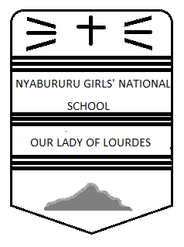
FORM 2 MATHEMATICS
CAT 1 TERM 3 2017
TIME: 2½ HOURS

INSTRUCTIONS
- Write your name, stream and class number in the spaces provided at the top of this page.
- The paper contains two sections i.e. I and II.
- Answer ALL the questions in Section I and II.
- All answers and working must be written on the question paper in the spaces provided below
each question.
- Marks may be awarded for correct workings even if the answer is wrong.
- Mathematical tables may be used where stated or otherwise BUT NOT calculators.

FOR EXAMINER’S USE ONLY.

SECTION I
1 | 2 | 3 | 4 | 5 | 6 | 7 | 8 | 9 | 10 | 11 | 12 | 13 | 14 | 15 | 16 | TOTAL

SECTION II
17 | 18 | 19 | 20 | 21 | TOTAL

GRAND TOTAL

SECTION A (50 MARKS)
Answer all questions in this section.
- Evaluate without using mathematical tables or calculator.
$\frac{0.0084 × 1.23 ×3.5}{2.87 × 0.056}$, expressing the answer as a fraction in its simplest form. (2mks)

- The size of an interior angle of a regular polygon is $3x$ while the exterior angle is $(x-20°)$. Find the number of sides of the polygon. (3mks)

- Use logarithm tables to evaluate (4mks)
$$\sqrt[3]{\left(\frac{0.032 ×14.26}{0.006}\right)}$$

- Two similar cans have different height of 8cm and 10cm. if the surface area of the large can is 480cm², what is the surface area of the smaller can. (3mks)

- The area of the triangle is 24cm² and the lengths of the adjacent sides are 7cm and 12cm. what is the angle between the adjacent sides. (3mks)

- Solve the simultaneous equations below
$$3x +y =7$$
$5x+2y=12$ (3mks)

- Without using mathematical tables or calculator evaluate;
${27}^{\frac{2}{3} }×{\left(\frac{81}{16}\right)}^{- \frac{1}{4}}$ (3mks)

- A hollow cylindrical steel pipe is 1.4m long and has an external diameter of 20cm. if the steel is 1cm thick, find the volume of the steel used in making this pipe. (3mks)

- A straight line through the points A(2,1) and B(4,m) is perpendicular to the line $3y+2x=5.$ determine the value of m. (4mks)

- If $tanθ= \frac{8}{15}$ , find the value of $\frac{sinθ - cosθ}{cosθ + sinθ}$ (3mks)

- Calculate the surface area of a solid cone whose slant height is 10cm and has base radius of 5cm (take $π= \frac{22}{7}$). (4mks)

- Calculate the area of the rhombus whose diagonals are 14cm and 24cm. (3mks)

- Solve for $x; sin3x=cos⁡(x+60)°$ (3mks)

- A worker digs a rectangular farm 35m by 45m. if he should be paid ksh.2000 per hectare, find how much he should be paid. (3mks)

- A teacher had a certain number of books, she gave $\frac{1}{3}$ of the books to Jane and $\frac{1}{4}$ to Lucy. She gave $\frac{1}{10}$ of the remaining books to June. If the teacher was left with 18 books, how many books had she given to Lucy. (3mks)

- Simplify; $\frac{4x-2}{4} - \frac{x-2}{3}$ (3mks)

SECTION B (50 MARKS)
- The sides of a triangle field are 170m, 190m, and 210m. find;
- The area of the field in hectares (5mks)
- The angles of the field (5mks)

- The Figure below shows two intersecting circles with centres A and B and radii 5cm and 4cm respectively. Angle PAQ = 50⁰ and angle PBQ = 65⁰. Calculate the area of the shaded region. (10mks)
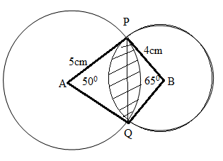

- In 1998 the student population in school B was 600. This was an increase of 25% over the number of students in 1997. The student population dropped by 10% in 1999 bur increased by 20% in the year 2000. Determine :-
- The student population in the;
- Year 1997 (2mks)

- Year 1999 (2mks)

- Year 2000 (2mks)

- Express as a percentage the increase in student population in the year 2000 over the population in the year 1998. (2mks)

- What was the percentage increase in student population between 1997 and 1999? (2mks)

- Use a ruler and pair of compass only for all constructions in this question.
- Construct triangle ABC, such that angle BAC = 75⁰, AC=7cm and AB = 8cm. (5mks)
- Construct the circum circle of triangle ABC and measure its radius (5mks)

- Calculate the volume of the solid frustum given below, giving your answer to four significant figures. (Take $π= \frac{22}{7}$). (10mks)
