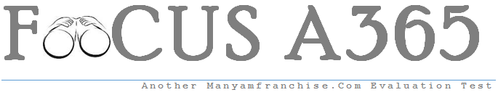

Gatitu Mixed Secondary School
Form 2 | Term 1 | 565 - Business Studies | 08-Jan-16 | Opener

- Distinguish between Economics and Accounting (3MKS)
- Define a promissory note (2MKS)
- Give two disadvantages of an open office (3MKS)
- From where can one obtain business ideas? (4MKS)
- Suggest three ways of protecting business environment (3MKS)
- What is internet?(3MKS)
- Define teleconferencing (3MKS)
- Who are open-air market traders? (3MKS)
- Explain IOU (2MKS)
- What is office etiquette?(2MKS)
- Give two services that are involved in tertiary production (3MKS)
- Describe three differences between hire purchase and deferred payment (3MKS)
- Who are cash and carry wholesalers? (3MKS)
- Explain generating business ideas (3MKS)
- Briefly define;(10MKS)
- Demand
- Want
- Bank draft
- Utility
- website

