DARAJANI BOYS’ HIGH SCHOOL,
P.O BOX 20-90129, NGWATA.

School Motto: “Knowledge is Liberty, Ignorance is Fatal”.

END OF YEAR EXAMINATION, 2015
FORM 2,
CHEMISTRY.
TIME: 2 HRS

NAME:__________________________________________________ADM.NO___________CLASS______
1. The grid below represents part of the periodic table. The letters do not represent the actual symbols.
 |  |  |  |  |  |  |  | A
B |  |  | X | G | P | Z | E | V
 | J |  | I | L | R | T
D | G |  |  |  |  |  | M

- Select the most reactive

- non-metal. (1mk)

- metal. (1mk)

b) Write the formula of the compound consisting of:- (10mks)
- D and Z only.

- X and Z only

- Oxide of B

- Carbonate of J

- Sulphate of D

- Nitrate of B

- Chloride of X

- Sodium compound of E

- Aluminium compound of Z

- Hydrogen compound of G

c) Select an element that can form an ion of charge (10mk)

(i) +1
(ii) -1
(iii) +2
(iv) +3
(v) -3
d) Which element has the least ionization energy? Explain (2mks)

e) To which chemical family do the following elements belong? (3mk)
J

E

B

(f)When a piece of element G is placed in cold water, it sinks to the bottom and effervescence of a colourless gas that burns explosively is produced. Use a simple diagram to illustrate how this gas can be collected during this experiment. (3mks)

(g)Use cross and dot diagrams to show the bonding between element B and E (3mks)

- (i)Compare the atomic radius of element B and D. Explain (2mks)

(ii)Compare the reactivity of element J and G .Explain. (2mks)

2.Define the following terms as used in chemistry:-
a)Alkali (2mks)

b) Hygroscopy. (2mks)

c)Neutralization reaction (2mks)

d) Salt (2mks)

3.a) What is meant by allotropy? (1 mark

b) The diagram below shows the structure of one of the allotropes of carbon

  - Identify the allotrope (1 mark)
………………………………………………………………………………………………………………………………………………………………………………………………..……………………………………………………………………………………………..……….
  - State one property of the above allotrope and explain how it is related to its structure.
(2 marks)
………………………………………………………………………………………………………………………………………………………………………………………………………………………………………………………………………………………………………….

.4. The set-up below shows laboratory preparation of hydrogen gas, use it to answer the questions that follow.

    - Identify two mistakes in the set-up (2 marks)

…………………………………………………………………………………………………………………………………………………………………………………………………………………………………………………………………………………………………………

b) Draw another diagram correcting the mistakes. (3mks)

c)Why is dilute nitric acid not used in preparation of hydrogen gas. (2 marks)
…………………………………………………………………………………………………………………………………………………………………………………………………………………………………………………………………………………………………………
d) Name two uses of hydrogen gas. (2mks)

5. (a) What is rust? (2mks)
(b) Give two methods that can be used to prevent rusting. (2mks)
(c) Name one substance which speeds up the rusting process. (1mk)

6.The diagram below was obtained from a contaminant food sample P. Contaminants Q, R,S, andT are suspected to be in P. Use it to answer the following questions.

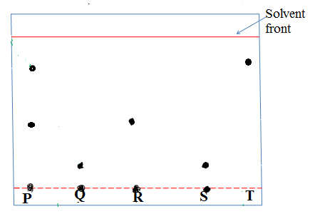
(a)Identify the contaminant in mixture P. (2mks)

(b)Which is the most soluble contaminant in P. (1mk)

7. Explain how you would separate mixture of nitrogen and oxygen gases given that their boiling points are – 196ºC and 183^{O}C respectively. (2mks)

8. The set – up below was used to study some properties of air.
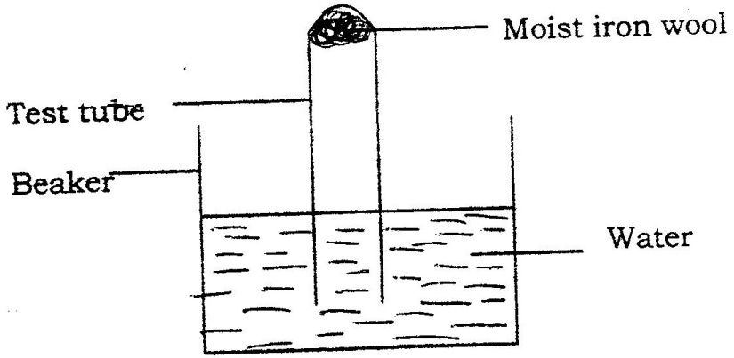

State and explain two observations that would be made at the end of the experiment. (2mks)

9. An element Y has the electronic configuration 2:8:5
a) Which period of the periodic table does the element belong? (1mk)

b) Write a formula of the most stable anion formed when element Y ionizes. (1mk)

c) Explain the difference between the atomic radius of element Y and its ionic radius. (2mks)

10. In an experiment to separate a mixture of two organic liquids, liquid M (b.p 56ºC) and liquid (b.p. 118oC), a student set up the apparatus shown below.
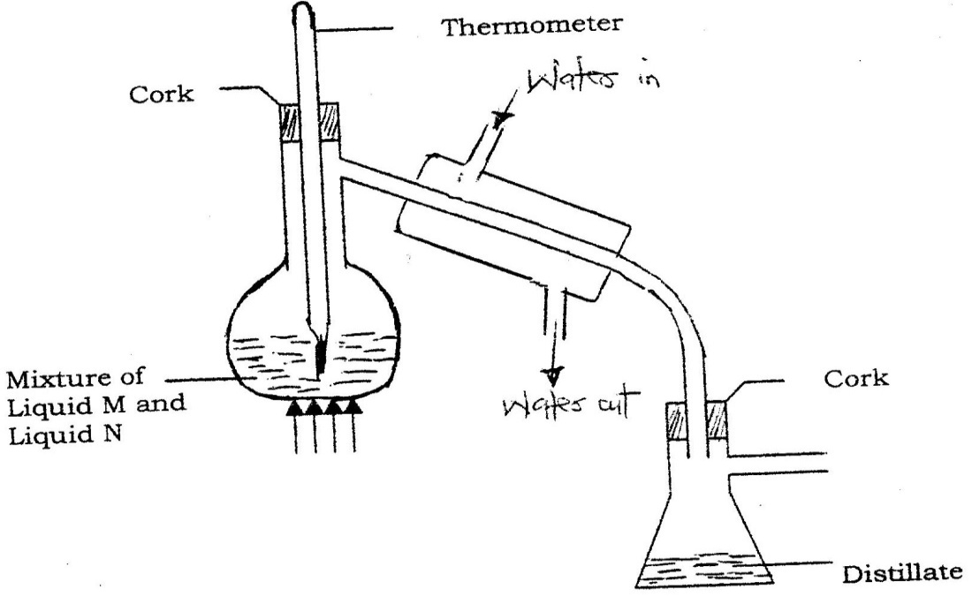

- Identify two mistakes in the set – up. (2mks)

- What method would the student use to test the purity of the distillates obtained? (1mk

11. In an experiment, a piece of magnesium ribbon was cleaned with steel wool. 2.4g of the clean magnesium ribbon was placed in a crucible and completely burnt in oxygen.After cooling the product weighed 4.0g
a) Explain why it is necessary to clean magnesium ribbon. (1mk)

b) What observation was made in the crucible after burning magnesium ribbon? (1mk)

c) Why was there an increase in mass? (2mk)

- Write an equation for the major chemical reaction which took place in the crucible. (2mks)

12. A small piece of sodium metal was placed into a beaker containing water.
I. State three observations made. ( 3mks)

II. Write an equation for the reaction that take place. (2mk)

III. What is the pH of the resulting solution. Explain. (2mks)

13.Study the set- up below and answer the questions that follow
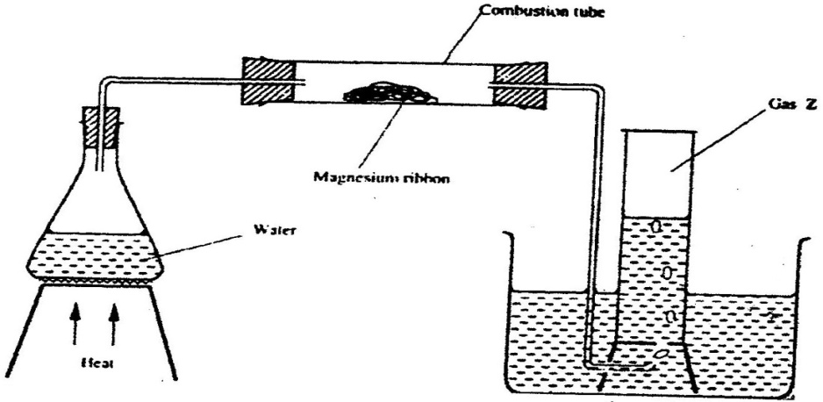

- Write an equation for the reaction, which take place in the combustion tube. (2mks)

(b) What property of gas Z allows it to be collected as shown in the diagram. (1mk)

(c)Name the method of gas collection shown above. (1mk)

(d)Give one observation made on the combustion tube after the experiment. (1mk)

14. The following are observations made from two solid substances x and y.
Solid | Electrical conductivity in solid state | Solubility in water | Boiling point
X | Poor | Insoluble | Sublimes
Y | poor | soluble | high

- State the most likely type of bonding in
  - Solid x …………………………………………… (1 mark)
(ii) Solid y ………………………………………………………………….. (1 mark)
15. When air is bubbled through pure water (PH=7) the PH drops to 6.0. Explain. (2 marks)
.……………………………………………………………………………………………………..………………………………………………………………………………………………………………………………………………………………….………
16. Determine the relative atomic mass of element K whose isotopic mixture occur in the proportions;
(3mks)

******************************END_ALL THE BEST*************************

