MWAKICAN EXAMINATION
END TERM 1 2015
CHEMISTRY FORM 2
TIME 2 Hrs
NAME: …………………………………………………………… ADM NO: ……………….. CLASS: …….
Instructions to candidates: Answer All Questions in the Spaces Provided

  - Two elements R and Q have their ionic configuration 2:8 and 2:8:8. They are found in group I and group 7 respectively in the periodic table. Write down the electronic configuration of their atoms;
    - Q [1 Mark]

    - R [1 Mark]

  - Write the formula of the compound formed when R and Q combine. [1 Mark]

- The table below shows the atomic numbers of element of the periodic table represented by the letters A to H.
(the letters are not the actual symbols for the elements)
Element | A | B | C | D | E | F | G | H
Atomic number | 3 | 7 | 8 | 9 | 11 | 12 | 13 | 14

    - Select 2 elements that would form ions with electronic configuration. (2:8) [2 Marks]

    - Select 2 elements which belong to the same group. [2 Marks]

    - Select one non-metal and one metal from the above table
        - Non-metal [1 Mark]

        - Metal [1 Mark]
    - Give the name of the group to which element E belongs in the periodic table. [1 Mark]

    - Using dots (.) or crosses (x), draw a diagram to show how electrons are distributed in energy levels in Element G. [2 Marks]

    - What is meant by the term “Isotopes”? [1 Mark]

  - The table below shows the PH values of some solutions.
Solution | A | B | C | D | E
PH | 6.0 | 13.0 | 2.0 | 10.0 | 7.0
- Which solution is likely to be
    - Strong base [1 Mark]

    - Neutral Solution. [1 Mark]

- What is the chemical name given to the process that occurs when solutions B and C react together? [1 Mark]

- Give 2 examples of solution A. [2 Marks]

- What are acid-base indicators? [1 Marks]

  - Give examples of 2 acid-base indicators and state their colour changer in acidic and basic solutions. [2 Marks]
Indicator | Colour in Acid | Colour in Base

  - Describe what is meant by Electroplating. [1 Mark]

  - Give two reasons for Electroplating [2 Marks]

  - Hydrogen is prepared in the laboratory by the action of dilute Hydrochloric Acid on Zinc granules.
    - Explain why Nitric (v) acid is not suitable in preparation of Hydrogen gas. [1 Mark]

    - Give any suitable drying agent of Hydrogen gas. [1 Mark]

    - What is the chemical name of the catalyst that is used in this experiment? [1 Mark]

    - Other than hydrogenation, state 2 uses of Hydrogen gas. [2 Marks]

  - Is air a mixture of a compound? Explain [2 Marks]

  - Name three factors that accelerate rusting. [3 Marks]

- Some black ink was subjected to a chromatographic analysis to determine its contents. To do this, it was analyzed alongside known dyes. Red, Green, Yellow and Blue. Study the diagram and answer the questions that follow:

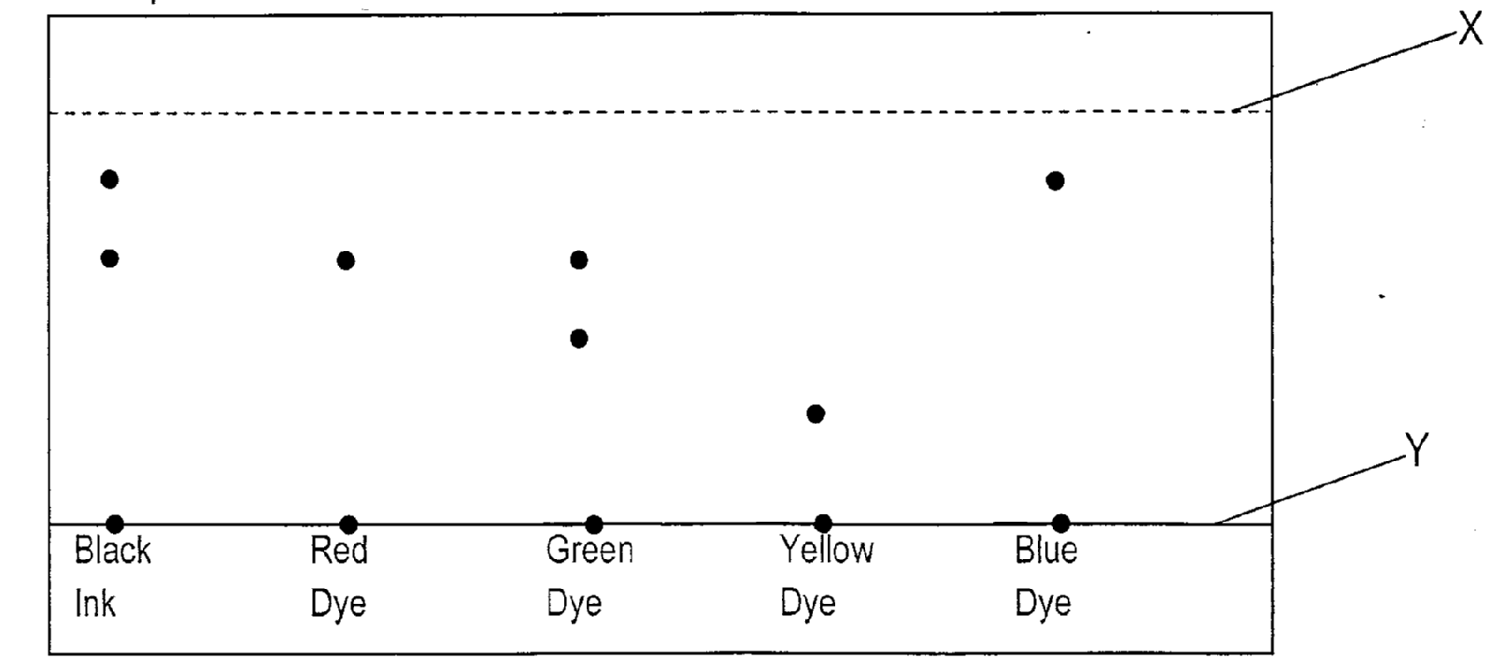
  - Identify lines marked by
    - X [1 Mark]

    - Y [1 Mark]

  - Which of the dye is most absorbed to the absorbent material? Explain. [2 Marks]

  - Which dye is not found in the black ink? [1 Mark]

  - Give one application of chromatography. [1 Mark]

- The table below gives the number of electrons, protons and neutrons in particles A,B,C,D,E,F and G. (letters are not actual symbols of elements)
Particle | Protons | Electrons | Neutrons
A | 6 | 6 | 6
B | 10 | 10 | 12
C | 12 | 10 | 12
D | 6 | 6 | 8
E | 13 | 10 | 14
F | 17 | 17 | 18
G | 8 | 10 | 8
    - Which particle is likely to be a halogen? [1 Mark]

    - What is the mass number of element E? [1 Mark]

    - What is the formula of the most stable ion of element C? [1 Mark]

    - Write the formula of the compound formed when E combines with G [2 Marks]

    - Why do particle B not react with particle D? [2 Marks]

    - How does the atomic radii of C compare with its ionic radius? [2 Marks]

    - Explain why the 1st ionization energy in element C is less than 2nd ionization energy? [3 Marks]

- Study the information in the table below.
Ions | Electron  Arrangement | Ionic  Radius
Na⁺ | 2.8 | 0.133
K⁺ | 2.8.8 | 0.95
Li⁺ | 2 | 0.065
    - Explain why the ionic radius of Na⁺ is greater than that of Na⁺ [2 Marks]

    - The shown ions have their corresponding atoms as follows: Na, K, Li. How does their reactivity down the group compare? [2 Marks]

    - What is the chemical name of the family where Na⁺, K⁺, Li⁺ belong? [1 Mark]

    - The number of neutrons in ion of Na⁺ is 12, determine its mass number of its atom. (Na)
[1 Mark]

- A mixture of kerosene, methylbenzene and water were shaken and left to separate out as shown in the diagram below.
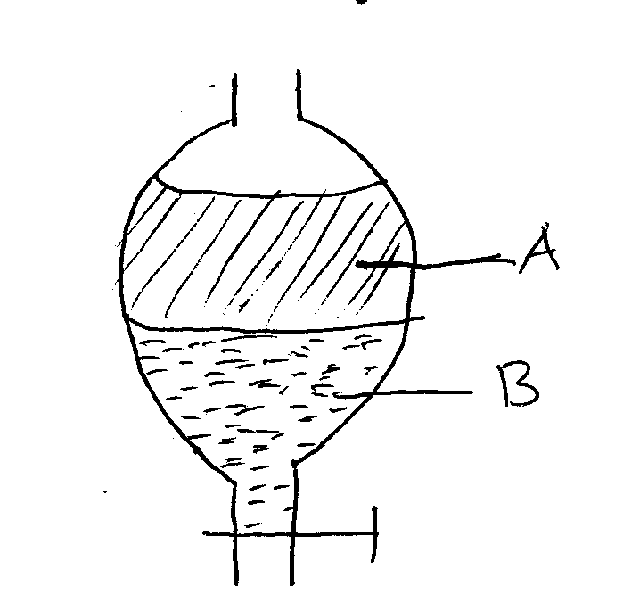

    - Identify liquids A and B [2 Marks]

    - Apart from density, state one property that makes it possible to separate them using the set up above? [1 Mark]

- Use the diagram below to answer the questions that follow.
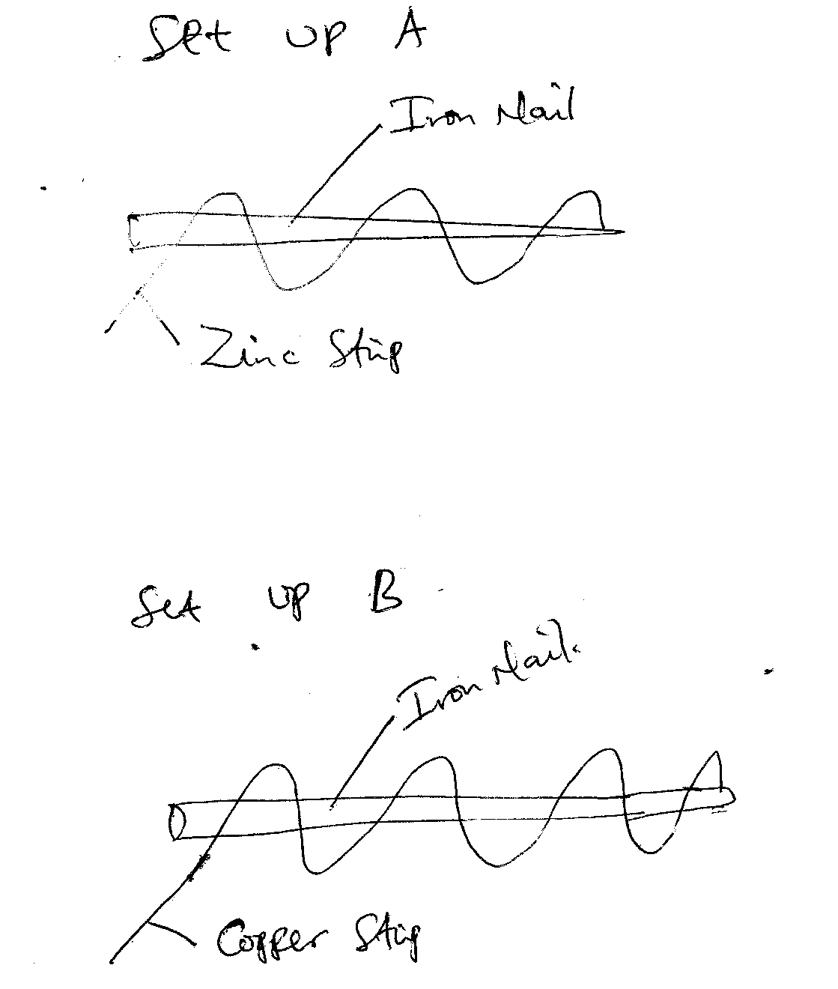
  - In which set up will the iron nail rust? Explain. [2 Marks]

  - What is the name given to the above method of preventing rusting? [1 Mark]

  - What is the chemical name of rust? [1 Mark]

  - Apart from the above method named in Q10, (b). give any other 2 methods of preventing rusting
[2 Marks]

- The diagram below represents the temperature –time curve for solids M and N.
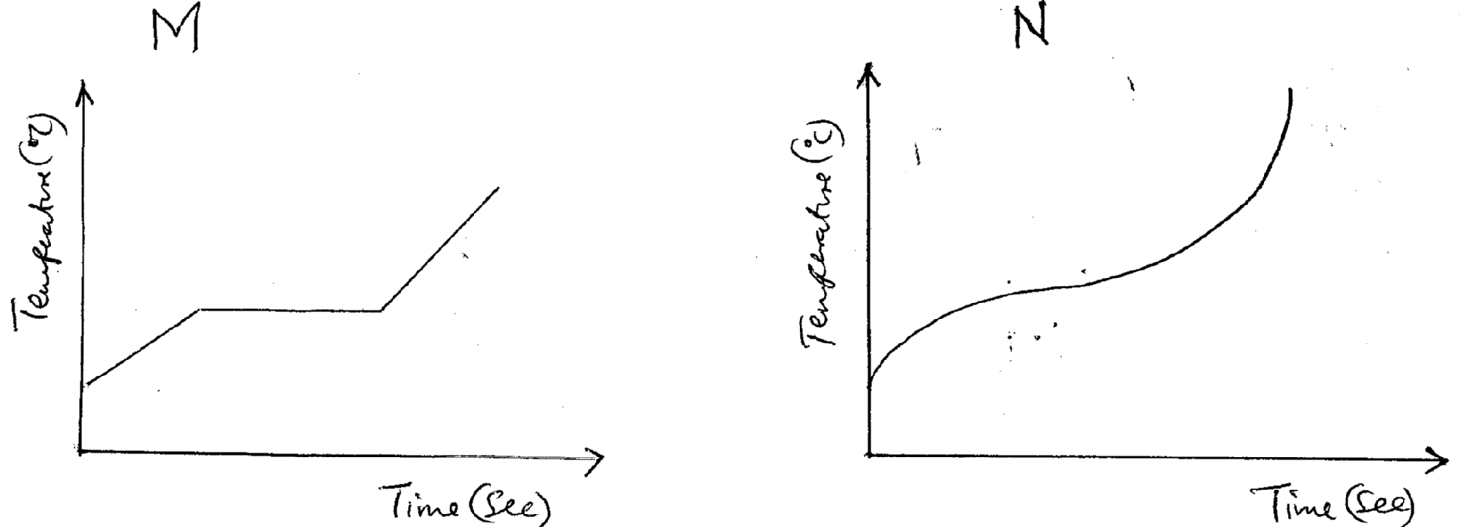
  - What is the name given to the curves above? [1 Mark]

  - Which of the two solids is an impure substance? Explain. [2 Marks]

  - Define what is meant by “heat of vaporization”? [1 Mark]

The R.A.M of element P is 63.5. it has 2 isotopes of masses 63 and 65 respectively. Determine the percentage abundance of each isotope. [3 Marks]

  - The flow chat below is a summary of fractional distillation of air.
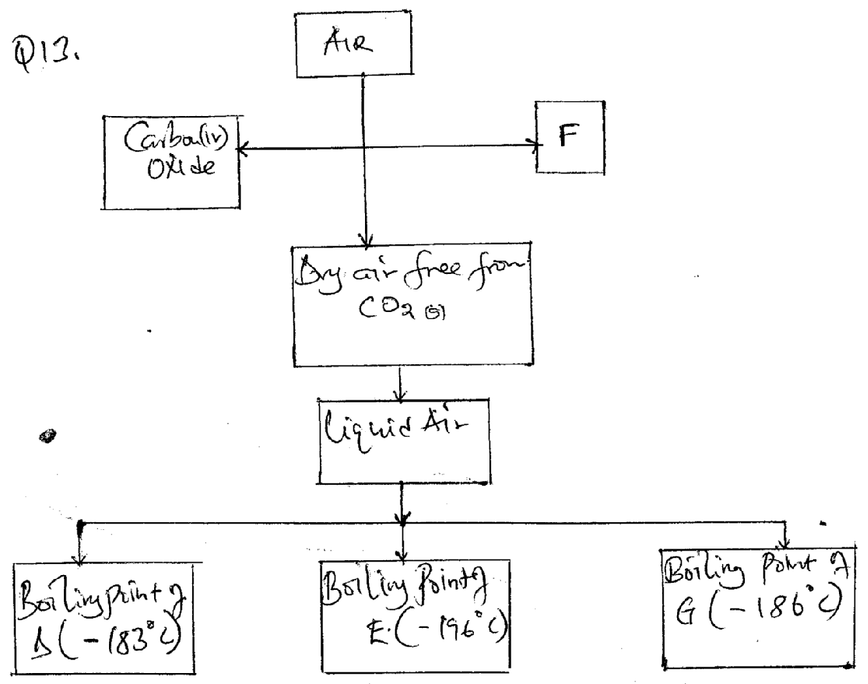
    - Explain how Co₂ is removed in step I [1 Mark]

    - State the form in which F is removed. [1 Mark]

    - Identify products D and E [2 Marks]

    - Explain how dust particles are removed. [1 Mark]

    - Give 2 substances used to remove Co₂ from air. [2 Marks]

    - Give one use of substance G. [1 Mark]

    - What is sublimation? [2 Marks]

    - Name 3 substances that undergo sublimation. [3 Marks]

    - A student was supplied with a colourless liquid and suspected to be water. Describe 2 chemical tests that could be carried out to show that the liquid was water. [2 Marks]
    - Write chemical symbols of the following elements. [2 Marks]
Neon

Aluminium

  - Write the chemical formula for the following compounds. [5 Marks]
    - Calcium Fluoride

    - Aluminium Sulphate

    - Sodium Carbonate

    - Carbon (iv) oxide

    - Potassium Nitrate

  - Balance the following equations;
    - Mg_{(s)} + Hcl_{(aq)} MgCl_{2(aq)+}H_{2(g)} [2 Marks]

    - NaOh_{(aq)+}H₂So_{4(aq)} Na₂So_{4(aq)}+H₂O_{(l)} [2 Marks]

  - Write a balanced equation for each of the following reactions. [1 Mark]
Action of dilute Hydrochloric Acid on Zinc metal.

------------------------------------------------------------END------------------------------------------------------------

