Gatitu Mixed Secondary Sch ool
Form 2 | Term 1 | 233 - Chemistry | 06-Jan-16 | Opener
1. Explain how you would separate a mixture of Nitrogen and Oxygen gases given that their boiling points are
-196⁰C and -183⁰C respectively. (2mks)

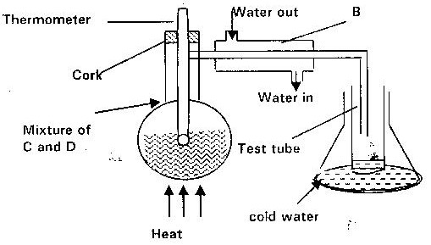
2.The set up below represents apparatus that may be used to separate a mixture of two miscible liquids “C” and “D” whose boiling points are 80^{0C} and 100⁰c respectively.

a) Name B.(1mk)\

b) What is the purpose of the thermometer? (1mk)

c) Which liquid is collected in the test tube? (1mk)

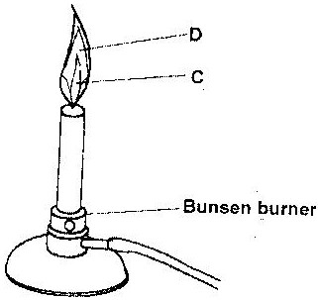
3. The diagram below shows a Bunsen burner when in use.

a) Name the region labelled C and D. (2mks)

4. The graph below is a cooling curve of a substance from gaseous state to solid state.
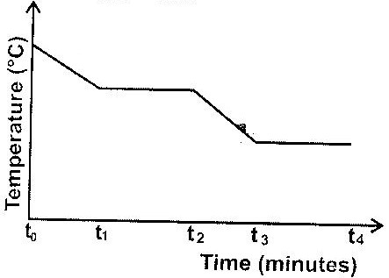

Give the name of the:
a) Process taking place between t₀ and t₁; (1mk)

b) Energy change that occurs between t3 and t4 (1mk)

5. For each of the following experiments give the observation, the type of change that occurs (physical or chemical) and the formula (e) of any substance(s) formed. If no new compound (substance) is formed write no new compound formed.
Experiment | Observation | Type of change | Formulae
Add few drops of concentrated sulphuric acid to small amount of sugar (C_{12H}22O₁₁₎
A few crystals of Iodine I₂ are heated gently in a test tube.
Few crystals of Copper (II) Nitrate are heated strongly in a test tube.
Sodium hydroxide platettes in an evaporating dish are left in humid air for one day.

6a) What method can be used to separate a mixture of ethanol and propanol? (1mk)

b) i) Explain how a solid mixture of sulphure and sodium chloride can be separated into solid sulphur and solid sodium chloride. (4mks)

ii) How can one determine that solid sulphure is pure? (2mks)

c) The table below gives the solubilities of potassium bromide and potassium bromide and potassium sulphate at 0⁰C and 40⁰C.
Substances | Solubilities in g/100g of water
Potassium bromide | 0⁰ | 40⁰
 | 55 | 75
Potassium sulphate | 10 | 12
7. Explain why potassium is kept under paraffin while phosphorous under water. (2mks

8. Study the information below and answer the questions that follow.
Solids | Cold water | Hot water
R | Soluble | Soluble
S | Insoluble | Insoluble
V | Insoluble | Soluble
Briefly explain how you can separate a mixture of solid R, S and V (3mks)

9. Solutions may be classified as strong basic, weakly acidic, strong acidic. The information below gives solutions and their PH values. Study it and answer the questions that follow.
Solutions | PH values
B | 1.5
C | 6
D | 14
Classify the solutions in the table above using the stated classification (3mks)

10. Study the experiment set up represented by the diagram below and answers the question that follows.
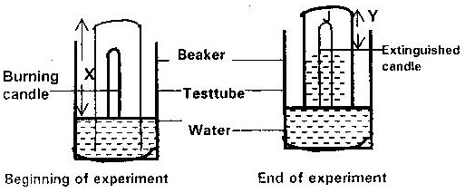

- Explain what would be observed if red and blue litmus papers were dipped into the water at the end of experiment.(2mks)

- Write an expansion in terms of X and Y to show the (%) percentage of gas used by the burning candle (1mk)

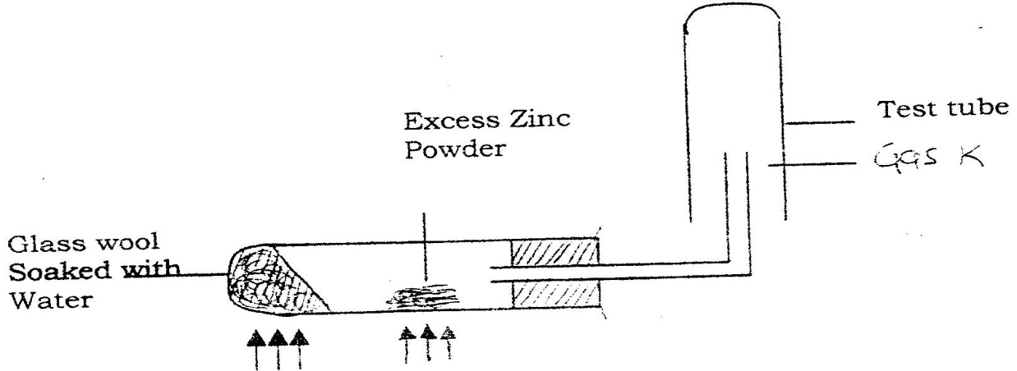
11. A student set up the experiment below to collect gas K. The glass wool was heated before heating the zinc powder.

a) Why was it necessary to heat the moist glass wool before heating zinc powder? (1mk)
b) What would happen if the zinc powder was heated before heating the glass wool? (1mk)
c) What property of gas K made it possible for it to be collected as shown in the diagram? (1mk)

