NAME:…………………………………………………………ADM:…….CLASS:……..
FORM 3
AGRICULTURE
PAPER 1
END TERM 2, 2019

TIME; 2 HRS
INSTRUCTIONS
- This paper contains three sections A, B and C.
- Answer all questions in Section A and B and any two from section C.
- All answers must be written in the spaces provided after the questions

SECTION A (30MKS)
- Name any two physical characteristics used to classify soil. (2mks)

- Name four types of livestock farming. (2mks)

- State four human factors that affect agriculture. (2mks)

- What is the importance of seed dressing in crop production. (1mk)

- State two conditions that may lead to sub-division of land. (2mks)

- Farmer growing maize on 10 hectares is to dress it with sulphate of ammonia (20% N) at the rate. of 120kg of S.A for hectare. AT the local market, S.A is available in 50Kg bag selling at 1500/- per bag. Calculate the amount of S.A the farmer needs to top dress his crop of maize. (3mks)

- Define the following terms. (1¹/₂mks)
- Nursery bed

- Seedling bed

- Seedbed

- State two examples of nitrogenous fertilizers. (2mks)

- State three disadvantages of broadcasting seeds. (1¹/₂mks)

- State four deficiency symptoms of nitrogenous fertilizers. (2mks)

- Give four conditions of the land which may make it necessary to carry out reclamation practices.
(2mks)

- State two mechanical methods of separating soil particles according to size during soil analysis.
(2mks)

- Give four pieces of information contained in a land title deed. (2mks)

- State four effects of post election violence in 2008 to agriculture production. (2mks)

- State two reasons why shifting cultivation has become unpopular in Kenya. (1mk)

SECTION B
- The diagram labeled E and F illustrate some soil structure. Study them carefully and answer the questions that follow.
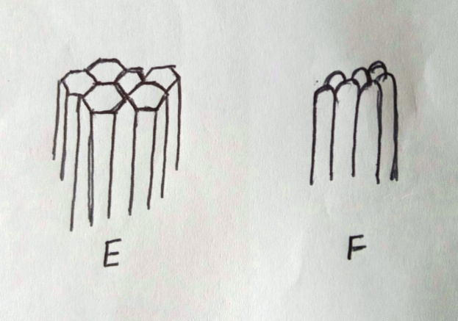

- Identify the soil structure E and F. (1mk)

- List down two field practices which can destroys the structures shown above. (2mks)

- Give two characteristic of a fertile soil. (2mks)

- The diagram below illustrate a compose heap. Study it carefully.

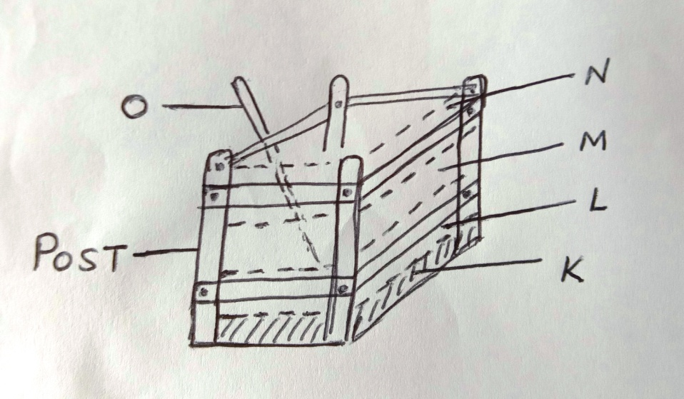
- Name the parts labeled K – N (2mks)
K

L

M

N

- State one use of each of the parts labeled K, M, N and O (2mks)
K

M

N

O

(c ) List four reasons why compost manure is not popularly used in the farm. (2mks)

- Study the diagrams below.
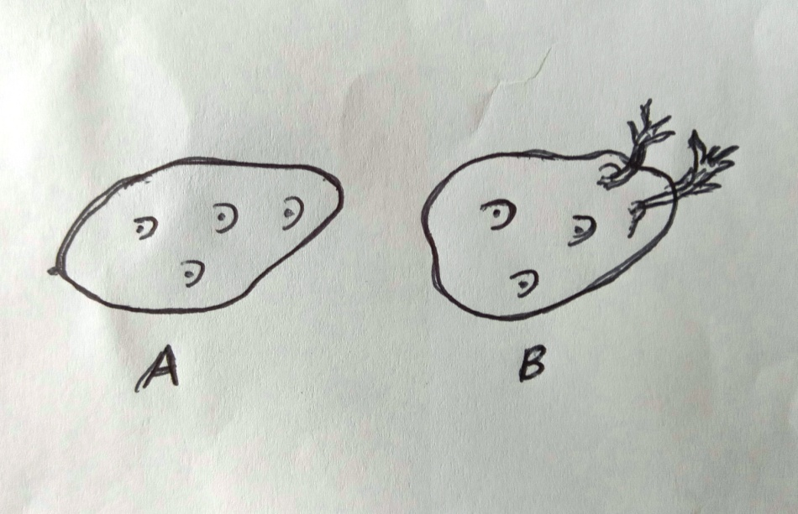
- Name the process used to test Irish potatoes in readiness for planting. (1mk)

- Which of the two is suitable for planting? (1mk)

- Give a reason for your answer in (b) above. (1mk)

- Give two reasons why maize need to be earthed. (2mks)

- (a)State the two types of the multiple stem pruning system in coffee. (2mks)

- Name any two carrot varieties planted by farmers. (2mks)

SECTION C (40MKS)
- (a) Discuss the factors that should be put into consideration while choosing suitable implements for primary cultivation. (8mks)

(b)Describe reasons for drainage as a method of land reclamation in crop production. (10mks)

(c)State two factors that influence mass wasting (2mks)

- a) Discuss ways in which nitrogen is removed from the atmosphere. (8mks)

b) Discuss factors to consider in choosing seed rates (10mks)

c) State two main methods of planting (2mks)

- a) Mention the procedure involved in harvesting fish. (5mks)

b) Discuss four types of soil erosion by water. (8mks)

c) Mention various biological measures employed in soil and water conservation. (7mks)

