NAME……………………………….. ADM NO……………. CLASS………….
END TERM 2, 2019
FORM 3 AGRICULTURE
PAPER 2
TIME: 2 HOURS

SECTION A (30 Marks)
Answer all questions in this section

- Name three methods that are used in selection of breeding stock in livestock production.

(½mks)

- State three signs of heat in pigs. (1 ½ mks)

- State two functions of a queen bee in a colony. (1mk).

4. Name two breeds of sheep kept for dual purpose. (2mks)

5. Give any four advantages of artificial insemination. (2mks)

6. State four methods of identification in livestock. (2mks)

7. Give reasons why roughage is necessary in ruminant animals. (2mks)

8. What is a notifiable disease? (1/2mk)

9. State four qualities of livestock ration. (2mks)

10. Define the following terms. (2mks)

(i) Flushing

(ii) Crutching

(iii) Ringing

(iv) Raddling

11. A part from transmission of disease, give three harmful effects of ticks on cattle. (1½mks)

12. State any four factors considered when siting farm structures (2mks)

13. State four major categories of farm tools and equipment (2mks)

14. State two reasons for proper care and maintenance of farm tools and equipments (1mks)

15. Give the functional difference between a rip saw and a cross cut saw. (1mk)

16. Differentiate between a broiler and a capon (1mk)

17. State two advantages of using embryo transplant. (1mks)

18. Give four reasons for seasoning timber before use. (2 marks)

19. State any four reasons for castrating a goat. (2mks)

SECTION B (20 marks)
Answer all questions in this section
20. If the maize meal contains 6% Digestible Crude Protein (DCP) and Fish meal contains
64% DCP, calculate the amount of each feed stuff in kilograms, required to
Prepare 200kg of chick mash containing 18% DCP (Show your working) (4mks)

21. Study the farm tools below and answer the questions that follow
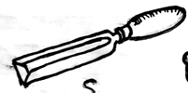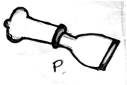

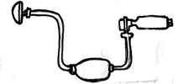

(a) Identify the farm tools labeled S, P, Q and R (2mks)
S
P
Q
R
(b) State the use of each of the tools labeled S and P (1mk)
S

P
(c) Give two safety precaution that should be taken when using the pair of tools Q and R above (1mk)

(d) State two maintenance practices which should be carried out on the tool Q (1mk

22. The diagram below shows parts of a plunge dip.
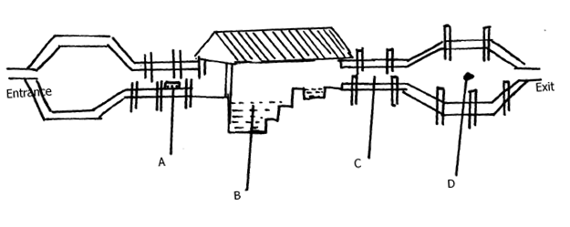
i) Name parts A, B, C and D (2mks)
A
B
C
D

ii) Give two reasons why cattle are held for some time in part C. (2mks)

iii) State two maintenance practices carried out on part B. (2mks)

23. Study the illustration of a camel below and answer the questions that follow
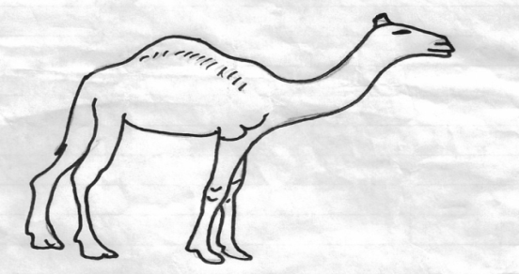

- Name the species of camel shown above (1mk)

(b) Name the environmental condition under which the camel above survives better (1mk)

(c) Give two reasons which make it possible for the livestock to survive in such
environment (2mks)

(d)Name another species of camel other than the one above (1mk)

SECTION C (40MARKS)
Answer any two questions
24 (a) Explain factors to consider during selection of a breeding stock. (10mks)
(b) Give reasons for maintaining a healthy stock on the farm (10mks)
25 (a)Explain ten effects of strong wind on crop production. (10mks)
(b)Describe ten cultural or biological methods of controlling soil erosion. (10mks)
26 a) Draw the differences between the digestive system of a ruminant and a non- ruminant (5mks)

(b) Explain five functions of water in nutrition (5mks)

(c) State ten safety precautions which should be taken when using
Workshop tools in order to prevent injury (10mks)

