FORM THREE
BIOLOGY PRACTICAL
END OF TERM 2 EXAM

NAME ………………………..……………………ADM……………….CLASS……….
Answer all the questions in the spaces provided.

1. You are provided with chemical reagents Q (Iodine solution), R (NaOH), S (CuSO₄), T (DCPIP)and food solution X
Using the reagents provided carry out food test on solution X
(a) Record your results in the table below. (12marks)

Food substance |  | Observation | Conclusion

(b) Suggest the importance of food substance present in solution X in a human body. (2mks)

………………………………………………………………………………………………………

………………………………………………………………………………………………………

2. Below is a photograph of a certain animal. Examine it and answer the questions that follow.
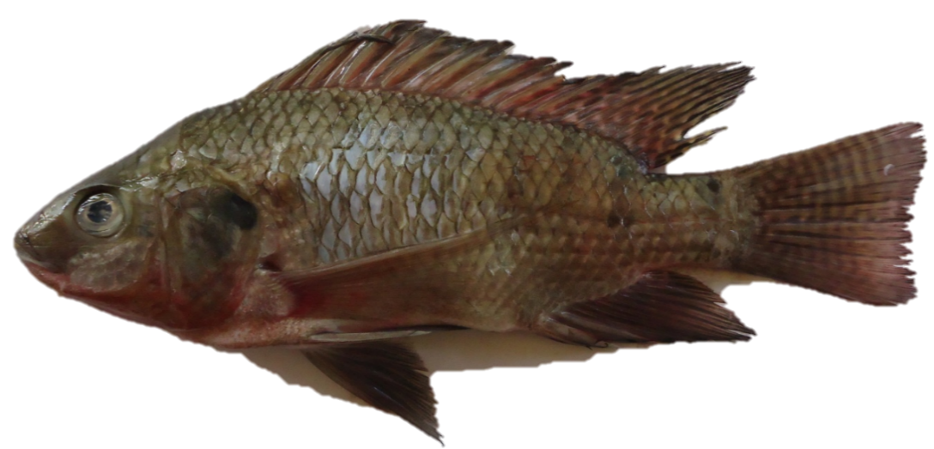

a) Giving a reason in each case, classify the animal into the taxonomic units in the table below. (4 marks)

Taxonomic unit | Name of taxonomic unit | Feature
Phylum
Class

(b)Study the photograph shown below part of animal above.

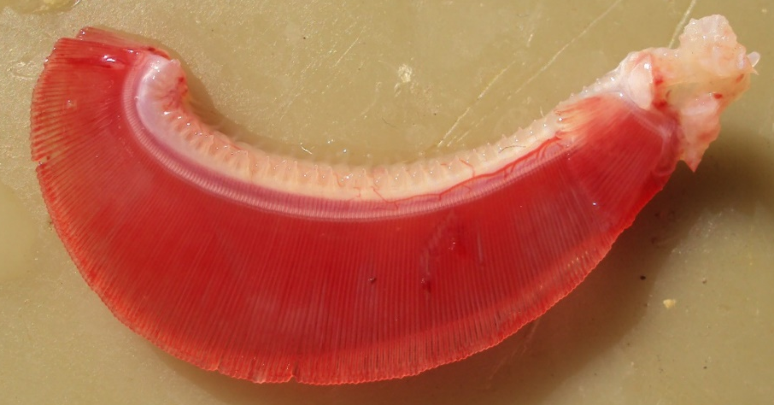
L
G
R
B

List adaptive characteristics of part labeled G to its function. (4mks)

……………………………………………………………………………………………………..

……………………………………………………………………………………………………..

……………………………………………………………………………………………………..

……………………………………………………………………………………………………..
(c).The following illustration shows a flow in the photograph shown above.
N/B; Figures show O₂
SATURATION
15 90
25 45 65
35 70 85
25 100
Blood capillary

(i) Indicate on the illustration the direction of blood and water flow. (1mk)

(ii)Name the type of flow represented in the illustration (1mk)

………………………………………………………………………………………………………

(d)(i)Name the process by which oxygen leaves water into capillaries of filaments. (1mk)

………………………………………………………………………………………………………

(ii)What condition enables an efficient exchange of oxygen by process identified in d(i) above

……………………………………………………………………………………………….(1mk)

(e)The atmospheric air has more oxygen than that dissolved in water yet a fish dies immediately after being withdrawn from water. Explain. (1mk)

……………………………………………………………………………………………………..

3.Study the photographs of plant structures shown below then answer the questions.
X1
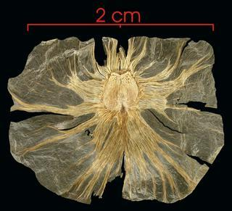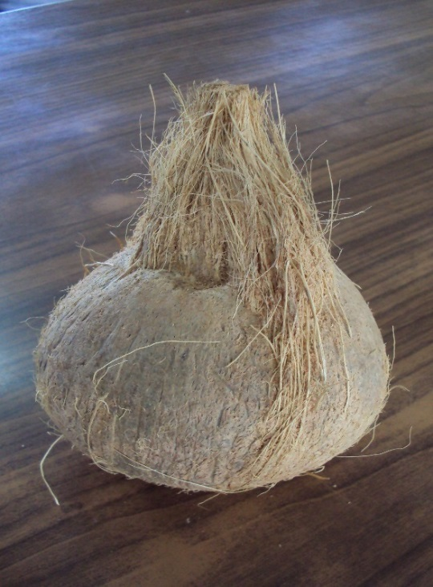
X2
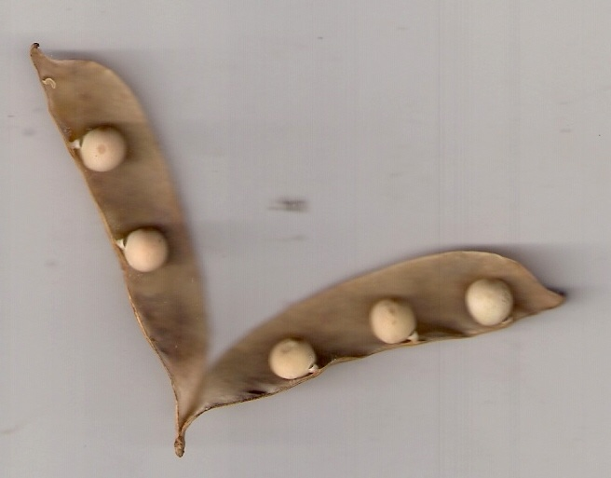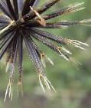
X3
X4
Q

R2

( a)For each type of structure shown above state a dispersal agent (4marks)

Structure | Dispersal agent
X1
X2
X3
X4

(b)Name the observable adaptive features in X1 and X2 that enable them to be dispersed by the dispersal agent identified. (2marks)

Structure | Adaptive features
X1
X2

(C)(i) Give possible description of leaves and roots of plant of flower labeled R2.

Roots………………………………………………………………………….,…….(2mks)

……………………………………………………………………………………………..

Leaves (3mks)

……………………………………………………………………………………………..

……………………………………………………………………………………………..

……………………………………………………………………………………………..

(ii) Flower R2 has polypetalous characteristic. Explain. (1mk)

……………………………………………………………………………………………………..

(iii) Name part labeled Q on X3. (1mk)

……………………………………………………………………………………………………..

