BUSINESS STUDIES
PAPER 1 FORM THREE
MARKING SCHEME

- Define the following terms as used in Business Studies. (4 mks)
- Economics

It refers to the study of how human beings strive to satisfy their unlimited wants using the limited / scarce resources.

- Entrepreneurship

It refers to the process of identifying business opportunity and acquiring necessary resources to maximize the profit.

- Opportunity cost

This is the value of the best next alternative forgone when acquiring or when a choice has been made.

- Scale of preference

It is a list of wants showing the order in which they are satisfied from the most urgent to the least urgent.

- Highlight four features of a good filling system. (4 mks)

- It reduces the effects of hunger.
- It is a source of important minerals for body building
- Protects the body against diseases
- Provides the body with warmth.

- Outline four importance of a warehouse to a consumer. (4 mks)

- It facilitates steady supply of goods by storing surplus goods and releasing them during times of shortages.
- May help them in stabilizing prices as supply becomes continuous.
- Some goods when stored improve in quality to the advantage of consumer.
- It can create employment opportunities to consumers
- Enables the consumers to check on quality of goods before they buy.

- Outline four benefits of a business plan.
- It is a requirement by the financiers.
- Helps in adoptability of a business.
- It is motivating factor to the entrepreneur.
- Helps in the allocation of resources.
- Helps in identifying the strength and weaknesses.

- Highlight four functions of an entrepreneur. (4mks)
- Starts the business.
- Controls the business.
- Makes decion.
- Bears the risks and enjoys the profit.
- Owns the whole project.

- Highlight four ways in which entrepreneurs can observe ethics in the management of their business. (4 mks)

- By having zero tolerance to corruption in business dealings.
- By practicing fair business practices with competitors
- By providing quality goods and services
- By compliance with the country’s laws and regulations.
- By offering fair prices on goods and services to avoid consumer exploitation.
- By not discriminating of employees in terms of gender, religion, ethnicity and race.
- By eliminating use of unfair means of achieving business objectives such as boarding and selling of counterfeit goods.

- The following information was extracted from the books of Dawida business enterprise for the year ended 30th June 2000.

Capital as at 30th June, 2000 640,000
Capital as at 1st July 1999 420,000
Drawing for the year 180,000
Net profit for the year 140,000

Determine the additional capital during the year. (4 mks)

Additional capital = closing capital – opening capital – profit + drawings
I = 640,000 – 420,000 – 140,000 + 180,000
I = 640,000 – 560,000 + 180,000
I = 640,000 + 180,000 – 560,000
I = 820,000 – 560,000
I = 260,000
Additional capital = 260,000/=

- Highlight four barriers to effective communication.(4mks)
- Language barrier.
- Noise
- Prejudgment.
- Poor listening.
- Poor timing.

- Below is a demand and supply curve.
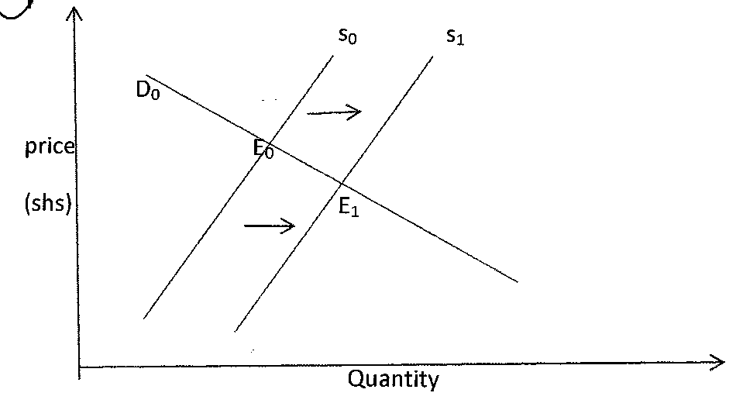
Highlight the factors that may have led to the above behavior. (4 mks)

- Reduction in the cost of production.
- Improvement in the state of technology
- Decrease in prices of other related commodities.
- Favourable government policies like reduction in taxes.
- Conducive climatic conditions.

- Outline four circumstances under which a cheque maybe dishonoured. (4mks)
- If the cheque is stolen.
- If the cheque is postdated.
- Incase the amount in words differs from the amount in figures.
- Incase the signature in the cheque differs from the specimen in the bank.
- Where the cheque is dirtified such that some information is missing.
- Give the difference between: (4 mks)

- Producer’s good and consumers goods.

- Producers goods are those good used to produce other goods e.g. tools,
- Consumer goods are those goods which are at their final stage of usage by consumers e.g. cloths.

- Material goods and non-material goods.
- Material goods are those goods which are tangible.
- Non-materials goods are actions/services that can be sold.

- Highlight four advantages of indirect production.(4mks) (4 mks)

- Leads to high starndards of living.
- High quality and quantity goods are produced.
- It saves time since there is specialization and division of labour.
- Since it encourages invention and innovation, better watter ways of production and practiced which may be cheaper.

- Highlight four methods through which the government get involved in business activities. (4 mks)

- Regulation.
- Training.
- Trade promotion.
- Provision of public utilities.
- Enabling environment
- Highlight four duties of commercial attaches in trade promotion. (4 mks)

- Publish and advertise their country’s exports in business journals and magazines.
- Select buyers, agents and distributors of the home country’s exports.
- Explore and identify new markets for more exports opportunities.
- Research and analyze markets for exports from their home countries.
- Keep statistics of products such as volume s, packaging sizes and methods of manufacturing.
- Assist sales missions from home countries by organizing educational tours for them.
- Inform traders in their home countries of standards required for exports.

- Complete the table below. (4 mks)

Factors of production | Reward
Land | Rent and royalty/rates
Capital | Interests
Labour | Wages and salaries
Entrepreneurship | Profit

- Outline three leakages in a circular flow of income. (3 mks)

- Savings
- Imports
- Taxes

- Outline four advantages of using celebrities in product promotion. (4 mks)

- They help in increasing recognition.
- They influence consumer purchases.
- Build awareness
- Attract new users / customers.
- Breathe life into failing brand.
- Help people in remembering advertisement.
- Makes people believe that the products contributes to superstar stats.
- Helps the product in getting a better position in the market.
- Build brand equity
- Helps the product in getting a better position in the market.

- Distinguish between goods and services. (4 mks)
No. | GOODS | NO. | SERVICES
 | Are tangible |  | Are intangible
 | Can be stored |  | Cannot be stored
 | Can be sdardandized. |  | Cannot be standandized
 | Most are perishable |  | Are highly perishable
 | Can change possession |  | Cannot be separated from the provider.
 | Most can be seen |  | Cannot be seen

- Kenya is planning to extend her pipeline transport. State four advantages of pipeline transport to the country. (4 mks)

- It is economically in labour / requires minimal manpower.
- Environmentally friendly since it is free of noise and smoke.
- Allows for continuous flow of goods being transported.
- Pipeline can be constructed even where it is difficult to construct roads such as rugged terrains.
- Has reduced damage on roads by tankers.
- Reduced delay occasioned by congestion on roads due to tankers
- Maintenance costs are low since it relies on gravitational force and booster stations.
- Not affected by adverse weather conditions.
- Has helped to reduce accidents caused by tankers on roads.

- Outline four emerging issues in office management. (4 mks)

- Use of computers in data processing, storing information and for communication.
- Adopting of open or landscape office layouts.
- The development of customer care departments in organizations to ensure customer satisfaction.
- Provision of cell phone to employees to ensure that they carryout office activities even while away from working stations.
- Traditional procedures and routines are becoming outdated and employees in management does work that could have otherwise have been done by clerks and typist.
- Identification badges
- CCTV security systems

- Kiburu carried out the following transactions during the month of February, 2105.

February 1: Started business by depositing sh 220,000 in business bank account.
7: Bought good on credit from Miyogo sh 72,000.
8: Paid rent by cheque sh 20,000
16: Sold goods to Kamula on credit sh 50,000

Required; Post the above transaction in the relevant ledger accounts.
Dr Capital A/c Cr Dr Bank a/c Cr
 | 1.5.15 bank 220,000 |  | 1.5.15 capital 20,000 | 8.5.15 rent 20,000

Dr Purcahse A/c Cr Dr Miyogo a/c Cr
7.5.15 Miyogo 72,000 |  |  |  | 7.5.15 Purchases 72,000

Dr Sales A/c Cr Dr Kamula a/c Cr
 | 16.5.15 Kamau 50,000 |  | 16.5.15 Sales 50,000

Dr Rent A/c Cr
8.5.15 ban 20,000 |  |  | @ = ½ mark total 4 marks

- Highlight four features of perfect competition market. (4 mks)

- Uniformity of buyers and sellers.
- Perfect mobility of factors of production.
- There is no government interference or intervention.
- Large number of buyers and sellers.
- There is freedom of entry and exit into the industry.
- Both buyers and sellers have perfect knowledge of what is happening in the market.
- There is excess demand or excessive supply.

23. Mention whether the following transactions have an increase, decrease or no effect on the assets, capital and liabilities of a business. (4 mks)

 | Transaction | Assets | Capital | Liabilities
(a) | Bought premises on credit | Increase | No Effect | Increase
(b) | Took stock of goods and donated to a local dispensary | Decrease | Decrease | No Effect
(c) | Withdrew money from bank for office use | No effect | No effect | No effect
(d) | Sold furniture receiving cash | No effect | No effect | No effect
- State the following abbreviations in full.
- GDP. Gross domestic product
- GNP……. Gross national products
- NDP…….. national domestic product
- NNP……. Net national product

