565/1
BUSINESS STUDIES
PAPER 1
END OF TERM 2 2019
TIME: 2 HOURS

Name: _______________________________________ Adm No.: _____________________

INSTURCTIONS TO CANDIDATES

- Write your name and adm. no in the spaces provided above.
- Sign and write the date of examination in the spaces provided above.
- Answer ALL the questions.
- All answers should be written in the spaces provided in this booklet.
- This paper consists of 8 printed pages
- Candidates should check the question paper to ascertain that all the pages are printed as indicated and that no questions are missing.
- Candidates should answer all the questions in English

FOR EXAMINER’S USE ONLY

Question | 1 | 2 | 3 | 4 | 5 | 6 | 7 | 8 | 9 | 10 | 11 | 12 | 13 | 14
Candidate’s score

Question | 15 | 16 | 17 | 18 | 19 | 20 | 21 | 22 | 23 | 24 | 25
Candidate’s score

TOTAL MARKS

- Define the following terms as used in Business Studies. (4 mks)
- Economics………………………………………………………………………………
………………………………………………………………………………………….
- Entrepreneurship………………………………………………………………………..
…………………………………………………………………………………………..
- Opportunity cost………………………………………………………………………...
…………………………………………………………………………………………..
- Scale of preference……………………………………………………………………...
…………………………………………………………………………………………..

- Highlight four features of a good filling system. (4 mks)

- ………………………………………………………………………………………….
- …………………………………………………………………………………………..
- …………………………………………………………………………………………..
- …………………………………………………………………………………………..

- Outline four importance of a warehouse to a consumer. (4 mks)

- ………………………………………………………………………………………….
- …………………………………………………………………………………………..
- …………………………………………………………………………………………..
- …………………………………………………………………………………………..

- Outline four benefits of a business plan. (4 mks)

- ………………………………………………………………………………………….
- …………………………………………………………………………………………..
- …………………………………………………………………………………………..
- …………………………………………………………………………………………..

- Highlight four functions of an entrepreneur.(4mks)

- ………………………………………………………………………………………….
- …………………………………………………………………………………………..
- …………………………………………………………………………………………..
- …………………………………………………………………………………………..

- State four importance of a balance sheet (4 mks)

- ………………………………………………………………………………………….
- …………………………………………………………………………………………..
- …………………………………………………………………………………………..
- …………………………………………………………………………………………..

- The following information was extracted from the books of Dawida businesses enterprise for the year ended 30th June 2000.

Capital as at 30th June, 2000 640,000
Capital as at 1st July 1999 420,000
Drawing for the year 180,000
Net profit for the year 140,000

Determine the additional capital during the year. (5 mks)

- Highlight four barriers to effective communication (4 mks)

- ………………………………………………………………………………………….
- …………………………………………………………………………………………..
- …………………………………………………………………………………………..
- …………………………………………………………………………………………..
- Below is a demand and supply curve.
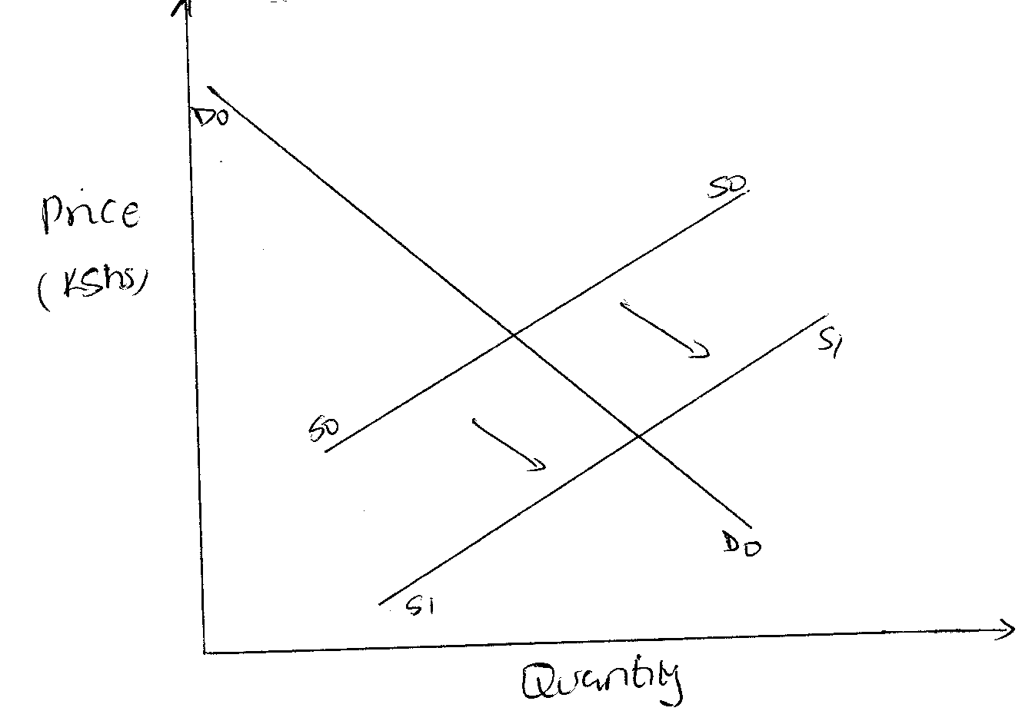

Highlight the factors that may have led to the above behavior. (4 mks)

- ………………………………………………………………………………………….
- …………………………………………………………………………………………..
- …………………………………………………………………………………………..
- …………………………………………………………………………………………..

- Outline four circumstances under which a cheque maybe be dishonoured.
(4 mks)

- ………………………………………………………………………………………….
- …………………………………………………………………………………………..
- …………………………………………………………………………………………..
- …………………………………………………………………………………………..

- Give the difference between: (4 mks)
- Double and co-insurance
………………………………………………………………………………………………
………………………………………………………………………………………………
………………………………………………………………………………………………
- Premiums and surrender value
………………………………………………………………………………………………
………………………………………………………………………………………………
………………………………………………………………………………………………

- Highlight four advantages of indirect production (4 mks)

- ………………………………………………………………………………………….
- …………………………………………………………………………………………..
- …………………………………………………………………………………………..
- …………………………………………………………………………………………..

- Highlight four methods through which the government get involved in business activities. (4 mks)

- ………………………………………………………………………………………….
- …………………………………………………………………………………………..
- …………………………………………………………………………………………..
- …………………………………………………………………………………………..

- Highlight four duties of commercial attaches in trade promotion. (4 mks)

- ………………………………………………………………………………………….
- …………………………………………………………………………………………..
- …………………………………………………………………………………………..
- …………………………………………………………………………………………..

- Complete the table below. (4 mks)

FACTOR OF PRODUCTION | REWARD
Land
Capital
Labour
Entrepreneurship

- Outline three leakages in a circular flow of income. (3 mks)

- ………………………………………………………………………………………….
- …………………………………………………………………………………………..
- …………………………………………………………………………………………..

- Outline four advantages of using celebrities in product promotion. (4 mks)

- ………………………………………………………………………………………….
- …………………………………………………………………………………………..
- …………………………………………………………………………………………..
- …………………………………………………………………………………………..
- Distinguish between goods and services. (4 mks)

GOODS | SERVICES

- Kenya is planning to extend her pipeline transport. State four advantages of pipeline transport to the country. (4 mks)

- ………………………………………………………………………………………….
- …………………………………………………………………………………………..
- …………………………………………………………………………………………..
- …………………………………………………………………………………………..

- Outline four factors that determine the size of a firm. (4 mks)

- ………………………………………………………………………………………….
- …………………………………………………………………………………………..
- …………………………………………………………………………………………..
- …………………………………………………………………………………………..

- Kiburu carried out the following transactions during the month of February 2015.

February 1: Started business by depositing sh 220,000 in business bank account
7: Bought goods on credit from Miyogo Sh 72,000
8: Paid rent by cheque Sh 20,000
16: Sold goods to Kamula on credit Sh 50,000.

Required: Post the above transaction in the relevant ledge accounts.(8mks)

- Highlight four features of perfect competition market. (4 mks)

- ………………………………………………………………………………………….
- …………………………………………………………………………………………..
- …………………………………………………………………………………………..
- …………………………………………………………………………………………..

- Mention whether the following transactions have an increase, decrease or no effect on the assts, capital and liabilities of a business. (4 mks)

 | Transaction | Assets | Capital | Liabilities
(a) | Bought premises on credit
(b) | Took stock of goods and donated to a local dispensary
(c) | Withdrew money from bank for office use
(d) | Sold furniture receiving cash

- State the following abbreviations in full (4mks)

(i)GDP………………………………………………………………………………………….
(ii)GNP………………………………………………………………………………………….
(iii)NDP…………………………………………………………………………………………
(iv)NNP…………………………………………………………………………………………

