NAME………………………………………………….ADM………….CLASS……………
BUSINESS STUDIES, FORM 3, TERM 2 -2019
TIME: 2¹/₂hrs
- a) Discuss five factors that may influence entrepreneurial practice positively in the country. (10mks)
- Positive / good societal attitude
- Government support
- Good peer influence
- Proper education and training
- High number of successful entrepreneurs
- High number of financial institutions
- High level of personal motivations
b) Explain five principals of insurance. (10mks)
- Principal of insuarable interest
- Principal of indemnity
- Principal of utmost good faith
- Principal of contribution
- Principal of subrogation
principal of proximate cause

- a) Explain five benefits of matatu reforms in transport sector.(10mks)
- Less congestions
- Reduction in accidents
- Adequate insurance
- Passengers confidence and safety
- More revenue to the government
- Order in the terminals as illegal touts evacuated
- Less pollutions.
b) Using a well labeled diagram, differentiate between shift in demand curve and movement along the demand curve. (10mks)
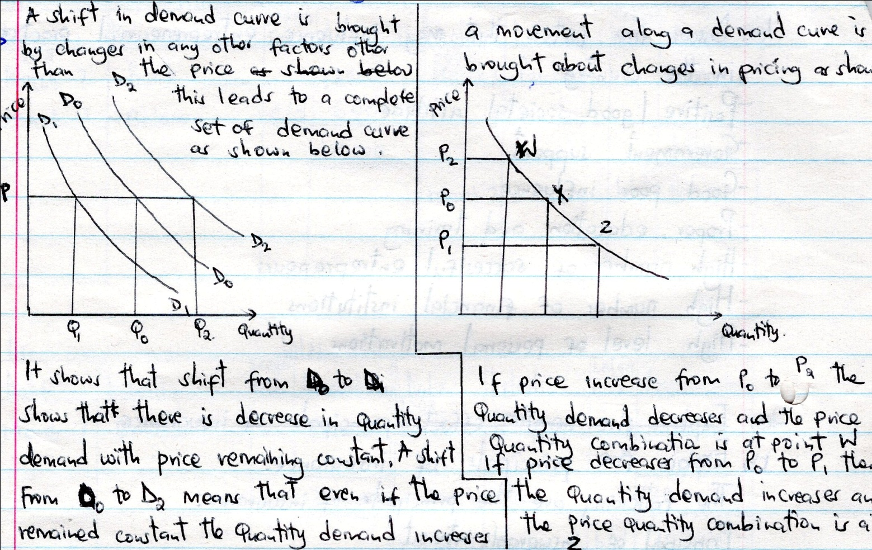
- a) Muema is planning to construct a warehouse for renting. Explain five measures that he may take to ensure its smooth operation. (10mks)
- Suitable location to receive and issue goods
- Proper building suitable to the type of goods to be stored
- Equipment and facilities for handling goods such as forklifts
- Safety equipment for personal protection
- Accessibility to its users near transport system
- Enough space for easy movement and accommodation of goods
- Well trained staff for proper management
- Required of the law
b) Explain five methods used to distribute imported manufactured goods. (10mks)
- Foreign manufacturer – Local consumer
- Foreign manufacturer – Foreign agent/ exporter Local agent Local consumer
- Foreign manufacturer Foreign agent Local agent local consumer
- Foreign manufacturer local agent local consumer
- Foreign manufacturer foreign agent local agent local wholesaler local consumer
- Foreign manufacturer own retail outlet local consumer

- a) Outline five measures that the Kenya government may take to reduce unemployment. (10mks)
- Increase government expenditure to stimulate aggregate demand hence the level of production
- Encourage local private investment to increase productivity
- Diversify the Kenyans economy
- Protect local industries from foreign competition in order to maintain employment level
- Find market for locally produced goods through aggressive export promotion in order to expand production capacities of local industries.

b) Explain five measures that the government may take to increase supply of maize in the market. (10mks)
- Increase subsidies the government parts of the pretition cost, making production move affordable.
- Eliminating quotas on production – by not limiting the quality of good to be produced/ producers are free to supply as much as they can to the market
- Favourable price control – the government fixes the prices of produce at high level which encourages emergence of new producers
- Improving acces to credit – the government extends loans to producers through bodies like KIE/IDDG/ICDG to boast investment in production
- Facilitate marketing – the government may form agencies that buy produce to cushion producer.
- a) Describe any five types of business activities. (10mks)
The following are the main type of business activities
- Extraction – Obtaining goods from their natural settings involved farming lumbering fishing etc
- Processing – Making resources move usefull without combining them with other eg maize milling.
- Manufacturing – Combining a number of resources to come up with a final product such as banking.
- Construction – Building of structures houses roads etc
- Direct personal services – Teaching nursing etc
- Commercial services – banking warehousing etc
Any five business practices well elaborated @2mks.

b) Munguti, who runs a retail store, had the following assets and liabilitie as at 31st March 2016.
Premises Sh. 100,000
Debtors Sh. 4,000
Creditors Sh. 16,000
Stock Sh. 2,000
Cash at bank Sh. 60,000
Cash in hand Sh. 20,000
Loan from AFC Sh. 50,000
During the month of April 2015, the following transactions took place
2015
April 1st sold goods at cost Sh. 2000cash
April 2nd Paid creditors Sh. 8000 cash
April 10th received Sh. 2000 from his debtors in cash
April 15th Bought a motor van for Sh. 35,00 paying by cheque
April 25th purchased goods worth Sh. 15000 and paid by cheque
Required: Prepare a balance sheet as at 25th April 2015. (10mks)
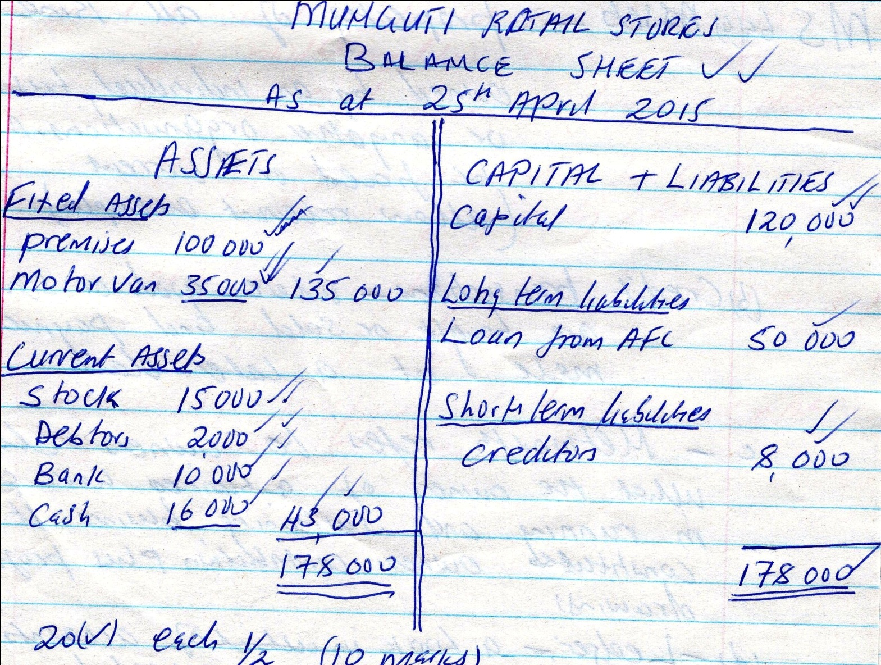

- a) Describe the following terms as used in accounting.
- Assets - Propert of all kind owned by an individual, business or anyother organization may be fixed or current (allow relevant examples)
- Credit transactions. – Where goos or services are bought or sold and payment is made at a later date
- Networth of a Business. – refers to owner claim what the owners of a business have contributed in running and sustaining business it constitutes owners contribution plus profits less drawings. (2mks)
- Ledger.- a book of accounts where all transactions are recorded (2mks)
b) Muinamo started a business on 1st March 2012 with a capital of 240,000 consisting of Sh. 130,00 in bank, Sh. 50,000 in cash and furniture worth Sh. 60,00. Transactions for the first week were as follows;
2012: March 2nd purchased a typewriter by cheque Sh. 20,000
March 3rd bought delivery van for Sh. 450,000 from Mwangaza motors on
Credit
March 4th Bought stock worth Sh. 15,000 for cash
March 5th Purchased goods worth Sh. 18,000 from Kinyua on credit
March 6th sold goods worth Sh. 30,000 on credit to Menge
March 7th paid 12,000 to Kinyua by Cheque
March 7th received Sh. 4,000 for rent by cheque
Required: Record the above information in the relevant ledger accounts and balance them off on 7th March 2012. (10mks)

