Name: ……………………………………………………… Adm No. ……………………………
Class: ……………………………………………………. Date: …............................................

233/1
CHEMISTRY
PAPER 1
FORM III
END TERM 2 EXAMS
Time: 2 hours

233/1
CHEMISTRY
FORM III

INSTRUCTIONS TO THE CANDIDATES:-

- Write your name and admission number on the spaces provided.
- Answer all the questions in the spaces provided.
- Mathematical tables and electronic calculators may be used
- All working MUST be clearly shown where necessary.

Question | Maximum score | Candidate’s score
1-30 | 80

This paper consists of 10 printed pages. Candidates should check to ascertain that all pages are printed as indicated and that no questions are missing

- The diagram below shows Chromatograms for five different dyes.
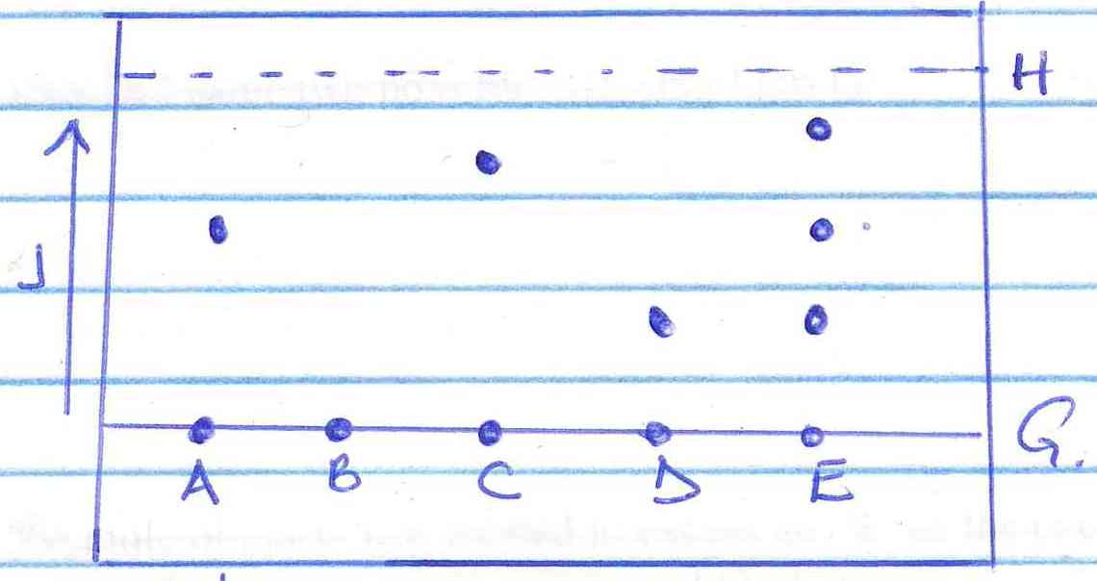

- Name one condition required to separate the chromatograms present in a dye. (1 mk)

- What is meant by the solvent front? . (1 mk)

- Which chromatograms are present in dye E. (1 mk)

- Name two industrial applications of chromatography. (2 mks)

- An element Y has the electronic configuration 2.8.5
- Identify its period ________________________________________________ (1mk)

- Write a formula of the most stable anion formed when U ionizes. (1mk)

c) Explain the differences between the atomic radius of element Y and its ionic radius. (2mks)

- a) What is meant by allotropy? (1 mark)
………………………………………………………………………………………………………......
……………………………………………………………………………………………………..........
b) The diagram below shows the structure of one of the allotropes of carbon

  - Identify the allotrope (¹/₂ mk)
…………………………………………………………………………………………………….

  - State one property of the above allotrope and explain how it is related to its structure. (1½mk)
……………………………………………………………………………………………………….
…………………………………………………………………………………………………….

- Study the flow chart below and answer the questions that follow.
White precipitate X
Metal oxide Add
NH_{3 (aq)}

Add
NH_{3 (aq)}
Colourless Solution Y

- Identify the metal oxide. (1mk)

- Write an ionic equation leading to the formation of the white precipitate X. (1mk)

- Give the formula of the ions responsible for the colourless solution Y. (1mk)

- a) Apart from their location, state any two differences between a proton and an electron.(2 mks)

(b) Protons and neutrons are found in the nucleus of an atom. State two important roles played by of neutrons in the nucleus of an atom. (2 mks)

- Give equations to show the reactions that take place when;
- Iron reacts with steam. (1 mark)

(b) Name and give one industrial use of the gas produced in the reactions in (i) above. (2mks)
Name:
Use:

- 20cm³ of an unknown gas Q takes 12.6 seconds to pass through small orifice.10cm³ of oxygen gas takes 11.2 seconds to diffuse through the same orifice under the same conditions of temperature and pressure. Calculate the molecular mass of unknown gas Q (O=16). (3mks)

- A compound of carbon, hydrogen and oxygen contains 71.12g by mass of oxygen, 2.2g hydrogen and the rest is carbon. It has relative molecular mass of 90.
a) Determine the empirical formula of the compound. (3mks)

b) Determine the molecular formula of the compound. (2mks)

- Study the information in the table and answer questions that follow:
Isotope  ₆₉  R₁  ³¹ | Relative abundance %
₇₁  R₂  ³¹ | 61.3  38.7
(a) Determine the number of neutrons of R₁ (1mk)

(b) Calculate the relative atomic mass of element R. (2mks)

- (a) Identify the type of bond formed in (i) and (ii). (1mks)

- (II)
(I)…………………………………………………..

(II)…………………………………………………..

- Use dot (.) and cross (x) diagram to draw the structure of Sulphur (IV) oxide. ( 2marks)

- Complete the table below. (3 mks)

Element | Latin Name | Symbol
__________________ | Plumbum
Copper | _______________ | Cu
Potassium | ________________ | K
Tin |  | Sn

- (a) State Gay Lussac’s law. (1mk)

b) What volume of oxygen will be required for complete combustion of 100cm³ of carbon (II) oxide. What is the volume of the product formed (All volumes at same temperature and pressure). (2mks)

- If 25.0cm³ of 0.1 M H₂SO₄ solution neutralized a solution containing 1.06g of sodium carbonate in 250cm³ of solution, calculate the molarity and volume of the sodium carbonate solution used. (3mks)

- (i) State Charles’ law. (1mk)

(ii) The capacity of a balloon to hold a gas at 5ºC is 1dm³ before it bursts due to expansions show whether it will burst or not at 35ºC at constant pressure. (2mks)

- What is the colour of the following?
Metal oxide | Colour when hot | Colour when cold
Zinc oxide | (i) | (ii)
Lead (II) oxide | (iii) | (iv)

(4mks)
- Form two students from Anestar Premier High School reacted three elements as shown in the table below
Element | Reaction with Oxygen | Reaction with water
X | Formed acidic oxide | No reaction
Y | Formed basic oxide | Formed soluble hydroxide gave off hydrogen gas
Z | Formed acidic oxide | Dissolved to form an acidic solution
Which element (s) is likely to be: (3mks)
- Non-metal (s)

- Metal (s)

- Insoluble in water

- State the function of the following parts of a Bunsen burner (3mks)
- Air hole

- Collar

- Base

- Study the flow chart below and answer the questions that follow
H₂O
O₂
Platinum
Ammonia
Gas X
Nitrogen (II) oxide
Nitrogen (IV) oxide
G & J
(aq)

- Identify gas X (1mk)

- Write an equation for the reaction between ammonia and gas X (1mk)

- Write an equation to show the formation of G and J (1mk)

- The diagram below shows the effect of sunlight on chlorine water
Sunlight

Gas W

Chlorine water

- Identify gas W (1mk)

- Write an equation to show the formation of gas W (1mk)

- What compounds are present in chlorine water? (1mk)

- Which compound is left in the beaker after complete formation of gas W? (1mk)

- Study the table below and answer the questions that follow
Element | Atomic number | Atomic radius | Ionization energy
K | 3 | 0.089 | 1800
V | 11 | 0.136 | 1450
T | 19 | 0.174 | 1150
- Define the term ‘ionization energy’ (1mk)

- Explain the trend in the ionization energy from element K to T (2mks)

- Compare the trend in the melting and boiling points of elements K and T. (2mks)

- Explain using chemical means how you would differentiate between carbon (II) oxide and carbon (IV) oxide. (2mks)

- The following diagram shows the effect of electric current on lead (II) Chloride.

a) When the circuit was completed no current flowed. Explain why. (1mk)

b) When lead (II) Chloride was heated to about 300⁰C, it melted and there was light on the bulb. State and explain the observation made at the anode. (2mks)

- The set-up below shows the products formed when solid lead (ii) nitrate is heated.

Heat gas yY

Lead II Nitrate
Crystals-

liquid X ice cold water
a) Identify:
(i) Liquid X …………………………………………………………… (1 mark)

(ii) Gas Y…………………………………………………………… ( 1 mark)

b) When lead (ii) Nitrate crystals are heated, they decrepitate and decompose, what is meant by the term decrepitating? (1 mark)
……………………………………………………………………………………………………………………………………………………………………………………………………………………

- Calculate the number of Al³⁺ ions released when 30cm³ of 0.1M of Aluminium Sulphate is dissolved in water. (L = 6.024 x 10²³). (3mks)

