GEOGRAPHY PAPER 1
FORM THREE
END OF TERM 2 – 2019
TIME: 2 ¾ HOURS.

MARKING SCHEME:

SECTION A: (Answer all questions in this section)
- (a) Give two components of the solar system. (2mks)
  - the sun
  - the planets
  - Asteroids.
  - Meteors.
  - Comets.

(b) State three effects of the movement of the earth around the sun. (3mks)

  - Change the position of the midday sub at different times of the year.
  - Varying length of day and night.
  - Causes the four seasons.
  - Causes the lunar eclipse.

- (a) How does a land breeze occur? (2mks)
This is the movement of the cool air from the land to the sea.

(b) Name three ocean currents found on the coasts of West Africa. (3mks)

  - Benguela currents
  - Guinea currents
  - Cannary currents

- The diagram below represents a barchans, use it to answer question (a).

- (i) Name the feature marked X. (1mk)
Horns

(ii) The air current marked Y. (1mk)
Eddy current

(iii) The slope marked Z. (1mk)
The steep concave leeward slopes.

- State two ways in which wind transports its loads. (2mks)
  - Suspension
  - Saltation
  - Surface creep

- The diagram below shows a composite volcano.

- Name the features marked P, Q, R. (3mks)
P – Crater
Q – Lava layers
R – Dyke

- Give two ways in which vulcanicity influences human activities. (2mks)
  - The lower slope are suitable for agricultural activities.
  - Scenic beauty, the mountains attracts tourists.
  - Expose minerals which are mined.

- (a) What is the difference between ice sheet and ice berg? (2mks)
An ice sheet is a large continuous mass of ice covering a vast area of land while an iceberg is a large mass of ice a floating in a large water bodies.

(b) Name three types of glacier moraine. (3mks)
  - Laterial moraine
  - Medial moraine
  - Terminal moraine
  - Ground moraine.

SECTION B:
Answer question 6 and any other TWO questions from this section.

- Study the map of Oyugis 1:50,000 (sheet 130/1) provided and answer the following questions.
- (i) What is the four figure reference of Kokungu dam? (2mks)
7134
(ii) What is magnetic variation of the map? (1mk)
Oº52’
(iii) Calculate the area covered by Kodera forest. Give your answer in square kilometer. (2mks)
14 half square = $\frac{14}{2}=7.0km∓{1 km}^{2}$

- Draw a square 10cm by 10cm to represent the area enclosed by Easting 84 and 94 and Northing 28 and 38. (1mk)

On the square, mark the name;
- Forest (1mk)
- Swamp. (1mk)
- District Boundary. (1mk)
- Range. (1mk)
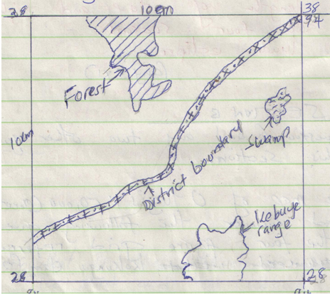

- Describe the relief of the area covered by the map. (6mks)
  - The highest point is approximately 6025 feet (6001-6049), while the lowest point is slightly 3750 feet.
  - There are many hills in the area.
  - There is a pass between Nyatworo and Nyandiere hills.
  - The eastern part has many river valleys.
  - The south west region is undulating due to widely spaced contours.
  - The south eastern part is highly descended due to many river valleys.

- Identify three social service of Kamangambo trading centre. (3mks)
    - Educational services
    - Health services.
    - Religious services.

- Citing evidence from the map, explain three factors that favour farming. (6mks)
  - High rainfall evidenced by many rivers offer suitable conditions for growing crops.
  - Labour evidenced by dense settlements offering labour during farming of crops.
  - Transport evidenced by many roads that facilitate transportation of the crops from the farm to the factory for processing.

- (a) (i) Apart from the Rift valley, name other relief feature formed as a result of faulting. (3mks)
  - Fault scarp
  - Block/ horst mountain.
  - Tilt block.

(ii) With the aid of a well labeled diagram, describe how Rift Valley may have been formed by tensional forces. (8mks)

  - layers of the rocks are subjected to tensional forces when there is some instability within the earth’s crust.
  - Line of weakness occur leading to development of adjacent normal faults.
  - The central block eventually sinks as the side blocks are pulled apart.

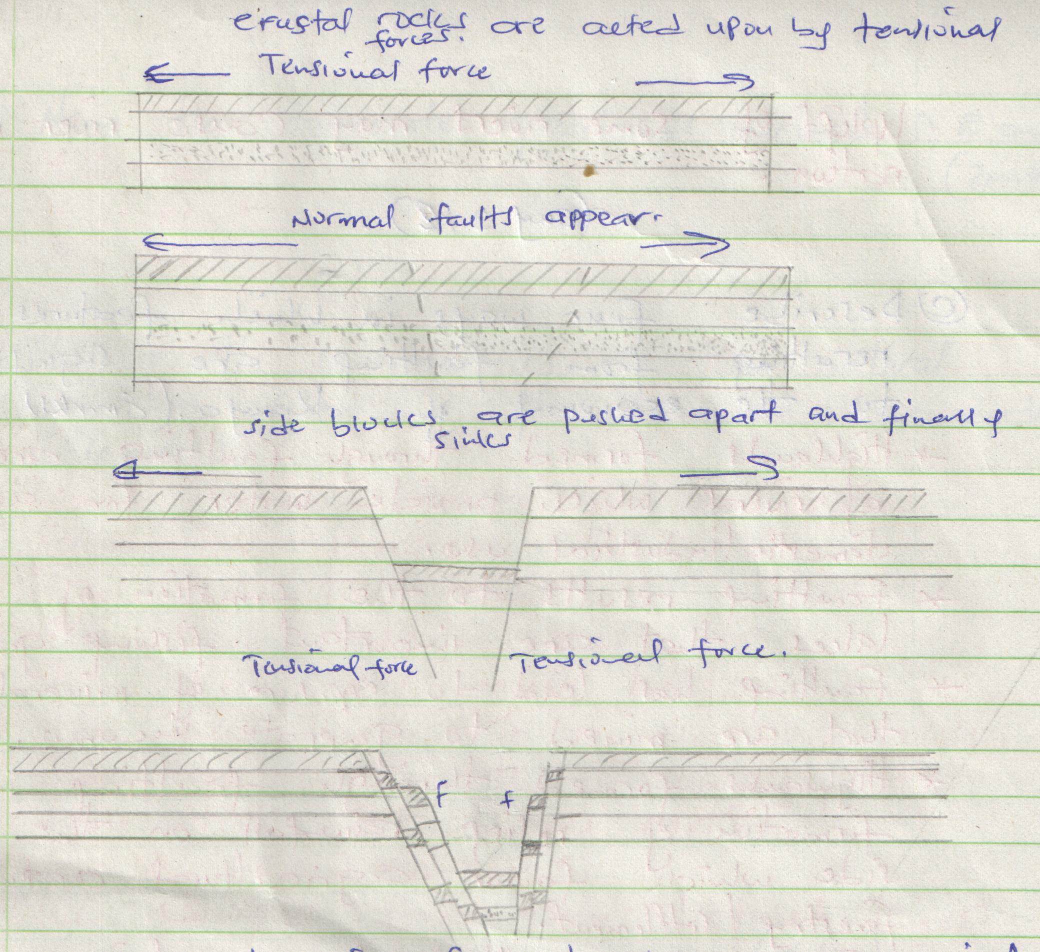

(b) Explain three ways in which faulting influences drainage system. (6mks)
- Uplifting landscape which may cause a change of flow of a river.
- Vertical faulting across a river may cause change of the base level resulting in the formation of waterfalls.
- Some rivers may disappear into the ground through fault guided drainage patterns.
- Some rivers may disappear into the ground through a fault forming underground stream.
- Uplift of some rivers may cause river rejuvenation.

(c) Explain four ways in which features resulting from faulting are of significance to the economy of Kenya. (8mks)
- Highlands formed through faulting are sources of rivers which provide water for agriculture, domestic and industrial use.
- Faulting has led to exposure of minerals that are mined to generate income.
- Faulting results to the formation of Lakes that are important fishing grounds.
- Highlands formed through faulting influence formation of relief rainfall on the windward sides which favour farming.
- Faulting has resulted to formation of deep faults which are passage of stream jets that are harnessed to generate electricity.

- (a) What is natural vegetation? (2mks)
Natural vegetation is a plant cover that grows wildly on the earth surface without interference from man and his animals.

(b) Name the temperate grassland found in the following countries.
- Canada. (1mk) - Prairies
- Russia (1mk – Steppers
- Australia. (1mk) – Downs

(c) Explain how precipitation influences distribution of vegetation in an area. (4mks)
- Moisture is an essential commodity for survival of plants.
- It is the various forms of precipitation which provide moisture to plants through the soil.
- The amount of rainfall a region receives determines the type of plants that would grow.
- Heavy rainfall in a region of high temperature would support vegetation grown.

(d) Describe the characteristics of the Savannah vegetation region. (6mks)
- Savannah vegetation is a mixture of trees and grass.
- The dominant type of vegetation is grass.
- Most of the trees are umbrella shaped.
- Most trees are acacia.
- Most of the trees are deciduous.
- Some trees have long roots.
- Most seeds are dominant during the dry season.

(e) Give two reasons why Tundra region has scanty vegetation. (2mks)

- Temperatures are too low to support vegetation.
- The surface is mainly bare rock.
- Water is always in frozen state.

(f) You are planning to carry out field study in a forest within your district.

- Give four reasons why it is important to seek permission. (4mks)
- Is an official requirement.
- Enable the administration arrange for transport.
- Enable the administration to take care of the disruption of school programme.
- Enable the administration to provide entry fee if required.

- Identify four challenges you are likely to encounter during the field study. (4mks)
  - Attack by wild animals.
  - Adverse weather conditions.
  - Thick and thorny vegetation.
  - Tiredness due to walking long distance.
  - Inadequate time for data collection.
  - Getting lost or loss of direction to follow.

- (a) (i) What is underground water? (2mks)
  - Body of water found in the pore spaces of a permeable rock layer underground and above the impermeable rock layers.

(ii) Explain how the following factors influence the presence of underground water.
- Amount of rainfall. (2mks)
  - High rainfall over a long period of time has led to more infiltration leading to a lot of underground water.

- Vegetation cover. (2mks)
Plenty of vegetation cover on the ground reduce surface runoff allowing infiltration causing a lot of underground water.

- Slope gradient. (2mks)
Gentle gradient allow more water infiltration into the ground leading to availability of more underground water.

(b) (i) What is an artesian basin? (2mks)
This is a saucer-shaped shallow depression consisting of a layer of permeable rock layer lying beneath two impermeable layers.

(ii) State three conditions leading to the formation of artesian basin. (3mks)
- The Aquifer should be sandwiched between two impermeable rock layers to hold water.
- The Aquifer should out crop in a region of high rainfall.
- The permeable rock must form a syncline for water to have enough pressure.

(c) (i) Identify three factors which influence the formation of Karst features. (3mks)
  - Presence of thick limestone to allow solubility of rain water.
  - Hard and well jointed limestone to allow water to percolate.
  - Hot and humid climate for chemical weathering.
  - Deep water table to form underground Karst features.

(ii) State four significance of Karst regions. (4mks)
- Karst region form unique scenery attracting tourist.
- Limestone rocks are raw materials for cement manufacturing industry.
- Karst region have their soil suitable for grazing sheep.
- Limestone rocks are used in building construction industry.

(d) Your class is planning to carry out field study in a Karst landscape.
- Give two reasons why it is important to seek permission from the school authorities. (2mks)
- Form official requirement.
- To enable administration arrange for transport.
- To enable administration provide essential tools.
- Identify three challenges that you are likely to encounter during field study. (3mks)
  - Attack by wild animals such as snake.
  - Harsh weather conditions high temperature.
  - Rugged therein makes movement difficult.
  - Injuries from sharp rocks.

- (a) What is a glacier? (2mks)
A glacier is a mass of ice moving outward from an area of accumulation.

(b) Give two reasons why there are no ice sheets in East Africa. (2mks)
- East Africa experiences high temperature.
- Most parts of East Africa have low altitude.
- East Africa is located at low latitude.

(c) Describe the formation of the following glacial features.

- Hanging valley. (6mks)

- There exist river valleys, both the main and tributary valley.
- A glacier occupies former river valley.
- Both the main and tributary valley are occupied by the glacier.
- There will be more erosion on the main valley compared to tributary valley.
- The main valley is therefore deepened and widened faster than tributary valley.
- The suspended tributary valley forms a hanging valley.

- Arête. (6mks)
- Two adjacent cracks or hollows exist on a mountain side.
- The two hollows or cracks are filled with ice.
- The ice erodes the sides through plucking and deepens the hollow through abrasion.
- Through erosion the back walls of the hollow slowly recedes and eventually the hollows are separated by a knife edged ridge.
- The ridge is called an arête.

(d) Name three erosional features found in glaciated lowland areas. (3mks)
- Crag and tail
- Ice eroded plain.
- Roche montonne

(e) Explain three positive effects of glaciations in lowland areas. (6mks)

- Glacial till provide fertile soil suitable for farming.
- Outwash plains comprises of sand and gravel used as building materials.
- Glacial lakes in low lakes can be exploited for various economic vs such as fishing.
- Glaciations forms features such as drumlins and askers which are tourist attraction.

