NAME: ……………………………………………………. ADM NO.: …………… CLASS: …..

GEOGRAPHY PAPER 1
FORM THREE
END OF TERM 2 – 2019
TIME: 2 ¾ HOURS.

SECTION A: (Answer all questions in this section)
- (a) Give two components of the solar system. (2mks)
(b) State three effects of the movement of the earth around the sun. (3mks)

- (a) How does a land breeze occur? (2mks)
(b) Name three ocean currents found on the coasts of West Africa. (3mks)

- The diagram below represents a barchans, use it to answer question (a).
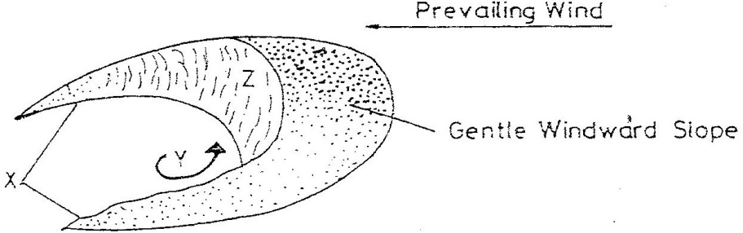

- (i) Name the feature marked X. (1mk)
(ii) The air current marked Y. (1mk)
(iii) The slope marked Z. (1mk)

- State two ways in which wind transports its loads. (2mks)

- The diagram below shows a composite volcano.
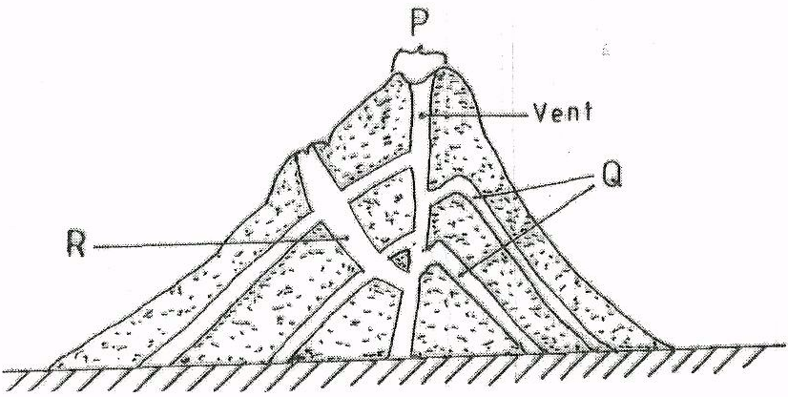

- Name the features marked P, Q, R. (3mks)
- Give two ways in which vulcanicity influences human activities. (2mks)
- (a) What is the difference between ice sheet and ice berg? (2mks)
(b) Name three types of glacier moraine. (3mks)

SECTION B:
Answer question 6 and any other TWO questions from this section.

- Study the map of Oyugis 1:50,000 (sheet 130/1) provided and answer the following questions.
- (i) What is the four figure reference of Kokungu dam? (2mks)
(ii) What is magnetic variation of the map? (1mk)
(iii) Calculate the area covered by Kodera forest. Give your answer in square kilometer. (2mks)

- Draw a square 10cm by 10cm to represent the area enclosed by Easting 84 and 94 and Northing 28 and 38. (1mk)

On the square, mark the name;
- Forest (1mk)
- Swamp. (1mk)
- District Boundary. (1mk)
- Range. (1mk)

- Describe the relief of the area covered by the map. (6mks)
- Identify three social service of Kamangambo trading centre. (3mks)
- Citing evidence from the map, explain three factors that favour farming. (6mks)

- (a) (i) Apart from the Rift valley, name other relief feature formed as a result of faulting. (3mks)
(ii) With the aid of a well labeled diagram, describe how Rift Valley may have been formed by tensional forces. (8mks)
(b) Explain three ways in which faulting influences drainage system. (6mks)
(c) Explain four ways in which features resulting from faulting are of significance to the economy of Kenya. (8mks)

- (a) What is natural vegetation? (2mks)
(b) Name the temperate grassland found in the following countries.

- Canada. (1mk)
- Russia (1mk
- Australia. (1mk)

(c) Explain how precipitation influences distribution of vegetation in an area. (4mks)
(d) Describe the characteristics of the Savannah vegetation region. (6mks)
(e) Give two reasons why Tundra region has scanty vegetation. (2mks)
(f) You are planning to carry out field study in a forest within your district.

- Give four reasons why it is important to seek permission. (4mks)
- Identify four challenges you are likely to encounter during the field study. (4mks)
- (a) (i) What is underground water? (2mks)
(ii) Explain how the following factors influence the presence of underground water.

- Amount of rainfall. (2mks)
- Vegetation cover. (2mks)
- Slope gradient. (2mks)

(b) (i) What is an artesian basin? (2mks)
(ii) State three conditions leading to the formation of artesian basin. (3mks)

(c) (i) Identify three factors which influence the formation of Karst features. (3mks)
(ii) State four significance of Karst regions. (4mks)

(d) Your class is planning to carry out field study in a Karst landscape.

- Give two reasons why it is important to seek permission from the school authorities. (2mks)
- Identify three challenges that you are likely to encounter during field study. (3mks)

- (a) What is a glacier? (2mks)
(b) Give two reasons why there are no ice sheets in East Africa. (2mks)
(c) Describe the formation of the following glacial features.

- Hanging valley. (6mks)
- Arête. (6mks)

(d) Name three erosional features found in glaciated lowland areas. (3mks)
(e) Explain three positive effects of glaciations in lowland areas. (6mks)

