MATHEMATICS PAPER 1
FORM THREE
END OF TERM 2 – 2019

MARKING SCHEME.
- Evaluate: (3mks)
$$1/2\left(3/5+1/4\left(\frac{7}{3}-\frac{3}{7}\right)of 1\frac{1}{2}÷5\right)$$
= $1/2\left(3/5+1/4\left(\frac{40}{21}\right)of 1\frac{1}{2}÷5\right)$
=$1/2\left(3/5+1/4\left(\frac{40}{21}×\frac{3}{7}\right)÷5\right)$
=$1/2\left(3/5+1/4\left(\frac{20}{7}\right)÷5\right)$
=$1/2\left(3/5+\left(\frac{1}{4}×\frac{20}{7}×\frac{1}{5}\right)\right)$
=$1/2\left(3/5+\frac{1}{7}\right)$
=$1/2×{26}/{35}$

=${13}/{35}$

- A triangle has vertices A(2,5), B(1,-2) and C(-5,1). Determine;
- The equation of line BC. (2mks)
B (1, -2) C(-5, 1)
Gradient = $\frac{1- -2}{-5-1}$
=$\frac{-3}{6}$ =$\frac{ -1}{2}$
B (1,-2) (x-y)
= $\frac{y+2}{x-1}$ = $\frac{-1}{2}$
y + 2 = ${-1}/2x+ 1/2$
y = ${-1}/2x+ {-3}/2$

- The equation of perpendicular line from A to BC. (2mks)

A (2,5) G = 2
= $\frac{y-5}{x-2}=2$
y – 5 = 2x – 4
y = 2x + 1

- The shaded region in the figure below shows an area swept out on a flat windscreen by a wiper. Calculate the area of the region. Take π= 3.142. (3mks)
4cm
120º
16cm
3.142 $×\frac{120}{360}×{20}^{2}-3.142×\frac{120}{360}×{16}^{2}$
418.93 – 268.12
= 150.81cm²

- A piece of metal has a volume of 20cm³ and a mass of 300g. Calculate the density of the metal in kg/m³. (3mks)

D = $\frac{mass }{volume}$
=$\frac{20}{300}×1000$
= 66.67kg/m³

- List the integral values of x which satisfy the inequalities below. (3mks)
$2x+21>15-2x≥x+6$

2x + 21 > 15 – 2x 15 – 2x ≥ x + 6
4x > -6 9 ≥ 3x
X > -1.5 3 ≥ x

-1.5 < x ≤ 3

Integral values -1, 0, 1, 2, 3

- Janet is a saleslady earning a basic salary of Kshs. 20,000 per month and a commission of 8% for the sales in excess of Kshs. 100,000. If in January 2010 she earned a total of Kshs. 48,000 in salaries and commissions. Determine the amount of sales. She made in that month. (3mks)
48,000 – 20,000 = 28,000/=

28000 = $\frac{8}{100}×x$
x = 350,000 + 100,000

= 450,000/=

- The interior angle of a regular polygon is 108º larger than the exterior angle. Find the number of sides of the polygon. (3mks)
x + (x + 108) = 180
2x + 108 = 180
X = 36
Interior = 36 + 108 Exterior = 36º
= 144

No. of sides = $\frac{360}{36}$
= 10 sides.

- Given that Cos A=$\frac{5}{13}$ and angle A is acute. Find the value of 2 tan A + 3 sin A without calculators. (3mks)

2$\left(\frac{12}{5}\right)$ + 3$\left(\frac{12}{13}\right)$
13
5
12
A

$\frac{24}{5}+\frac{36}{13}$

=$\frac{492}{65}$

- Without using a calculator evaluate: (2mks)
$\frac{-9+\left(-7\right)×\left(-8\right)-(-5)}{-2+(-6)÷3×6}$
$-9+56+5$ -2 + (-2) $×6$
52 -14
$= \frac{52}{-14}= \frac{-26}{7}=$
= $-3\frac{5}{7}$

- Solve for x in the equation below. (3mks)
$$\frac{6x-4}{3}-\frac{2x-1}{2}=\frac{6-5x}{6}$$

t² t 6
6x – 4 - 2x -1 = 6 – 5x
3 2 6

2( 6x – 4 ) – 3 ( 2x – 1) = 6 – 5x
12x – 8 – 6x + 3 = 6 – 5x
11x = 11
x = 1

- Calculate the area of the trapezium show below. (3mks)
15cm
35º
20cm
8cm

A = ½ x (15+20) $×$8 sin 35
= 80.3cm²

- Solve the simultaneous equation. (4mks)

x² + y² = 26
x + y = 4

x = 4 – y
(4 - )² + y² = 26
16 – 8y + y² + y² = 26
2y² – 8y – 10 = 0
y² – 4y – 5 = 0

y = -1 x = 5
y = 5 x = -1

- Express 72 and 125 as products of their prime factors. (2mks)

72 125

2 36 5 25

2 18 5 5

2 9

3 3

$72 = 2 × 2 × 2 × 3 × 3$ $125 = 5× 5 × 5$

- A service vehicle left town P for town Q at 1000hrs had a puncture after travelling for 4 hrs 20 mins. Fixing a new tyre took 33 minutes. The vehicle then travelled for 1 hr 20mins to reach town Q. At what time did it arrive in 12 hour clock system. (3mks)
1000hrs
420
1420 hrs
33
1453
120
1613

4:13p.m

- A tourist visited Kenya with 2500 US dollars and changed the US dollars into Kenya shillings at a local bank in Kenya when the exchange rates at the time were as follows:
Buying Selling
1 US dollar shs. 78.45 shs. 78.55
1 Sterling Pound shs. 120.25 shs. 120.45
- How much did he get in Kenya shillings? (2mks)
2500 x 78.45
= 196125

- While in Kenya he used shs. 80,000 and after his stay he converted the remaining amount into Sterling pounds. Calculate to 2 decimal places the Sterling pounds that he got. (2mks)

196125 116123
80000 120.45
116125

= 964.09 sterling pounds

- Use logarithms tables to evaluate: (4mks)

$$\sqrt[3]{\frac{497×9.84}{5.24×7.65}}$$

No. std term log

497 4.97 x 10² 2.6964
9.84 9.84 x 10º 0.9930
3.6894
5.24 5.24 x 10⁰ 0.7193
2.9701
7.65 7.65 x 10⁰ 0.8837
2.0864

2.0864 = 0.6955
3
Anti log 0.6955
= 4.959
=4.96

- A motorist left Embu for Nairobi a distance of 240km at 8:00 a.m and travelled at average speed of 90km/hr. Another motorist left Nairobi for Embu at 8:30a.m and travelled at 100km/hr. Find;
- The time they met. (3mks)

45 240km
Embu Nandi
8: 00 am 90km/h
T= 30mins
S= 90km/h
D= 45km
D.A = 195km
RS = 190km/hr
T = ³⁹/₃₈

8.30 am
62
9.32 am

- How far they met from Nairobi. (3mks)

T= ³⁹/₃₈hr
S = 100km/hr
D= 102.63 km

- The time of the day each motorist arrived at his destination. (4mks)

Embu Nairobi Nairobi Embu
D = 240km D = 240km
S = 90km/hr S = 100km/hr
T= 2hr 40mins T = 2h 24mins
8.00 8.30
2.40 2.24
10.40am 10.54 am

- A farmer has a rectangular farm which measures 100m by 80m. The farmer intends to fence the plot using post at intervals of 4m apart leaving a gate of 4m. Also he will use four strands of barbed wire. Each post cost shs. 125 and wire is sold at rolls of 60m costing 1,500/=. Calculate;
- The number of post he will use. (2mks)
P = 180 $×$ 2
= $\frac{360-4}{4}=89+1$
= 90 posts

- The total length of the barbed wire. (2mks)
(360 – 4) $×4$

= 1424 m

- The total cost of fencing the farm if the cost of the gate is 8,000/= and labour is shs. 1,500. (5mks)
(90 x 125) + (1424 x 1500) + 8000
60
11250 + 35600 + 8000 + 1500
= sh. 56350
- The farmer wishes to subdivide further the farm into square plot. Find the maximum area of the plot.
10 100 80
2 10 8
5 4

G.C.D =20
AREA = 20 X 20
= 400m²

- The parents of a certain mixed school decided to buy a school van worth Kshs. 900,000. Each student was to contribute the same amount of money. 50 students were transferred from the school; as a result each of the remaining students had to pay kshs. 600 more.
- Find the original number of the students in the school. (5mks)

900000 - 900000 = 600
( x – 50) x

900000x – 9000000x + 45000000 = 600
X (x -50)

45000000 = 600x² – 30000 x
600x² – 30000x – 45000000 = 0
X² – 50x – 75000 = 0
50± √2500- 4 x 75000
2
50 + 550 50 - 550
2 2
X = 300 students

- Find the percentage change in contributions per student. (3mks)
Original = 900000
300
= 3000
New = 900000
250
= 3600
= 600 x 100
3000

= 20%

- If the ratio of boys to girls in the school was 11:7, find the amount of money contributed by boys alone. (2mks)

B G
11 7
= 11 x 900000
18
= sh. 55,000

- The figure below shows two circles of radii 8cm and 6cm with centres O₁ and O₂ respectively. The circles intersect at points A and B. The lines O₁O₂ and AB are perpendicular to each other. If the common chord is 9cm;
(Take π=3.142.
6cm
8cm
B
A
O₂
O₁

Calculate to 4s.f
- Angle AO₁B (2mks)
${Sin}^{-1} θ=\frac{4.5}{8}$
$θ=34.23$
AO₁B = 34.23 $×$2
= 68.46º

- Angle AO₂B

${Sin}^{-1}θ=\frac{4.5}{6}$
$θ=48.59$
AO₂B = 48.59 $×$2
= 97.18º

- Area of the shaded region. (6mks)
$\frac{68.46}{360}×3.142×8^{2}-1/2×8×8 Sin 68.46$
$38.24-29.76$
= 8.48cm²

$\frac{97.18}{360}×3.142×6^{2}-1/2×6×6 Sin 97.18$
$30.53-17.86$
= 12.67

Shaded Area = 8.48 + 12.67
= 21.15cm²

- A village water tank is in the form of a frustum of a cone of height 3.2m. The top and bottom radii of 18m and 24m respectively as shown below.
3.2m
18m
24m

- Calculate;
- The surface area of the tank excluding the bottom. (4mks)
18
24
9.6 x
3.2
$\frac{24}{18}=\frac{3.2+x}{x}$
$24x=57.6+18x$
$6x=57.6$
$x=9.6m$

S.A Big Cone = $\frac{22}{7}×24×27.2$
= 2051.66cm²

S.A Big Cone = $\frac{22}{7}×18×20.4$
= 1154.06

S.A Big Cone =2051.66 – 1154.06 + ${\left(\frac{22}{7}×24×27.2\right)}^{2}$
= 897.6 + 1018.29
= 1915.89m²

- The capacity of the tank in litres. (3mks)
$V=1/3×\frac{22}{7}×24×24×12.8$
Big cone
= 7723.89m³
$V=1/3×\frac{22}{7}×18×18×9.6$
Small cone
= 3258.51
$V=7723.89-3258.51$
4465.3757$×$1000
4465375.7 litres

- 15 families each having 15 members use the water tank and each person uses 65 litres daily. How long will it take for the full tank to be emptied? (3mks)
$\frac{4465375.7}{15×15×65}$

= 305.3 days.

- Measurements of a maize field using baseline XY were recorded as shown below in metres

Y
240
To R 160 190
180 75 To Q
150 50 To P
To S 100 120
100 100 To N
To T 30 50
20 20 To M
X

- Show the map of the maize field by scale drawing. Take 1cm rep 20m. (4mks)
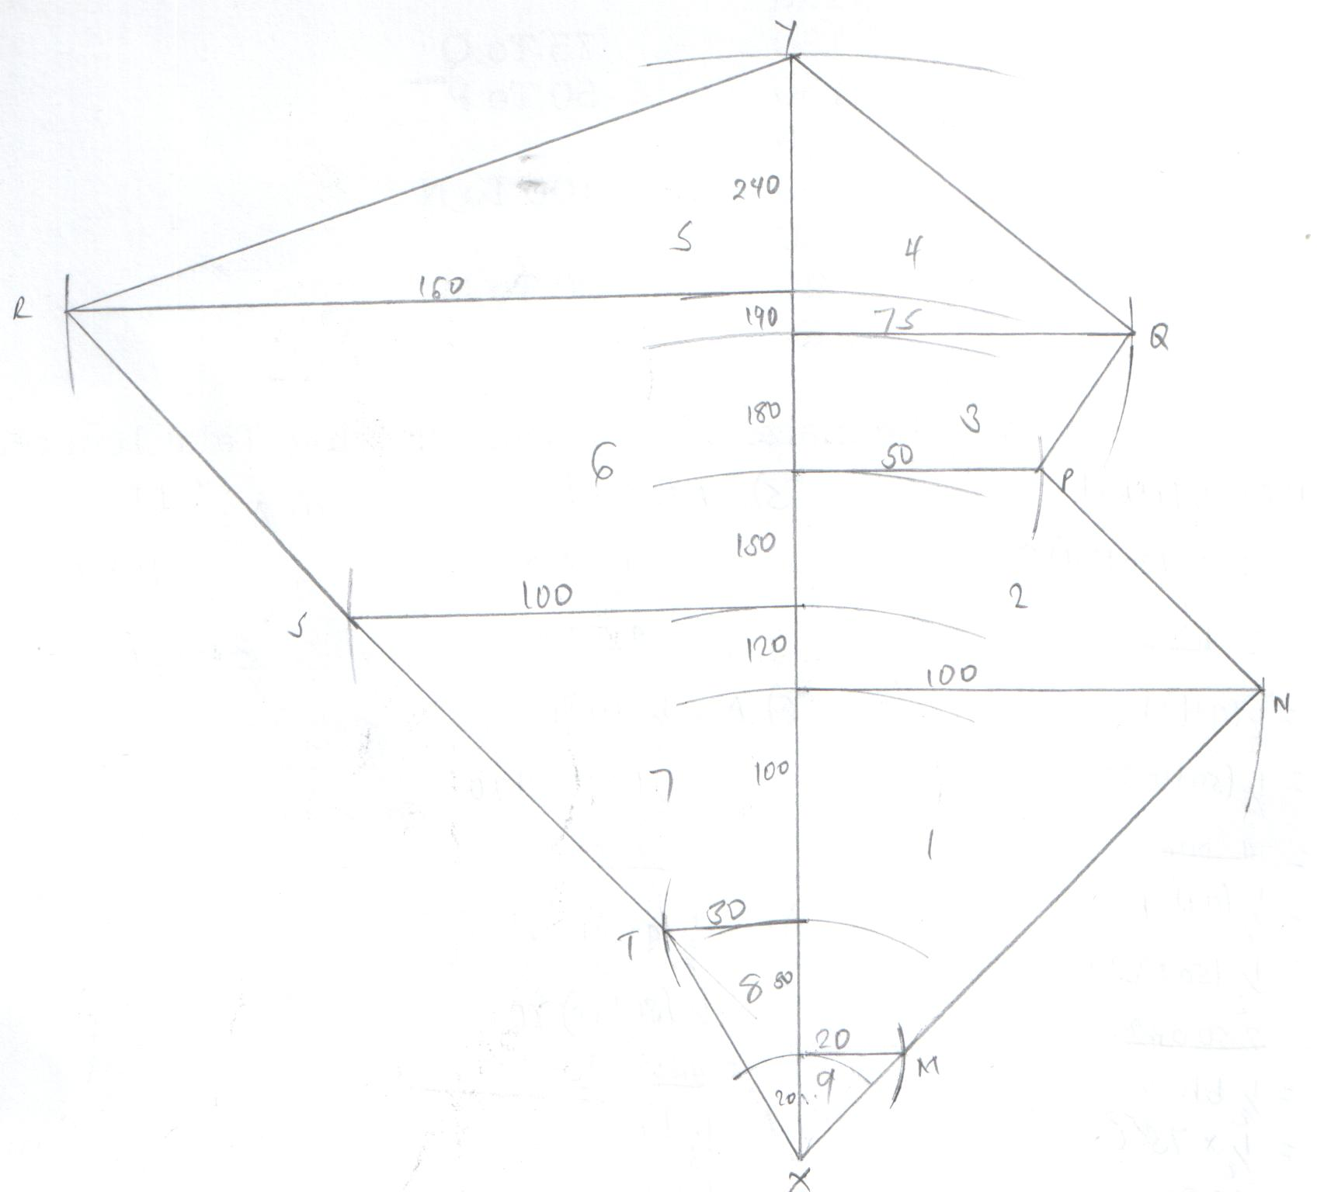

- A = ½ (a + b)h
= ½ (20 +100)80
= 4800m²

- A = ½ (a + b ) h
= ½ (20 + 100)60
= 4500m²
- A = ½ (a +b)h
= ½ (50 +75 ) 40
= 2500m²
- A= ½ bh
= ½ x 75 x 60
= 2250m²
- A = ½ bh
= ½ x 160 x 50
= 4000m²
- A = ½ (a + b)h
= ½ ( 100 + 160) 70
= 4550m²
- A = ½ bh
= ½ x 30 x 50
= 750
- A = ½ bh
= ½ x 20 x 20
= 200m²

- Find the area of the field in hectares. (4mks)

= 4800 + 4500 + 2500 + 2250 + 4000 + 5600 + 4550 + 750 + 200
= 29150m²
1 ha = 10, 000m²
= 29,150m²
= 29150 x 1
10000
= 2.9150ha

- If the cost of one hectare is Kshs. 65,000, find the total cost of the maize field. (2mks)
1 ha = shs 5000
2.9150 ha =
= 2.9150 x 65000
1
= ksh. 189475

- Using a ruler and pair of compass only construct the following.
- Triangle XYZ where XY is 6cm and angle XYZ is 135º and YZ=7cm. Measure XZ. (3mks)

- Drop a perpendicular from Z to meet line XY at K. measure YK. (3mks)

- Bisect line XY and let the bisector meet line XZ at Q. (2mks)

- Join Q to Y and measure angle XQY. (2mks)
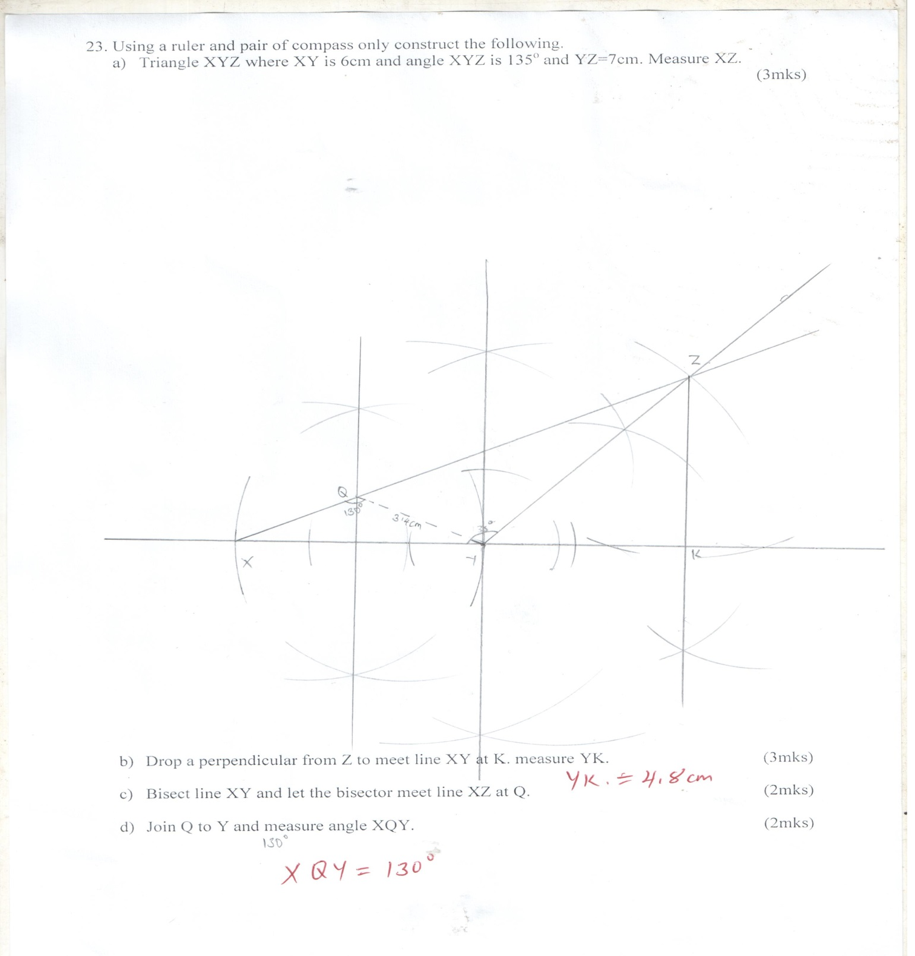

- Complete the table for the function.
- y=1 – 2x – 3x² in the range -3 ≤ x ≤ 3 (2mks)
x | -3 | -2 | -1 | 0 | 1 | 2 | 3
-3x²2 | -27 | -12 | -3 | 0 | -3 | -12 | -27
-2x | 6 | 4 | 2 | 0 | -2 | -4 | -6
1 | 1 | 1 | 1 | 1 | 1 | 1 | 1
y | -20 | -7 | 0 | 1 | -4 | -15 | -32

- Use the table above to draw a graph of y=1 – 2x – 3x² on the graph provided. (4mks)
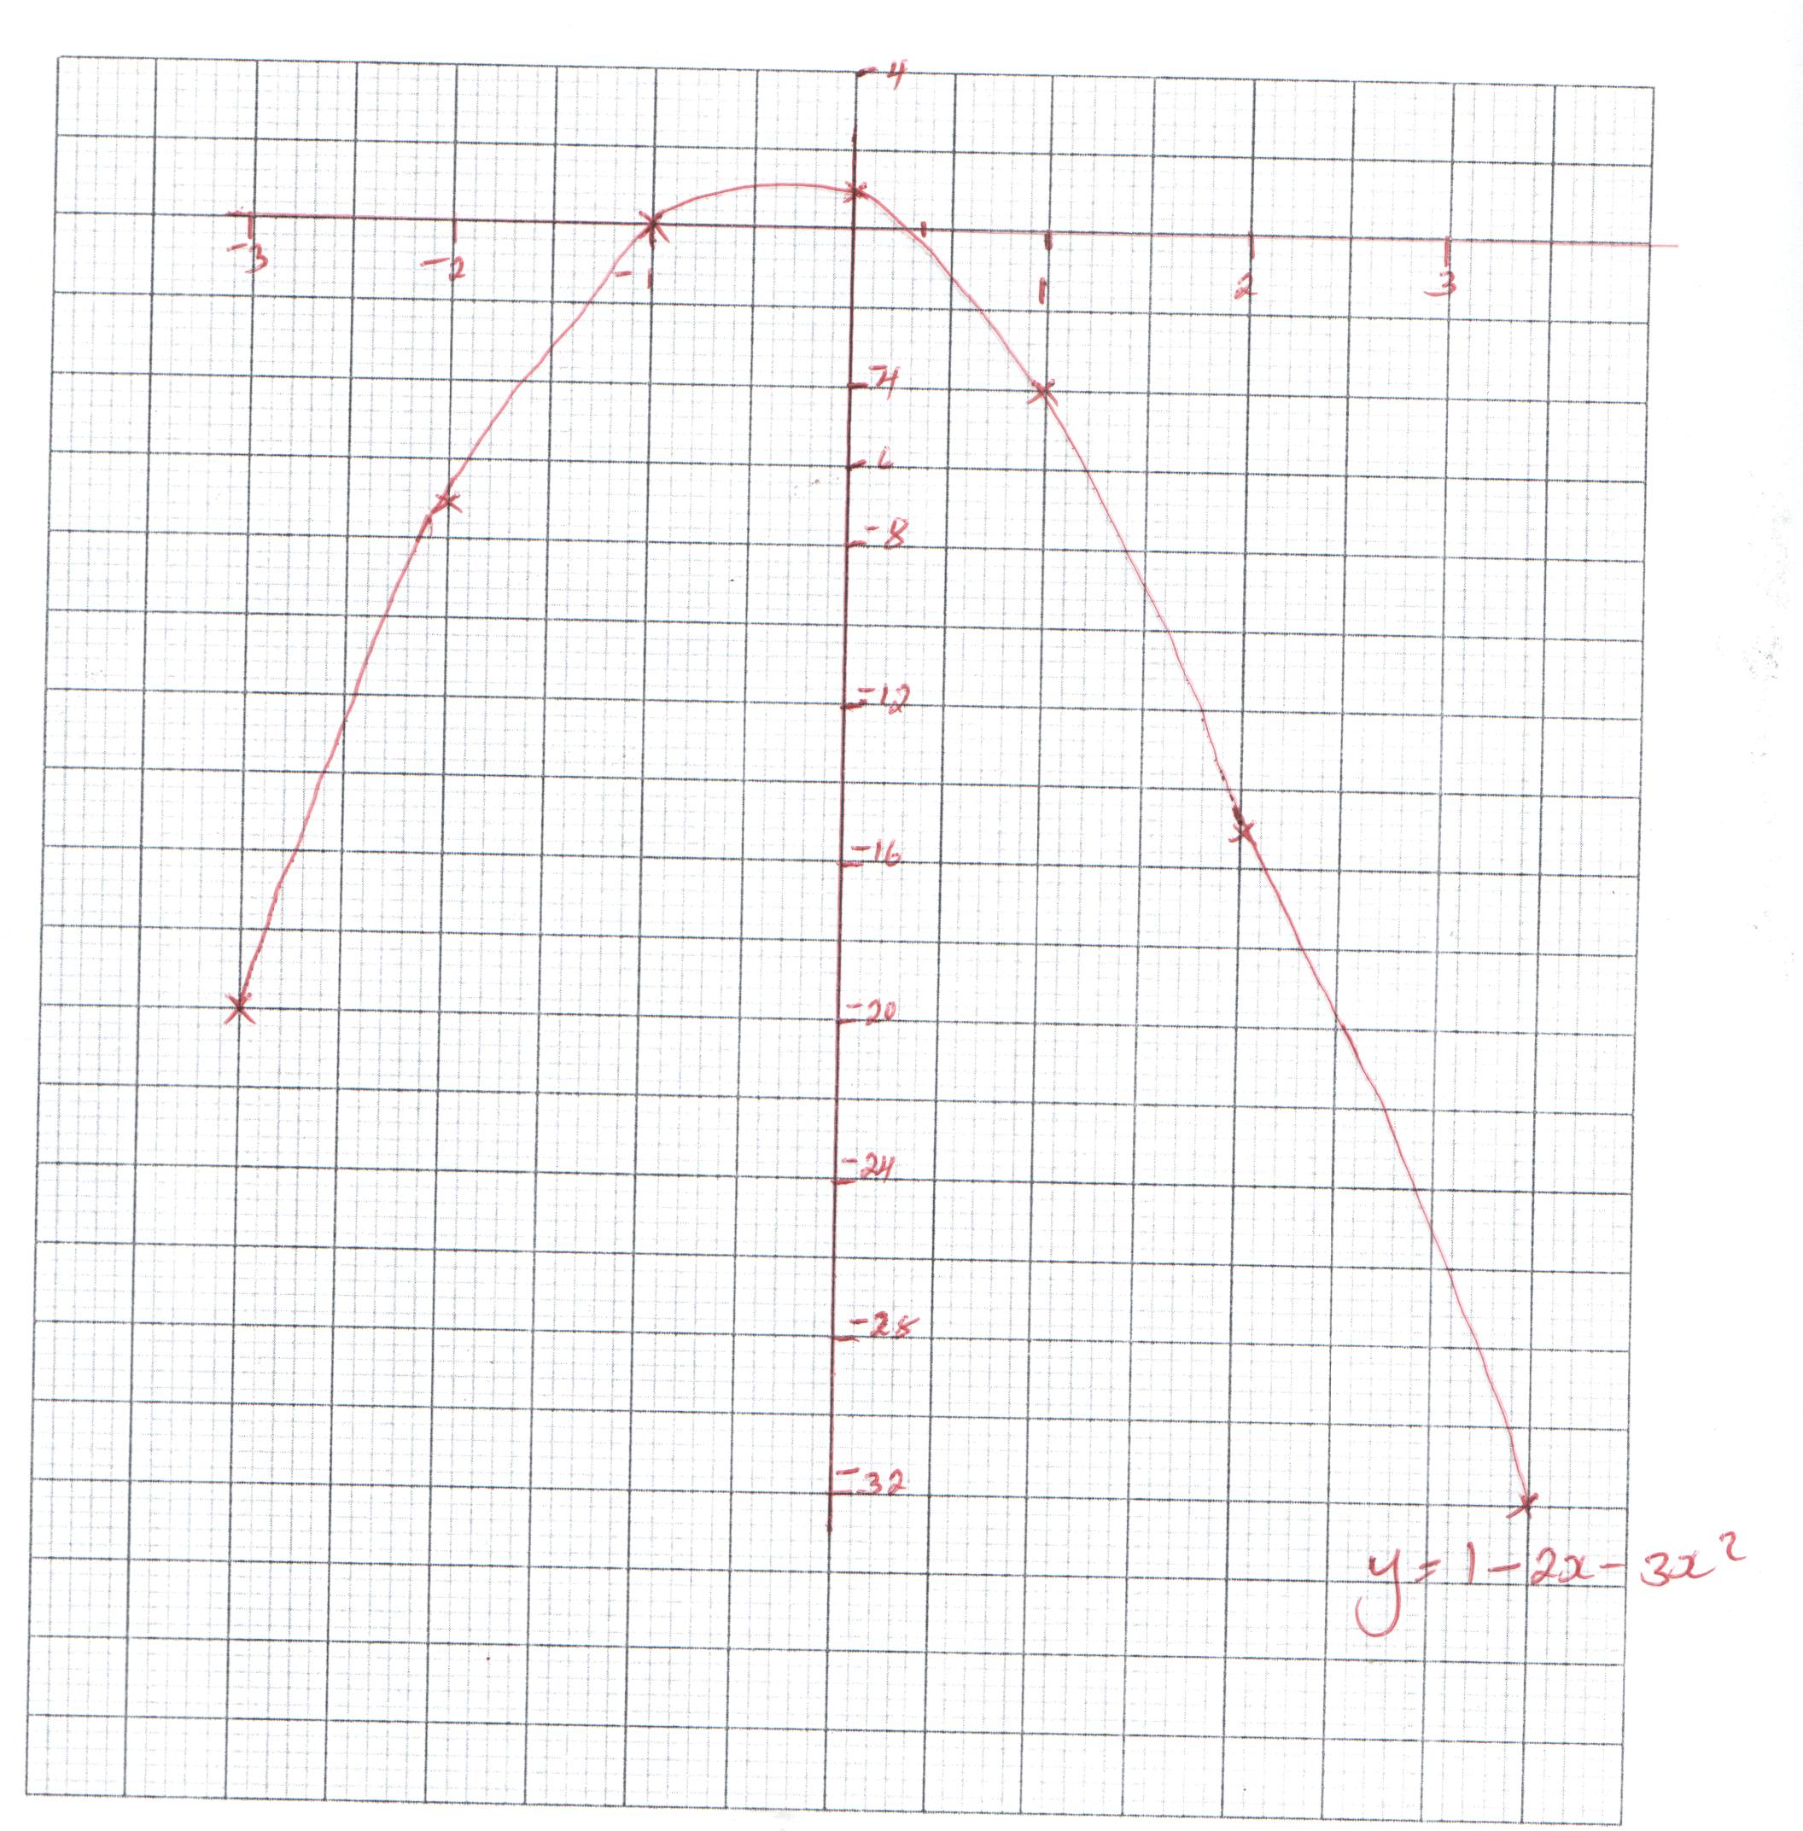

- Use the graph in (b) above to solve;
- y=1 – 2x – 3x² = 0 (2mks)
1 – 2x – 3x²=0
-1, 0.2

- 2 – 5x – 3x² = 0 (2mks)
- 2x – 3x²=0
- 5x – 3x² = 0
-1 + 3x = 0
3x = 1
X = ¹/₃

