NAME: ………………………………………………. ADM NO: ……………………………….
CLASS:……………………………………………. DATE: ……………………………………… SIGNATURE: …………………………….
232/1
PHYSICS
FORM THREE (3)
JUNE/JULY 2019
TIME: 2 HOURS

INSTRUCTIONS:
- Write your name, Adm no., class, signature and date of examination in the spaces provided at the top of the page.
- Answer all the questions in the spaces provided after each question.
- All numerical answers should be expressed in decimal notations.
- You may use electronic calculators and tables.

- The figure below shows a spherical ball placed between 2 wooden blocks and a meter rule.
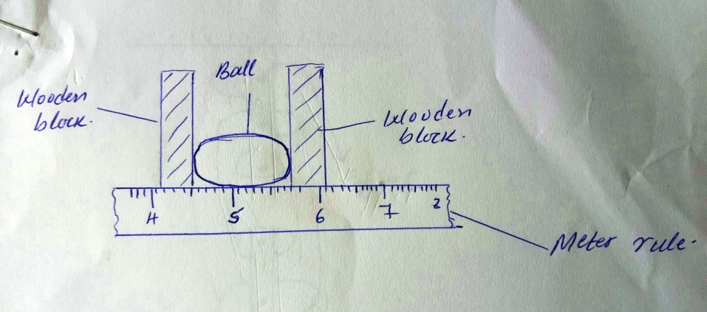
What is the volume of the ball? (3 mks)

2. A solid weighs 16.5N on the surface of the moon. The force of gravity on the moon is 1.7N/kg.
Determine the mass of the solid. (2 mks)

3. 30cm³ of a liquid X was added to 70cm³ of water and the resulting mixture had a volume slightly
less than 100cm³, explain the observation. (2 mks)

4. Explain how heat loss by;
(i) Radiation is minimised in a vacuum flask. (1 mk)

(ii) Conduction is minimized in a vacuum flask. (1 mk)

5. The figure below shows part of a scale of vernier caliper. Given that the device has a zero error of –
0.02 and has been used to measure the diameter of a ball.
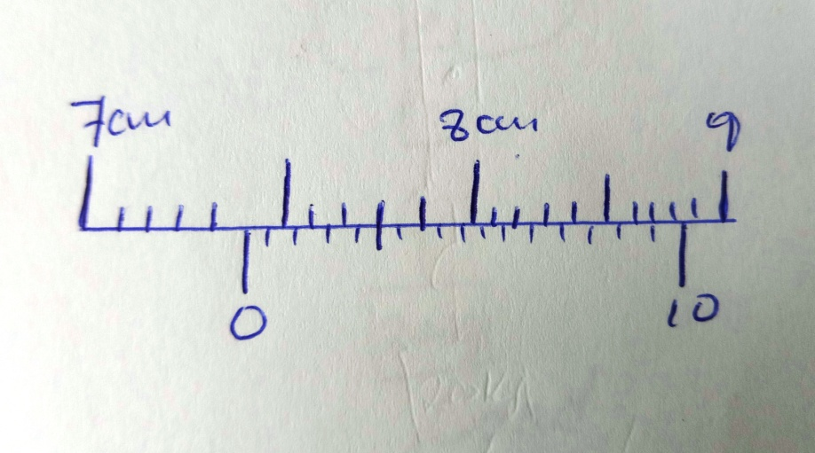
What is the radius of the ball? (2 mks)

6. A pipe of radius 6mm is connected to another pipe of radius 9mm. If water flows in the wider pipe
at 2m/s, what is the speed in the narrower pipe? (3 mks)

7. The springs below are identical and have negligible weight. The extension produced on the system of springs is 20cm.
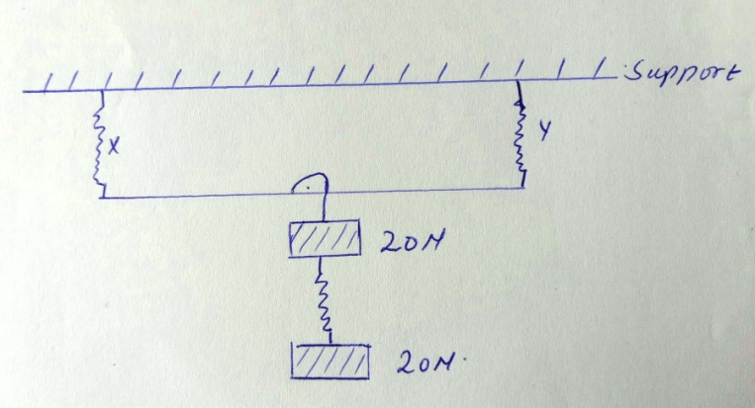

Determine the constant of each spring. (4 mks)

8. An air bubble of volume 0.5cm3 when released from the bottom of a lake rises to the surface of the lake.
(i) Explain why the bubble rises. (2 mks)

(ii) Calculate the volume of the bubble at the surface of the lake given that the lake is 92.7m deep and the atmospheric pressure is equivalent to 10.3m of water pressure. (4 mks)

(b) What assumption have you made in arriving at your answer? (2 mks)

9. A fixed mass of gas at constant pressure has a volume of 600cm3 at 0ºC. At what temperature will its volume be 1099cm³? (4 mks)

10. (a) State three uses of magnets. (3 mks)

(b) Define the following terms as used in Physics:-
(i) Magnetic materials. (2 mks)

(ii) neutral point. (2 mks)

11. State three conditions for a body to be in equilibrium. (3 mks)

12. State four practical applications of friction. (4 mks)

13. Use simple sketches of a cone to illustrate the three states of equilibrium and name. (6 mks)

14. (a) Give a reason why water is not suitable as a barometric liquid. (3 mks)

(b) Explain the application of (a) above. (3 mks)

15. Use domain theory of magnetism to explain how a magnet may lose its magnetism on heating and hammering. (4 mks)

16. Explain the following observations:-
(i) A boy jumping from a high table tends to spread his legs. (1 mk)

(ii) Convex mirrors are not preferred for use as driving mirrors. (1 mk)

(iii) Why convex mirrors are used as driving mirrors and in supermarkets. (1 mk)

17. (a) State three practical applications of c.o.g. (3 mks)

(b) Name two factors that affect the c.o.g of a body giving a reason for each. (4 mks)

18. A car travelling at a speed of 72km⁻¹ is uniformly retarded by application of brakes and comes to rest after 8 seconds. If the car with its occupants has a mass of1250kg, ca;culate
- breaking force. (2mks)

- Work done by bringing it to rest (2mks)

19. A block and tackle system is used to lift a mass of 200kg. If this machine has a velocity ratio of 5 and an efficiency of 80%;
(a) Sketch a possible arrangement of the pulleys, showing how the rope is wound. (2 mks)

(b) Calculate the effort applied. (Take g = 10N/kg) (2mks)

