NAME………………………….……………………….ADM…………………CLASS……………
232/2

PHYSCIS
FORM THREE,
END OF TERM 2 -2019

SECTION A (25MKS)

- State two characteristics of image formed by plane mirrors. (2mks)

- State two factors that affects the speed of sound air. (2mks)

- What is a virtual image? (1mks)

- In the figure below, on the same diagram sketch the path of the ray after striking mirror AB. (1mk)
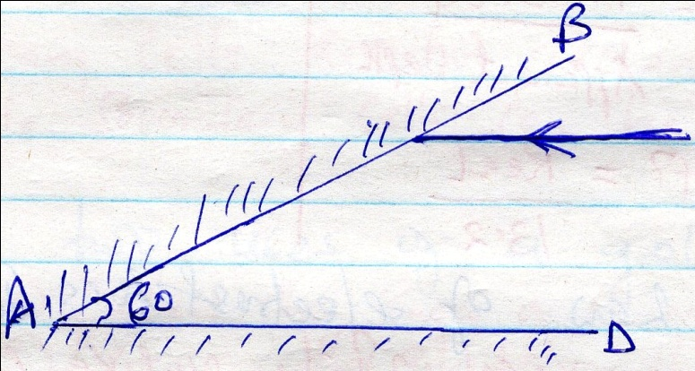
- An object is 25m tall is at a point 8m from the pin hole camera. If the image is 8.6m from the pin hole. Calculate the size of the image. (3mks)

- A curve at the button of a jar glycerin appears to be 13,2cm below the surface glycerin. Calculate the height of the Colum of glycerin in the jar. (refractive index of glycerin is 1.47.

- State the law of electrostatics. (1mk)

- The figure below shows resistor network.
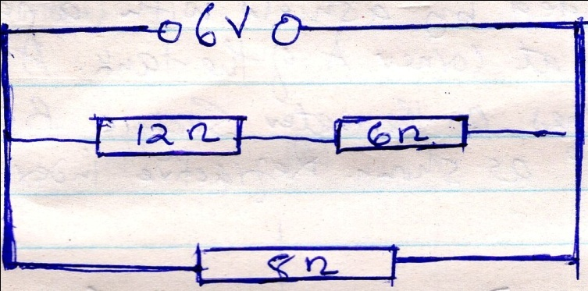
From the figure determine
- Total resistance. (3mks)

- Total current. (3mks)

- Distinguish between primary and secondary cells. (1mk)

- Give two uses of a gold leaf electroscope. (2mks)

- Two mirrors are inclined at an angle 60⁰c determine the number of images formed. (3mks)

SECTION B (55MKS)

- The figure below shows a transparent water tank containing water. An electric lamp surrounded by a shield with a narrow slit is fixed at corner A of the tank. A light ray from the slit shines on the water surface BC at an angle of 48⁰ as shown. Refractive index of water is ⁴/₃
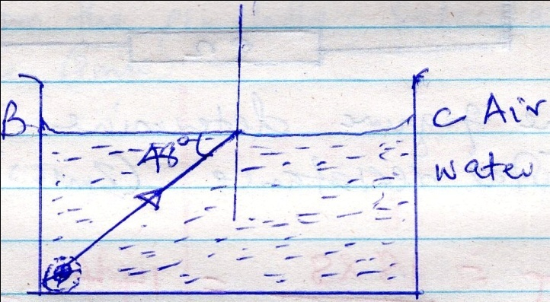
- Determine the angle of retraction for the ray shown. (3mks)

- Complete the ray diagram to show retracted ray (1mk)

- Determine the angle of incidence for which the angle of retraction is 90⁰ (3mks)

- Calculate the speed of light in water given that the speed in air is 3.0 x 10⁸mls

- a) Draw magnetic field pattern between the following poles. (2mks)

N N

b)Using dormain theory, explain why it is not possible to magnetize a magnetic material beyond a certain limit. (3mks)

- The figure below shows an electromagnet connected to a battery.
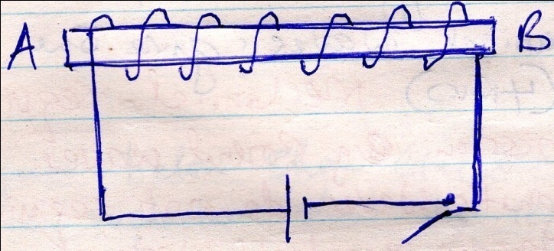
- On the same diagram indicate the direction of the flow of current when the switch is closed. (1mk)

- State polarities A and B. (2mks)

- State three ways of increasing the strength of the electromagnet. (3mks)

- State two uses of electromagnets (2mks)

- a)Define the following terms
- Amplitude (1mk)

- Frequency (1mk)

b)state one difference between electromagnetic and mechanical waves give one example in each. (4mks)

- The wave shown in the figure below has a velocity of 200mls.
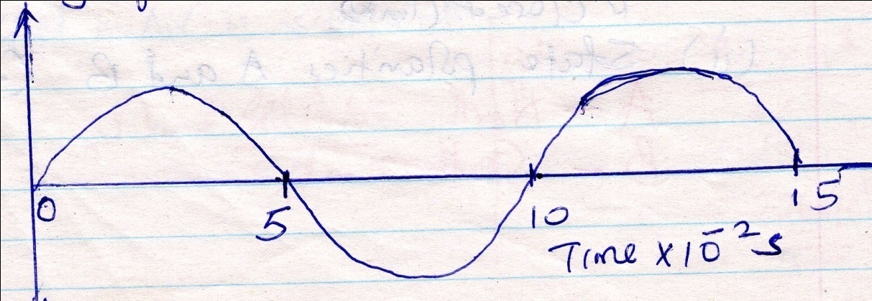
Determine
- The period of the wave. (1mk)

- The frequency of the wave. (3mks)

- The wavelength of the wave, (3mks)

- a) The figure below shows circular waves approaching a concave reflector. Show the reflected waves. (2mks)
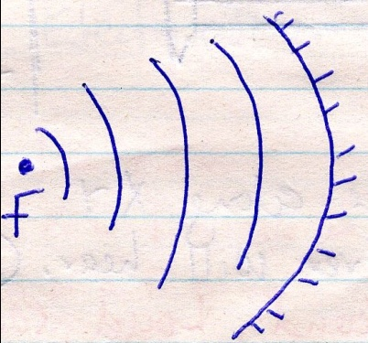
b)In the figure below water waves of one incident on an aperture which is greater than the wavelength of the waves. Show the pattern of the waves beyond the aperture.(2mks)
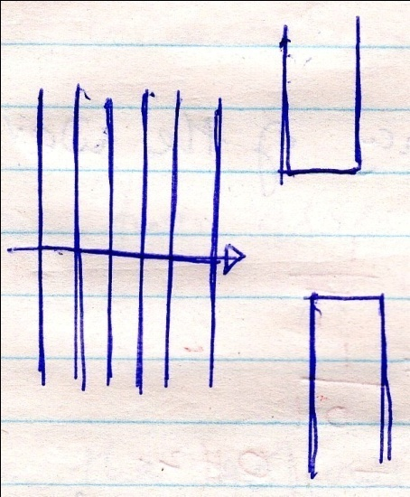

- The figure below shows the set up to demonstrate interference of sound.
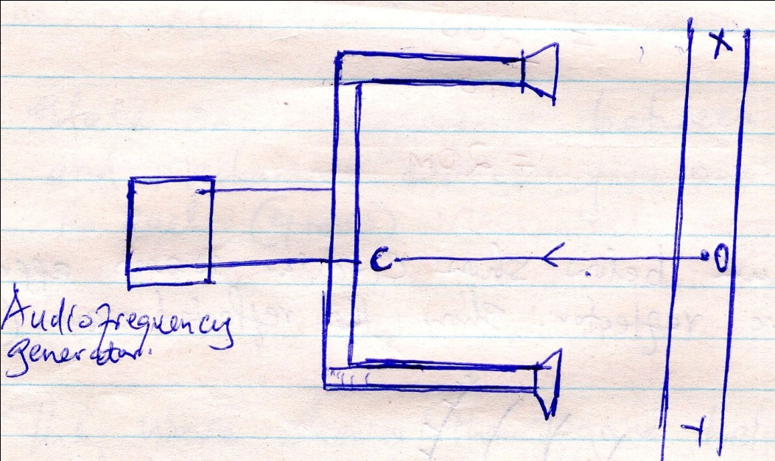
- An observer moves along XY state and explain what the observer will hear. (3mks)

- State and explain what now the observers will hear if he moves along line 0C (2mks)

- a) State ohims law. (1mk)

b) Differentiate between potential difference (pd) and electromotive force (Emf) (2mks)

c)A cell drives a current of 2.0A through 0.6 resistor. When the same cell is connected to 0.952 resistor the current that flows is 1.5A. find.
i) The internal resistance of the cell. (3mks)

ii)The electromotive force (Emf) of the cell. (3mks)

- State two factors that affect the resistance of metallic conductor. (2mks)

