END TERM 2

232/3
PHYSICS
PAPER 3

MARKING SCHEME
1.d)
Mass m (g) | 100 | 150 | 200 | 250 | 300 | 350
Time for 20 oscillation t (s) | 6.59 | 8.03 | 9.60 | 10.91 | 11.57 | 12.56
Period time T (s) | 0.3295 | 0.4015 | 0.4800 | 0.5455 | 0.5785 | 0.6280
T² (S²) | 0.1086 | 0.1612 | 0.2304 | 0.2976 | 0.3347 | 0.3944

* For t each correct value ½mk max 3mks
* For T all values correct 2mks more than 3 correct
1mk less than three correct 0mk. max 2mks
* For T² all values correct 1mk max 1mk
f) Gradient = ∆ Y = ∆T² $=\frac{0.25-0}{0.225-0}$¹ =1.111 s²/kg ¹
∆X ∆m
g) y = mx +c
T²=π² M+0 =Slope = π²
K K
K= π² = π² = 8.972N/m
slope 1.11
k) Lines P₁ P₂ & P₃ P₄ intersecting at I
I) Q P₀ = 10.0cm
Q 1= 6.6 cm
m) n$=\frac{{QP}_{0}}{QI}$ $=\frac{10.0}{6.6}$ =1.5152

n) Refractive index

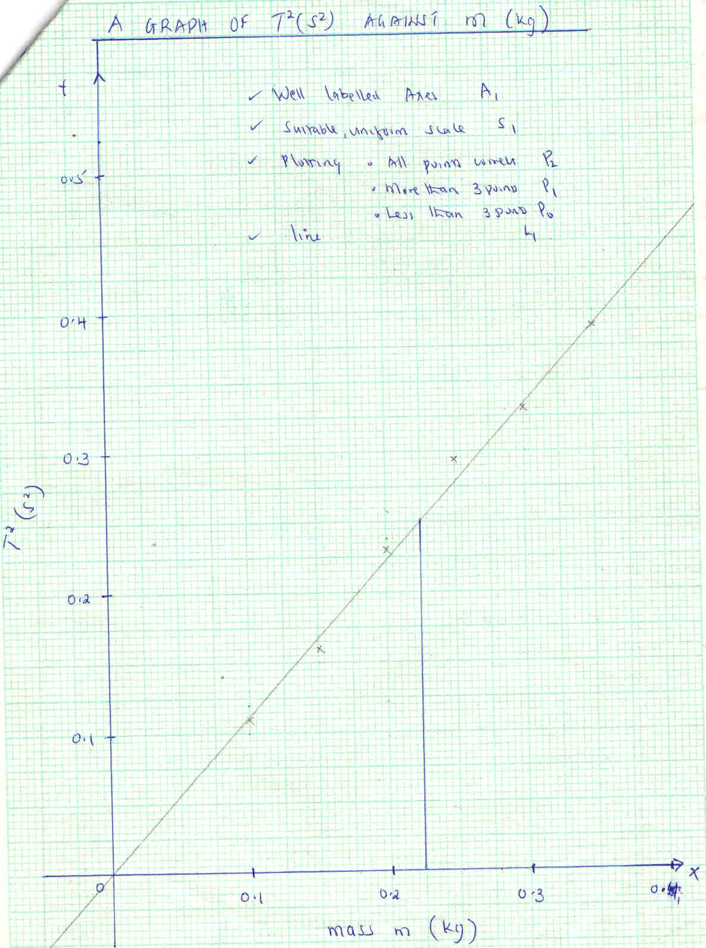
QUESTION 2
b) I= 0A
E=3.0 ± 0.2 V
c)
Length L (cm) | 70 | 50 | 40 | 30 | 20 | 10
p.d V (V) | 2.4 | 2.3 | 2.2 | 2.1 | 2.0 | 1.8 | $±$ 0.2v
Current 1 (A) | 0.18 | 0.21 | 0.25 | 0.29 | 0.32 | 0.38 | $±$0.01v
@½mk
max 6mks

e) Slope $=\frac{∆V}{∆I}$ $=\frac{\left(3.0-2.5\right)V}{\left(0-0.15\right)A}$

$=\frac{0.5}{0.15}$

= -3.33Ω
f) y = m x +c
$=$ -rI +E
i) E. m. f of the battery = y intercept
= 3.0v
since the two cell are in series, the e. m .f of one cell $=\frac{E}{2}$ =1.5V

ii) Slope = -r
therefore the internal resistance of the battery = -slope
= -(3.33)
=3.33Ω

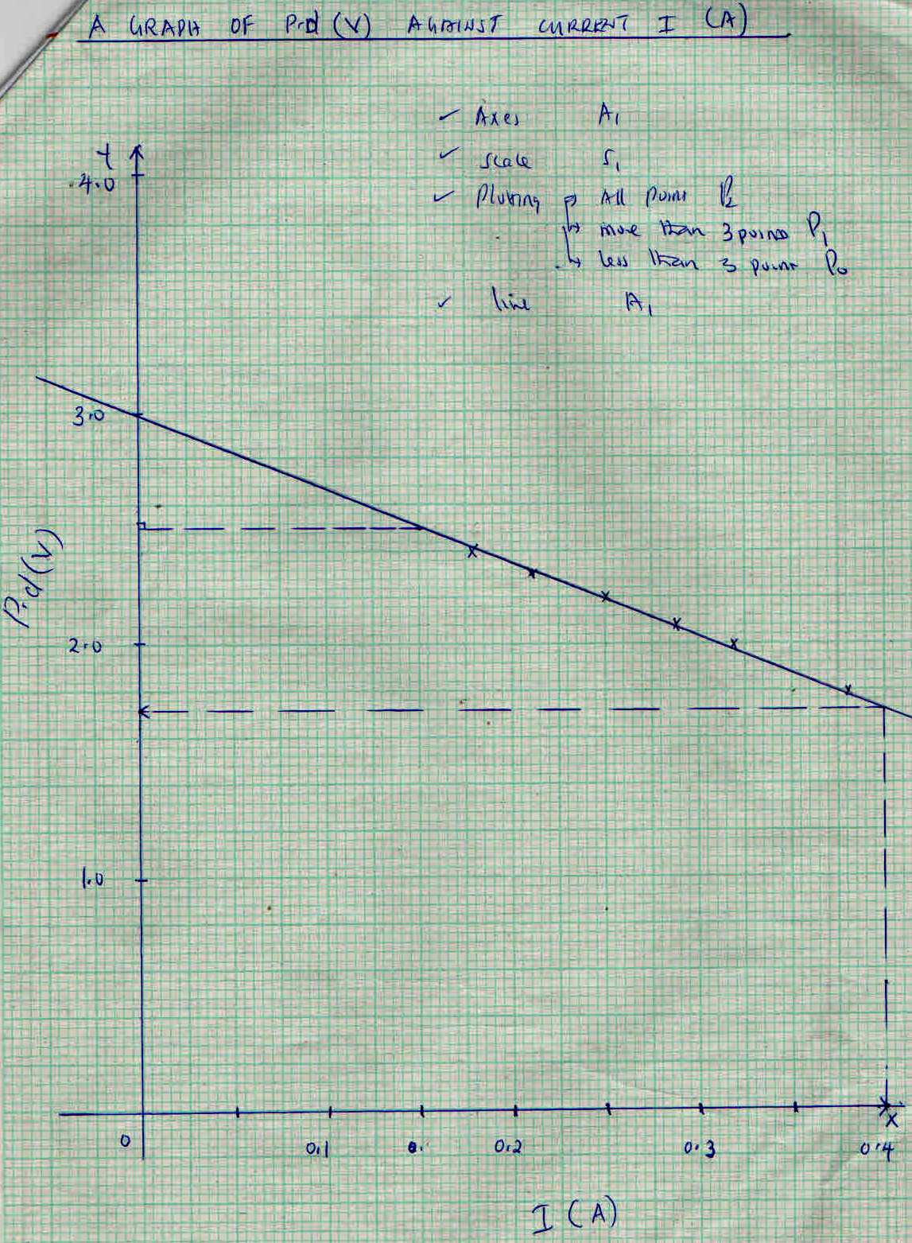
e)

Since the cells are in series, the internal resistance of one cell $=\frac{r}{2}$ $=\frac{3.33}{2}$ $=$1.665Ω
iii) From the graph:
when 1= 0.4A
V=1.75V

