MUKINDURI MIXED DAY SECONDARY SCHOOL
MIDTERM EXAM TERM 2 2017
GEOGRAPHY FORM 1
NAME……………………………………………………..ADM……………
ANSWER ALL QUESTIONS ON SPACE PROVIDED
- State four reasons why its important to study geography. (4mks)

- a)What is solar system. (2mks)

b)Use the diagram below to answer the question that follow.

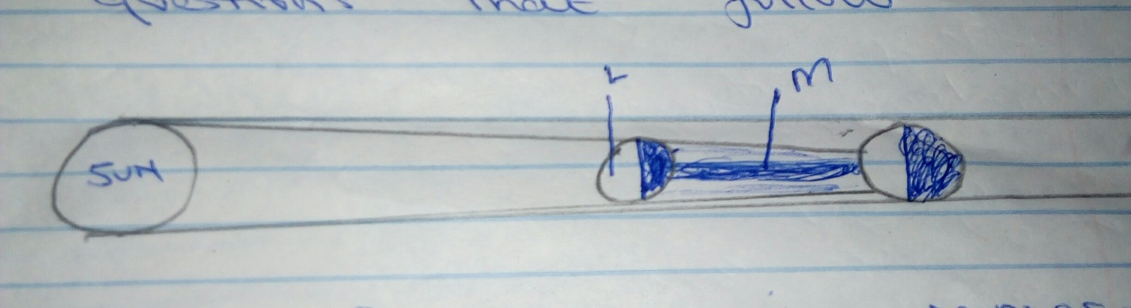

- What type of eclipse is represented by the diagram? (1mk)

ii)Name the features marked L and M (2mks)

- a)The diagram below represents the internal structure of the earth. Use it answer question a;

- i) Name the parts marked (3mks)
A
B
C
ii)Name the minerals found in layer A (2mks)

- Name the boundary which separate layer B from C (1mk)

- state three characteristics of the mantle. (3mks)

- a) i)Define weather . (2mks)

ii)Name five elements of weather. (5mks)

- a) Identify two instruments of measuring weather kept in the Stevenson screen. (2mks)

b)State conditions necessary in siting a weather station. (3mks)

c)Give reasons why stevenson`s screen is
i) painted white (2mks)

ii)has louvers (2mks)

- a)Name liquids found in six`s thermometer. (2mks)

b)The table below shows the temperature and rainfall readings for station in one week. Use it to answer questions which follows.
Day  Temp ⁰C | mon  23 | Tue  24 | wed  24 | thur  21 | fri  25 | sat  25 | sun  23
Rainfall in mm | 50 | 49 | 55 | 45 | 60 | 60 | 49

- calculate the range of temperature for the week (2mks)

- calculate the total mean weekly temperature (2mks)

- calculate the total rainfall for the week. (2mks)

c)Why is weather forecasting important. (3mks)

d)Name four factors which influence temperature of a place. (4mks)

- a)Define wind. (2mks)

b)Draw a well labeled diagram of a sea breeze. (4mks)

- a)Name two ways of identifying clouds. (2mks)

b)Give two examples of low clouds. (2mks)

- a)Name two components of the atmosphere. (2mks)

b)Name layers of the atmosphere. (4mks)

c)Which layer of the atmosphere is ozone layer. (1mk)

d)Give three characteristics of the lower layer of the atmosphere. (3mks)

e)Define the following terms
- Zero- lapse rate (2mks)

- Negative lapse rate (2mks)

- Positive lapse rate. (2mks)

f)Which layers of the atmosphere experience positive lapse rate. (2mks)

- a)Define the following terms
- statistics (2mks)

- statistical data (2mks)

b)Name two source of statistical data (2mks)

c)name secondary sources of statistical data. (3mks)

- a)Define the following
- humidity (2mks)

- absolute humidity (2mks)

- relative humidity (2mks)

b)Name factors which influence humidity. (2mks)

c)Name pressure belts of the world. (4mks)

d)Name instruments used to measure humidity in a weather station. (2mks)

