PERFECT STEPS PUBLISHERS
0721745374/0721707626
Nairobi

END OF YEAR EXAMS 2015

Geography form 1
Answer all questions
1 (a).Define the term solar system 2MKS

(b). State three reasons why the interior of the earth is believed to be very hot 3mks

2(a). What is the shape of the earth. 2mks

(b). Name three forces responsible for the shape of the earth. 3mks

3(a), define the term earth revolution 2mks

(b) State three effects of earth revolution 3mks

4(a) Name the two discontinuity in the interior of the earth 2mks

(b) Name three metals that makes the interior of the earth 3mks

5. state five planets in order of their distance from the sun 5mks

6. (a)Define the term weather 2mks

(b) Name three elements of weather. 3mks

© State three factors influencing the temperature of a place. 3mks

D)(i) Highlight factors to consider when sitting a weather station 3mks

(ii) state three instruments that are kept in Stevenson screen 3mks

E. State four types of local winds. 4mks

f) Explain the meaning of the following terms

(I)Negative lapse rate 2mks.

(ii) Zero lapse rate. 1mk
(iii) State four layers of the atmosphere 4mks

7. (i) Define mining. (2mks)
(ii) State three ways in which minerals occur.
(3mks)
(b) (i) Describe stripping as a method of mining. (3mks)
(ii) Give four factors which favour the formation of Trona in Lake Magadi. (4mks)

(c) (i) Apart from land dereliction, explain three other problems facing the mining industry in Kenya.

(6mks)

(ii) Give three effects of land dereliction. (3mks)

(d) Identify four problems facing gold mining in South Africa. (4mks)

8.(a) Name and explain two main sources of statistical data 4mks.

(b) State five methods of collecting statistical data 5mks

C ) Highlight five ways in which data can be recorded.

9(a) State two characteristics of planets. (2mks)

(b)Give three weaknesses of the passing star theory. (3mks)

10(a) Differentiate between lapse rate and temperature inversion. (2mks)

(b) The diagram below represents a type of a wind. Use it to answer the questions that follow.
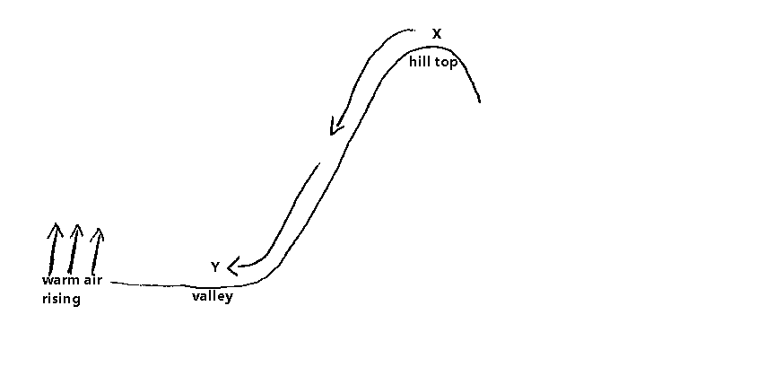
Name
(i) The type of the wind. (1mk)
(ii) Zones X and Y (2mks)

PRINTED AND COMPILED BY
PERFECT STEPS PUBLISHERS
0721 745374/ 0721 707626 NAIROBI

MARKING SCHEME GEOGRAPHY FORM 1
1 (a).Define the term solar system 2MKS
-It refers to the sun the planets and the heavenly bodies surrounding it.
(b). State three reasons why the interior of the earth is believed to be very hot 3mks
- presence of the radio activity in the mantle and core
-during the formation of the earth the the interior cooled much slower hence retaining much of the original heat
- the weight of the underlying material exerts pressure on the interior hence increasing heat.
2(a). What is the shape of the earth. 2mks
-Sphere/geoid
(b). Name three forces responsible for the shape of the earth.
- Centripetal
-Centrifugal
Gravitational
3(a), define the term earth revolution 2mks
It’s the movement of the earth along its orbit in 365 days
(b) State three effects of earth revolution 3mks
-causes the four seasons
- causes lunar eclipses
-causes difference of 15 MINbetween the meridians
4(a) Name the two discontinuity in the interior of the earth 2mks
-Mohorocivic
-Gutenberg
(b) Name three metals that makes the interior of the earth 3mks
-Silicon
-aluminum
-Magnesium
5. State Five Planets In Order Of Their Distance From The Sun 5mks
Mercury
Venus
Earth
Mars
Jupiter
6. (a)Define the term weather 2mks
- It’s the daily atmospheric condition of a place
(b) Name three elements of weather. 3mks
-Temperature
-Wind
-Precipitation
© State three factors influencing the temperature of a place. 3mks
-Altitude
-Latitude
-Aspect
D)(i) Highlight factors to consider when sitting a weather station 3mks
- Should be away from tall building n vegetation to allow free circulation of air.
-Should be on gently sloping ground to avoid flooding.
-Should be fenced to ensure security of instruments
(ii) state three instruments that are kept in Stevenson screen 3mks
-Thermometer(maximum n Minimum)
-Barometer
-hygrometer.
E. State four types of local winds. 4mks
-Katabatic
-Anabatic
-Land breeze
-Sea breeze
f) Explain the meaning of the following terms
(I)Negative lapse rate 2mks.
- It’s the phenomenon where temperature decreases with increase in height,
(ii) Zero lapse rate. 1mk
It’s a phenomenon where temperature remain constant as the height increases
(iii) State four layers of the atmosphere 4mks
-troposphere
-Stratosphere
-Mesosphere
-Thermosphere(a)

7. (a) (i) MINING refers to the process of extracting valuable minerals from the earth surface or beneath the earth’s surface. (2mks)
(ii) Three ways in which minerals occur
Veins and lodes
Seams and beds
Weathering products
Alluvial deposits Any 3 x 1 = 3mks
(b) (i) Stripping as a method of mining
It involves the removal of overburden or overlying rock/soil/vegetation to expose the underlying mineral ore.
If the mineral ore is soft, it is mined using simple tolls eg. Hoe and spades.
If it is hard, it is blasted to loosen and then loaded to trunks, railway wagons for further processing. 3 x 1 = 3mks)
(ii) Factors which favour the formation of Trona in L. Magadi
High temperature above 37⁰c
Inland drainage basins where minerals are deposited
High evaporation rate leading to minerals being left behind after evaporation
The minerals are also brought to surface by the hot springs and washed into the basin.
4 x 1 = 4mks
C. (i) Problems facing mining industry in Kenya
Insufficient capital – scarcity of money to prospect for minerals, buy and install machinery for mining and processing.
Control of mining operations in Kenya by foreign companies who remit bulk of the export revenue to their countries at the expense of Kenya.
Some minerals occur in small quantities and are uneconomical to export eg. Silver mica etc.
Lack of adequate skilled personnel which has resulted to the importation of expartriates from outside Kenya to run mining operations
Collapse of mines eg. Gold mining areas like kakamega resulting to the death of miners
Inaccessibility of some areas where minerals are located due to poor transport making it difficult to be exported
Shortage of power supply which is required for mining making it difficult for Kenya to maximize mineral exportation.
Any relevant point Any 3 x 2 = 6mks
C. (ii) Effects of land dereliction
Accelerates soil erosion in the area
Wastes potential agricultural land
It erodes the aesthetic value of land
It may cause accidents to children – deep open pits pose danger to travelers
Water collects in open pets to form breeding grounds for mosquitoes and other pests.
Any 3 x 1 = 3mks)

Problems facing gold mining in S. Africa
Rising cost of production
Continuous rise in labour cost

8.(a) Name and explain two main sources of statistical data 4mks.
- Primary data: this is the data that is being collected for the first time ie first hand data.
-Secondary data. This refer to the data that has already being collected and recorded.
(b) State five methods of collecting statistical data 5mks
-Direct observation
-Administering questionnaire
-Interviews
-Sampling.
-Experiments
C ) Highlight five ways in which data can be recorded.
-Tallying
-Note taking
- Tape recording
-photographing
-labelling the samples.
9
Characteristics of planet.
All planets revolve around the sun
Each planet has its own gravitational force maintained by the sun
They are spherical
Planets rotate as they revolve. 2 x 1 – 2mks

Weaknesses of the passing star theory.
Chances of another star approaching the sun are next to nil
High temperature gaseous materials drawn from the sun would disperse rather than condense.
The effects of the star that set the planets in orbit around the sun would have reduced by now.
The gases would have followed the star since it had a greater gravitational pull.
The origin of the star is not mentioned. 3 x 1 = 3mks

10(a) Differentiation between lapse rate and temperature inversion
lapse rate is the rate at which the temperature decreases with increasing attitude while temperature inversion is where temperatures increase with altitude. (2mks)
(b) (i) Katabatic wind (1mk)
(ii) X – High pressure zone. (1mk)
Y – low pressure zone. (1mk)

PRINTED AND COMPILED BY
PERFECT STEPS PUBLISHERS
0721 745374/ 0721 707626 NAIROBI

