GATITU MIXED SECONDARY SCHOOL
GEOGRAPHY FORM ONE CAT 1 END TERM 3 2014
TIME: 1 HR
- State two components of the solar system. 2mks

- Give two theories that explain the origin of the earth and solar system. 2mks

- State three fores that are responsible for the shape of the earth 3mks

- State two effects of rotation of the earth 2mks

- Highlight the four layers of the atmosphere. 4mks

- Give three factors considered when sitting a weather station. 3mks

- State two weather instruments found in the Stevenson screen. 2mks

- Why the Stevenson screen is painted white? 1mk

- What is the significance of weather forecasting? 2mks

- Define the following terms:
- Environmental lapse rate 1mk

- Zero lapse rate. 1mk

- The three isothermal layers of the atmosphere are tropopause, stratopause and menopause. What is common about the layers 1mk

- State any four types of precipitation. 4mks

- Fill the table below using the appropriate isoline 4mks
element | Isoline
Air pressure
Rainfall
Sunshine intensity
Temperature

- Use a well labeled diagram to show how solar eclipse is formed. 3mks

- Study the diagram below and answer the questions that follow.
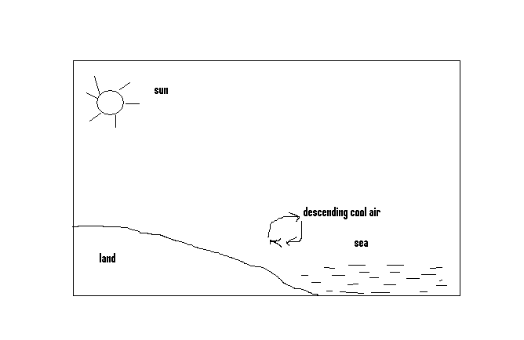
- What type of breeze is represented in the diagram above 1mk

- When does it occur 1mk

- Use the diagram below to answer the questions that follow.
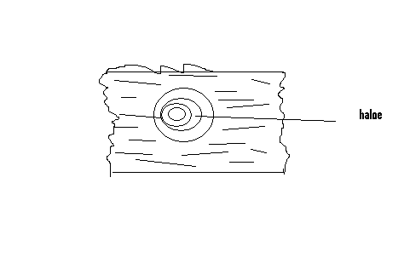
- What type of cloud is shown above? 1mk

- State two characteristics of the cloud. 2mks

Learn from the past, live by today and dream for the future,,,,,,, Willis fp

