GATITU MIXED SEC SCHOOL GEOGRAPHY FORM TWO OPENER
TERM TWO 2015

Answer all the questions in this section
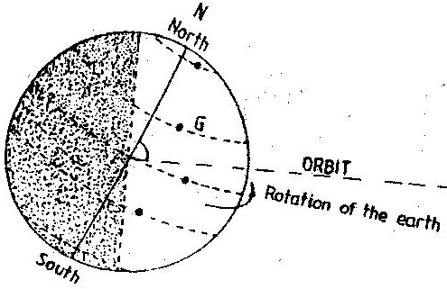
- The diagram below represents the earth on its axis. Use it to answer question (a)

  - (i) Name the latitude marked G (1mark)

(ii) What is the angle of inclination of the earth’s axis from it orbit? (1mark)

  - State two effects of the rotation of the earth (2marks)

- (a) What is magma? (1mark)

(b) Differentiate between a sill and a dyke (2marks)

(c) The diagram below represents a composite volcano. Name the features marked P,Q, and R (3marks)

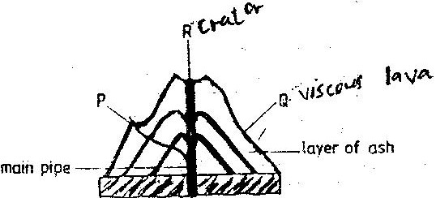

3.State three causes of earthquakes (3marks)

4.Give four proofs that the earth is spherical (4marks)

(a) State two conditions considered in choosing a suitable site for a weather station (2marks)

(b) Name three weather recording instruments that are placed in a Stevenson’s screen (3marks)

(c) Give two reasons why weather forecasting is important (2marks)

5. The diagram below represents the flow of air current. Use them to answer
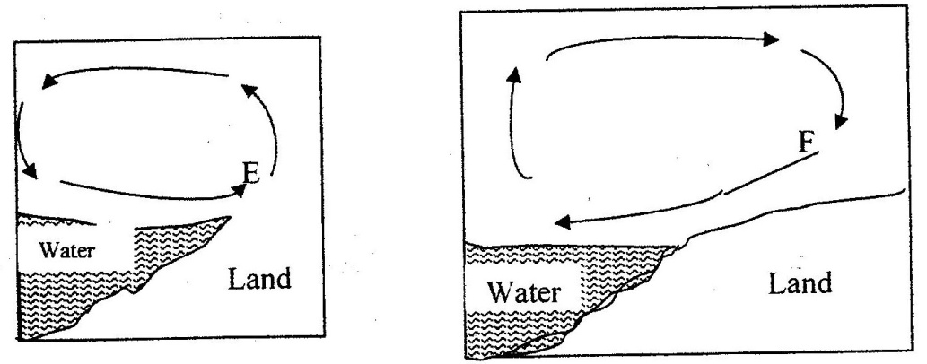
question

- (i) In your answer booklet, name the air current marked E (1mark)

- (ii) Why does the air cools as it rises (2marks)

6.The diagram below represents features produced by faulting.
Use it to answer questions that follow.
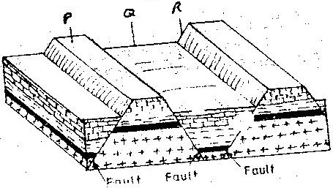

- Name the features marked P,Q, and R (3marks)

- Differentiate between a normal faulty and a reverse fault. (2marks)

