COUNTY MULTILATERAL EXAMINATION 2016
FORM TWO GEOGRAPHY END OF TERM TWO
ANSWER ALL THE QUESTIONS IN THIS PAPER
1(a) What is a rock? (2 mks)

b) Give three characteristics of sedimentary rock. (3 mks)

2(a) What is a mineral? (2 mk)

b) Explain how the following influence the occurrence of minerals.
i) Evaporation. (2 mks)

ii) Vulcanicity (2 mks)

3. Give three reasons why it is important to study geography. (3mks)

4(a) State two main types of photograph. (2 mks)

b) Identify three main parts of a photograph. (2 mks)

5(a) Give two natural causes of climate change. (2 mks)

b) Give three human factors that contribute to increased carbon dioxide in the atmosphere. (3 mks)

6. Study the map of Migwani provided (1:50,000) and answer the following questions.
i) Give the six figure grid reference of Usyanischool 95-65. (2 mks)

ii) Give the latitudinal extent of the area covered by the map to the nearest degree.
(2 mks)
b(i) What was the magnetic variation when the map was prepared in 1970. (2 mks)

ii) Identify three main rivers shown on the map to the east of easting. 10 ( 3mks)

c(i) Find the distance of the day weather road from the grid square 1280 to grid square 1083. Give your answer in kilometers. (2 mks)

ii) What is the area of part of the map enclosed between easting 10 and northing 80. (2 mks)

d(i) Identify two methods of representing relief shown on the map extract. (2 mks)

ii) name four social services provided in the area covered by the map.

iii) Name three man made features on the grid square 9980. (3 mks)

7(a) (i) What is natural vegetation. (2 mks)

ii) State thee characteristics of Mediterranean vegetation. (3 mks)

b) The diagram below represents zones of natural vegetation on a mountain in Africa. Use it to answer the questions below.
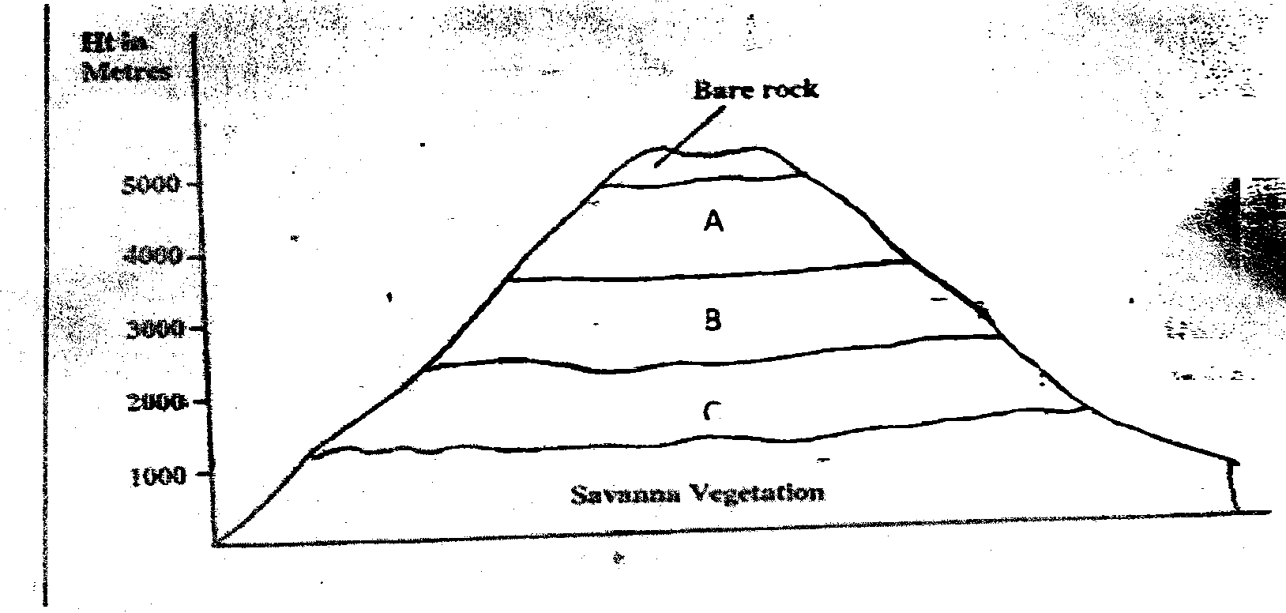

i) Name the vegetation zones marked A, B and C. (3 mks)

ii) Describe the characteristics of savanna vegetation. (6 mks)

iii) Name the temperate grassland found in the following countries.
- Australia 1 mk

- Canada 1mk

- Russia 1mk

d) Explain four ways in which the desert vegetation adapt to environmental conditions of the region. (8 mks)

8(a)(i) Distinguish between faulting and folding. (2 mks)

iii) Draw a well labeled diagram to show the parts of a fold. ( 5mks)

b)(i) Illustrate the formation of the Rift Valley by tensional forces. (7 mks)

ii) Give reasons why the Rift Valley is not well developed in Tanzania. (2mks)

(c) You are to carry out a field study in the Rift Valley.
i) Outline the preparation. (4 mks)

ii) What three other faults features would you study apart from the Rift Valley. (3mks)

iii) Formulate a null hypothesis of your study.

iv) Give two follow up activities you would carry out. (2 mks)

