NAME …………………………….. INDEX NO. ……..…
DATE ……………………………. CLASS ……………..
MWAKICAN FORM 3 JOINT EXAMINATION – 2015 TERM 1
KENYA CERTIFICATE OF SECONDARY EDUCATION

312/2
GEOGRAPHY
PAPER II
FORM 3
MARCH/APRIL 2015
TIME 2 ½ HOURS

INSTRUCTIONS TO CANDIDATES
- This paper consists of two sections: A and B.
- Answer ALL the questions in section A. in section B, answer question 6 and any two other questions.
- All answers must be written in the answer booklet provided.

SECTION A: 25 MARKS
Answer all the questions
1. (a) What is a photograph? (2 mks)

(b) Name three types of ground photographs. (3 mks)

2. (a) State three formations in which minerals occur. (3 mks)

(b) Name two areas where gold is mined in East Africa. (2 mks)

3. (a) Distinguish between forest and forestry. (2 mks)

(b) State three factors favouring growth of Mt. Kenya forest. (3 mks)

4. (a) Name two types of questionnaires. (2 mks)

(b) State three factors to consider when preparing a questionnaire. (3 mks

5. (a) Name three middle east countries that are oil producers. (3 mks)

(b) Give two by products obtained when crude oil is refined. (2 mks)

SECTION B
Answer question 6 and any other two questions.
6. The table below shows Kenya’s principal mineral by value in Ksh. 000,000 between 1991 – 1994.
MINERAL | 1991 | 1992 | 1993 | 1994
SODA ASH | 60 | 70 | 80 | 100
FLOURSPAR | 25 | 50 | 40 | 60
DIATOMITE | 35 | 40 | 50 | 55
LIMESTONE | 70 | 80 | 95 | 110
(a) (i) Draw a cumulative bar graph to represent the information given above. (8 mks)

(ii) State three advantages of using cumulative bar graph in data presentation. (3 mks)

(b) Explain three ways in which Kenya has benefited from mining soda ash. (6 mks)

(c) (i) Name three main places where diamonds are mined in south Africa. (3 mks)

(ii) Describe the processing of diamond in South Africa. (5 mks)

7. (a) (i) Name two indigenous softwood trees in Kenya. (2 mks)

(ii) State five factors that favour the development of softwoods in Kenya. (5 mks)
(b) (i) Explain four problems experienced in commercial exploitation of tropical rain forests in Africa. (8 mks)

(ii) Give four protective roles of forests in a country. (4 mks)

(c) Explain three problems Canada experiences in exploiting her forests. (6 mks)

8. (a) Name three methods of underground mining. (3 mks)

(b) Explain four factors influencing the exploitation of minerals. (8 mks)

(c) Give four significance of mining in Kenya. (4 mks)

(d) State four problems facing the mining industry in Kenya. (4 mks)

(e) Explain three negative effects of mining on the environment. (6 mks)

9. Use the table below to answer the questions that follow.
(a) Differentiate between secondary and primary data. (2 mks)
Number of dairy animals in division X on the Kenyan highlands in 1992.
TYPE | NUMBER
Guernsey | 8400
Ayrshire | 7200
Jersey | 10800
Friesian | 16400
Sahiwal | 5200

(b) (i) Using a scale of 1cm to represent 4000 animals, represent the above data using a divided rectangle. (6 mks)

(c) State two advantages of using a divided rectangle to represent data. (2 mks)

(d) Name three other ways through which the data above can be statistically presented. (3 mks)

(e) Name five methods of collecting data. (5 mks)

(f) Name three major methods of analyzing data. (3 mks)

(g) Give two advantages and two disadvantages of using a simple wind rose in
data presentation. (4 mks)

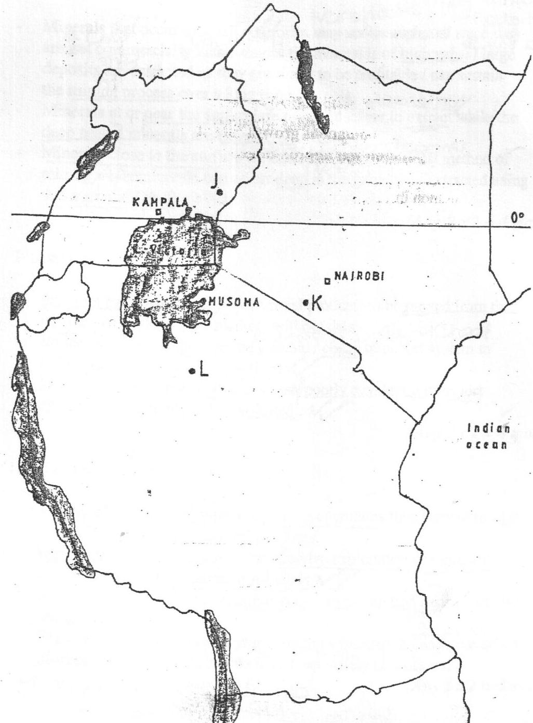
10. The map below shows the location of some minerals in East Africa.

(a) Name the minerals mined in the areas marked J, K and L. (3 mks)

(b) Students from Gatero secondary school went for a field work in the area marked K.
- List down the normal pattern that the fieldwork procedure takes. (5 mks)

(ii) Give five activities the students will require to do before going for the fieldwork. (5 mks)

(iii) State three objectives of the study. (3 mks)

(iv) List three problems they are likely to encounter during the study. (3 mks)

(v) Prepare a working schedule to be used during the study. (4 mks)

(vi) List two follow-up activities that they will carry out after the study. (2 mks)

