NAME …………………………….. INDEX NO. ……..…
DATE ……………………………. CLASS ……………..
MWAKICAN FORM 3 JOINT EXAMINATION – 2015 TERM II
KENYA CERTIFICATE OF SECONDARY EDUCATION

312/2
GEOGRAPHY
PAPER II
FORM 3
JULY/AUGUST 2015
TIME 2 ³/₄ HOURS

INSTRUCTIONS TO CANDIDATES
- This paper consists of two sections: A and B.
- Answer ALL the questions in section A. in section B, answer question 6 and any two other questions.
- All answers must be written in the answer booklet provided.

SECTION A: 25 MARKS
Answer all the questions
- (a) Name two areas where gold is mined in Tanzania. (2 mks)
(b) State three industrial use of copper as a mineral. (3 mks)
(c) Name three methods of alluvial mining (placer mining). (3 mks)

- (a) A photograph is divided into 3 parts. Name them. (3 mks)
(b) State three limitations of using photographs. (3 mks)

- (a) List three main types of sampling. (3 mks)
(b) Name the methods that are used to analyse statistical data. (3 mks)

- Name two types of questionnaires. (2 mks)

- Outline three types of field work. (3 mks)

SECTION B:
Answer question 6 and any other two questions from this section.
- Use the table below to answer the questions that follow.
(a) The table below shows the quantity of minerals produced in Kenya in tonnes in 2010 and 2011.
MINERALS/YEARS | 2010 | 2011
Soda ash | 290,000 | 350,000
Fluorspar | 40,000 | 80,000
Salt | 20,000 | 40,000
Others | 10,000 | 20,000
TOTAL | 360,000 | 490,000
- Draw proportional circles to present the information above. (14 mks)

- State two advantages of using proportional circles in data representation. (2 mks)

(b) (i) Name any two fuel minerals. (2 mks)

(ii) Name three major oil producers in the Middle East. (3 mks)

(iii) State four contribution of oil to the economies of the Middle East countries. (4 mks)

- Study the map below showing the distribution of world’s natural forests.
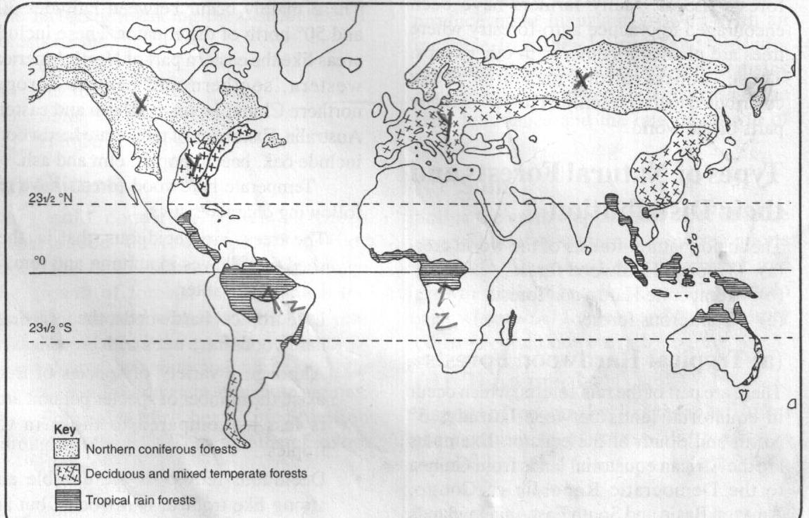

- Name the types of forests found in the regional marked X, Y and Z. (3 mks)

- State three characteristics of temperate hardwood forests. (3 mks)

- (i) Differentiate between afforestation and Re-afforestation. (2 mks)

(ii) Explain four measures the government has taken to realize effective management of the forests. (8 mks)

(iii) State five problems facing forests in Kenya. (5 mks)

(d) Explain two importance of forest exploitation in Canada. (4 mks)

- (a) Name two major types of aerial photographs. (2 mks)

(b) To describe the major relief features in a photograph, some clues are used. Name four of them. (4 mks)

(c) Explain how each of the following features would be indentified in a photograph.(8 mks)
(i) Settlement

(ii) Planted trees

(iii) Mining

(iv) Manufacturing

(d) (i) Name two methods of open cast mining. (2 mks)

(ii) Briefly explain the shaft method of underground mining. (5 mks)

(iii) Name the areas where the following minerals are mined in Kenya. (4 mks)
- Fluorspar –
- Diatomite –
- Gold –
- Titanium –

- (a) What is field work? (2 mks)

(b) Name three types of fieldwork. (3 mks)

(c) You plan to carry out a field study of an open air market near your school.
- State four types of information you would collect during the field study. (4 mks)

- List four methods you would use to collect the data. (4 mks)

- Explain three ways in which the local authority would use your findings to improve the open air market. (6 mks)

- State two hypothesis for the study. (2 mks)

- What are the advantages of learning geography through fieldwork. (4 mks)

- (a) The table below represents Kenya’s export crops 2009-2011 in ‘000 tonnes.
COMMODITY | 2009 | 2010 | 2011
Coffee | 230 | 200 | 190
Tea | 210 | 240 | 320
Sisal | 50 | 30 | 40
(a) (i) Using the table above, draw a comparative bar graph to present the data. (7 mks)

(ii) State two advantages of using comparative bar graphs to present data. (2 mks)

(iii) Name three other methods of data presentation that can be used to present the data above. (3 mks)

(b) Name two methods used in taking measurement as a way of collecting statistical data. (2 mks)

(c) Name three secondary sources of statistical data. (3 mks)

(d) Explain four factors you would consider when setting up questions in a questionnaires. (8 mks)

