GATITU MIXED SECONDARY SCHOOL
MID TERM EXAM FORM three 2015
GEOGRAPHY

1. a) i)Name two sources of rivers. (2mks)

ii)The diagram below shows the three stages of the long profile of a river.
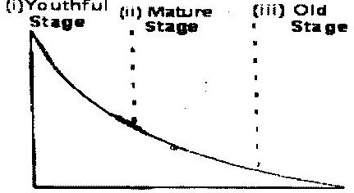

Give two features formed by the rivers in each of the three stages. (6mks)

2. The diagram below shows the structure of the earth.
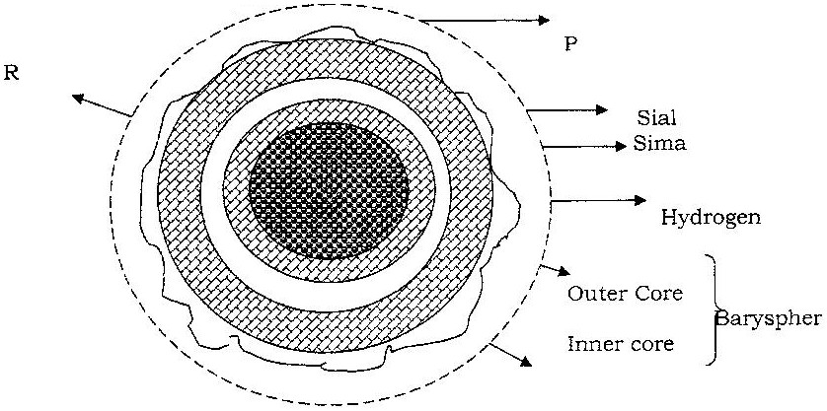

a) Name the parts marked p, q and R (3mks)

b) Name the minerals that make up
sima (2marks)

3. what is desertification? (1mark)

) State two negative effects of desertification. (2marks)

4. a) The table below shows climatic data of a station in Kenya.
Use it to answer question

Month | Jan | Feb | Mar | April | May | June | Jul | Aug | Sep | Oct | Nov | Dec
Temp in ºC | 28.9 | 29.7 | 30.3 | 29.9 | 29.7 | 29.2 | 28.4 | 28.7 | 29.6 | 30.1 | 29.2 | 28.7
Rainfall in mm | 9.0 | 8.0 | 21.0 | 49.0 | 25.0 | 9.0 | 20.0 | 10.0 | 4.0 | 10.0 | 17.0 | 11.0

- What is the annual range of temperature at the station? (1mark)

- Calculate the total rainfall for the station.

b) State two factors that influence climate. (2marks)

c) What is the solar system? (2 marks)

5..The diagram below shows some intrusive features formed by vulcanicity.
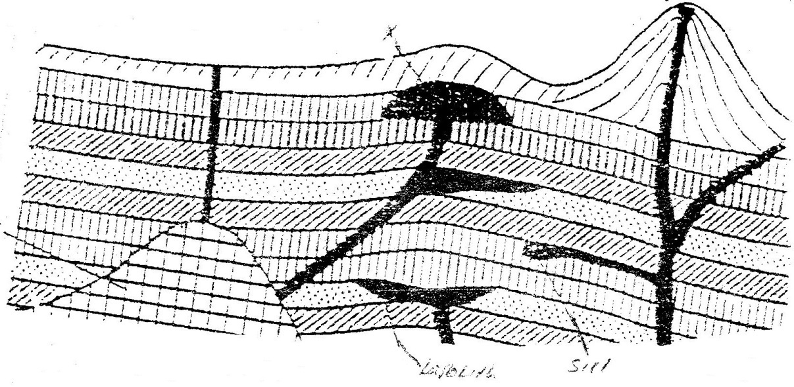
Use it to answer question (a)

a) i) Name features marked X,Y, and Z (3mks)

ii) Explain how a sill is formed (4mks)

b) Describe the characteristics of a composite volcano (3mks)

c) Explain four ways in which volcanic mountains positively influence human activities. (8mks)

d) Students carried a field study on volcanic rocks
i) Give three reasons why it is necessary to collect rock samples during such a field study. (3mks)

ii) State two problems they are likely to have experienced during the field study (4mks)

