PERFECT STEPS PUBLISHERS
END TERM EXAMS 2015
0721 745374/ 0721 707626 NAIROBI
FORM 3 PAPER 1
312/1

GEOGRAPHY
PAPER 1
2³_{/4} HOURS

Instructions to candidates

1. This paper has two sections: A and B.
2. Answer ALL the questions in section A. In section B answer question 6 and any other two questions.
3. All answers must be written in the answers booklet provided.
4. Candidates should check the question paper to ascertain that all questions are included without any part missing.

SECTION A

Answer ALL the questions in this section.

1. (a) What is a plateau? [2marks]

(b) Name two examples of lava plateau found in Kenya. [2 marks]

2. a) Name the temperate grasslands found in the following regions.
i) Canada [1 mark]
ii) Australia [1 mark]
iii) Argentina [1 mark]

b) State three ways in which plants adapt to hot desert conditions. [3 marks]

3. a) Differentiate between chemical and physical weathering. [2 marks]

b) State three factors that affect the speed of mass wasting. [3 marks]

4. a) Define the term drainage basin. [2 marks]

b) The diagram below shows river capture.

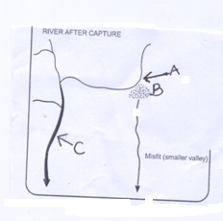

Name the parts marked. [3 marks]
A
B
C

5. a) The diagram below shows a feature resulting from wind erosion to in a desert.
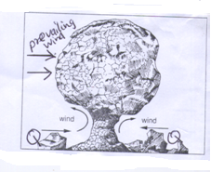
i) Identify the feature shown above. [1 mark]

ii) Name the materials marked Q. [1 mark]

b) i) State two reasons why the feature shown is harrow at the bottom.

ii) Give one example of a ridge feature formed through wind erosion in the desert. [1 mark]

SECTION B
Answer question 6 and any two other questions from this sections.
Answer question 6 and any other TWO questions from this section.

6. Study the map of Nkubu (1:50,000) sheet 122/1 provided and answer the following questions.

a)i)Calculate the bearing of the water hole at grid square 4388 from the trigonometric station at grid square 4193. [2 marks]
ii) Convert the scale of the map to a statement scale. [2 marks]
iii) Measure the length of the dry weather road D477 from the function at grid square 5099 to the Junction at grid square 5799. [2 marks]
iv) Calculate the area enclosed by the roads E778 and the all weather bound surface road B6 on the South east of the area covered by the map. [2 marks]

b) i) Describe how relief have influenced settlements in the area covered by the map.
[6 marks]
ii) Citing evidence from the map name three human economic activities carried out in the area covered by the map. [3 marks]

c) Using a vertical scale of 1 cm to represent 50 meters.
i) Draw a cross section from grid reference 540940 to 540998. [3 marks]
ii) On the cross section, mark and name the following. [3 marks]
  - Road
  - A swamp
  - A quarry
iii) Calculate the vertical exaggeration of the section you have drawn. [2 marks]

7. a) i) What is a rock? [2 marks]
ii) State two reasons why sedimentary rocks are widespread in the coastal plain. [2 marks]

b) i) State four changes that may occur in sedimentary rocks when they are subjected to intense heat and pressure. [4 marks]
ii) Describe three processes through which sedimentary rocks changes into metamorphic rocks. [6 marks]

c) Describe how coral rocks are formed. [5 marks]

d) Suppose you were to carry out a field study of rocks within your vicinity of your school.
i) Name three secondary sources of information you would use to prepare for the field study. [3 marks]
ii) State three activities you would carry out during the field study. [3 marks]

8. a)i)Define the term climate. [2 m arks]
The map below shows climatic regions in Kenya. Use it to answer the questions
(ii) and (iii).

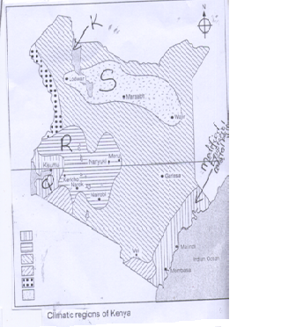

ii) Identify the types of climate found in the shaded areas marked Q, R and S. [3 marks]
iii) Name the lake marked K. [1 mark]

b) State the characteristics of the modified equatorial coastal region climatic type. [4 marks]

c) Explain how the following factors influence climate.
i) Altitude [3 marks]
ii) Continentality [3 marks]

d) i) Name three cold deserts in the world. [3 marks]

ii) Explain three human activities that contribute to climate change. [6 marks]

9. a) i) Differentiate between a spring and a well. [2 marks]

ii) State four conditions favouring formation of Artesian well. [4 marks]

b) i) What is a Karst scenery? [2 marks]

ii) Name five features formed on the surface in a Karst area. [5 marks]

c) With the aid of well labeled diagrams describe how a limestone pillar is formed. [6 marks]

d) Explain the significance of Karst scenery to human economic activities. [6 marks]

10. a) i) Define the term glaciation. [2 marks]

ii) Name two types of glaciers. [2 marks]

b) i) State two processes through which glaciers erode. [2 m arks]

ii) With the aid of well labeled diagrams describe how a cirque is formed. [8 marks]

iii) Give two examples of tarn lakes on Mt. Kenya. [2 marks]

c) You intend to carry out a field study on glaciated landscape.
i) State three reasons why you would require a route map. [3 marks]

ii) Name three features formed by glacial deposition you would have identified. [3 marks]

iii) Give three follow up activities you would be involved in after the field study. [3 marks]

PRINTED AND COMPILED BY PERFECT STEPS PUBLISHERS: 0721 745374/0721707626 NAIROBI

MARKING SCHEME FORM 3GEOGRAPHY PAPER 1

Q1. (a) What is plateau?
It is an extensive fairly level land which is elevated in relation to the adjacent area.
Or
An elevated plain with an even or undulating, slightly dissected surface and separated by distinguishable scarp from the adjacent country. [2 marks]

(b) Two examples of lava plateaus in Kenya.
  - Yatta
  - Laikipia
  - Uasin Gishu
  - North West Kenya
  - Maralala –stony Athi plateau

Q2. (a) Temperate grasslands
i) Canada – Prairis
ii) Australia – Downs
iii) Argentina – Pampas [1 mark each]

(b) Three ways in which plants adapt to hot desert conditions.
  - Some plants have thick or succulent leaves or barks to enable them store water.
  - Some plants have long roots to tap water from underground.
  - Some plants have thin spiky or needle like leaves or waxy leaves to reduce the rate of transpiration.
  - Some plant seed remain dormant for a long time, awaiting the short rains to germinate.
  - Some plants have thick or hard barks to reduce transpiration.
  - In the absence of moisture, some plants wilt but have quick recovery ability.
  - Some plants have thorns to protect themselves against browsing animals.
  - Some plants are quick sprouting to take advantage of the short lived desert rains.
  - Most plants are stunted due to the harsh conditions.
  - Some plants have underground bulbs to survive the long drought.

Q3. (a) Difference between chemical and physical weathering.
Chemical weathering is the actual decay or decomposition of rocks while physical weathering is the disintegration of rocks without alteration of its chemical composition.
(b) Three factors that affect the speed of mass wasting.
  - Steep slopes leads to faster movement of materials/gentle slopes leads to slow movement of materials.
  - The nature and weight of the materials.
  - The level of saturation of the ground/amount of water.
  - Bare surfaces leads to fast movement/dense vegetation cover reduces the movement of materials.
  - Earth movements triggers mass wasting .
  - Human activities like mining building and construction, deforestation, quarrying, overgrazing, cultivation initiates and accelerates mass wasting.
[any 3 x 1 = 3 mks]

Q4. (a) Define a drainage basin.
It is the entire system of the river its tributaries and distributaries.
[2 marks]
(b) Features of a river capture.
A = Elbow of capture
B= Wind gap
C=Pirate stream/master stream
[3 marks]
Q5. a) Desert feature
i) Mushroom block
ii) Q – Rock debris
bi) Two reasons why the feature below is narrow at the bottom.
Higher rate of wind abrasion from the heavier materials on the ground.
The occurrence of wind eddies results in higher rate of wind deflation.
[2 x 1 = 2 marks]
ii) One example of a ridge feature formed through wind erosion in the desert.
  - Zeugen
  - Yardangs [1 mark]
Q6. Map work
a)(i) Calculating bearing of waterhole from the trigonometric station.

150^{o√√} + 1 (149º/151º)

ii) Conversion of the RF scale to statement scale.
1:50,000 50,000 = ½
100000
1 centimeter represents half a kilometer.√√

iii) The length of the dry weather road D477
8.4 km√√ + 0.1 (8.3 km/8.5 km)

iv) The area enclosed by the roads E778 and the B6.
29 feet sq = 29 km²
= 44 km² + 0.5
30half sq = 30 x ½ = 15 km²

b)i) Describing how relief have influenced settlements in the area covered by the map.
  - Areas with steep slopes as indicted by closeness of contours are avoided as its difficult to construct a house.
  - Areas with gentle slopes as indicated by spaced contours have dense settlements as it’s easy to construct a house.
  - River valleys are avoided e.g along R. Kithinu because of inaccessibility.
  - The high altitude shown by contours 2640 m at Kaiye hill/ for example areas near Kenya forest are sparsely settled due to low and favourable temperatures.
[3 x 2 = 6 marks]
ii) Human economic activities in the area covered by the map.
  - Trading evidenced by presence of shops/mkts
  - Processing industry evidence by presence of coffee factories
  - Livestock farming evidence by presence of cattle dips/dairy experimental farm
Forestry/lumbering evidenced by forest camp
- Transporting evidenced by presence of roads
- Communication evidenced by presence of Post office
- Quarrying evidenced by presence of quarries
- Farming evidenced by presence of farmers training centre.
[Many other correct 3 x 1= 3 marks]
(c) i)

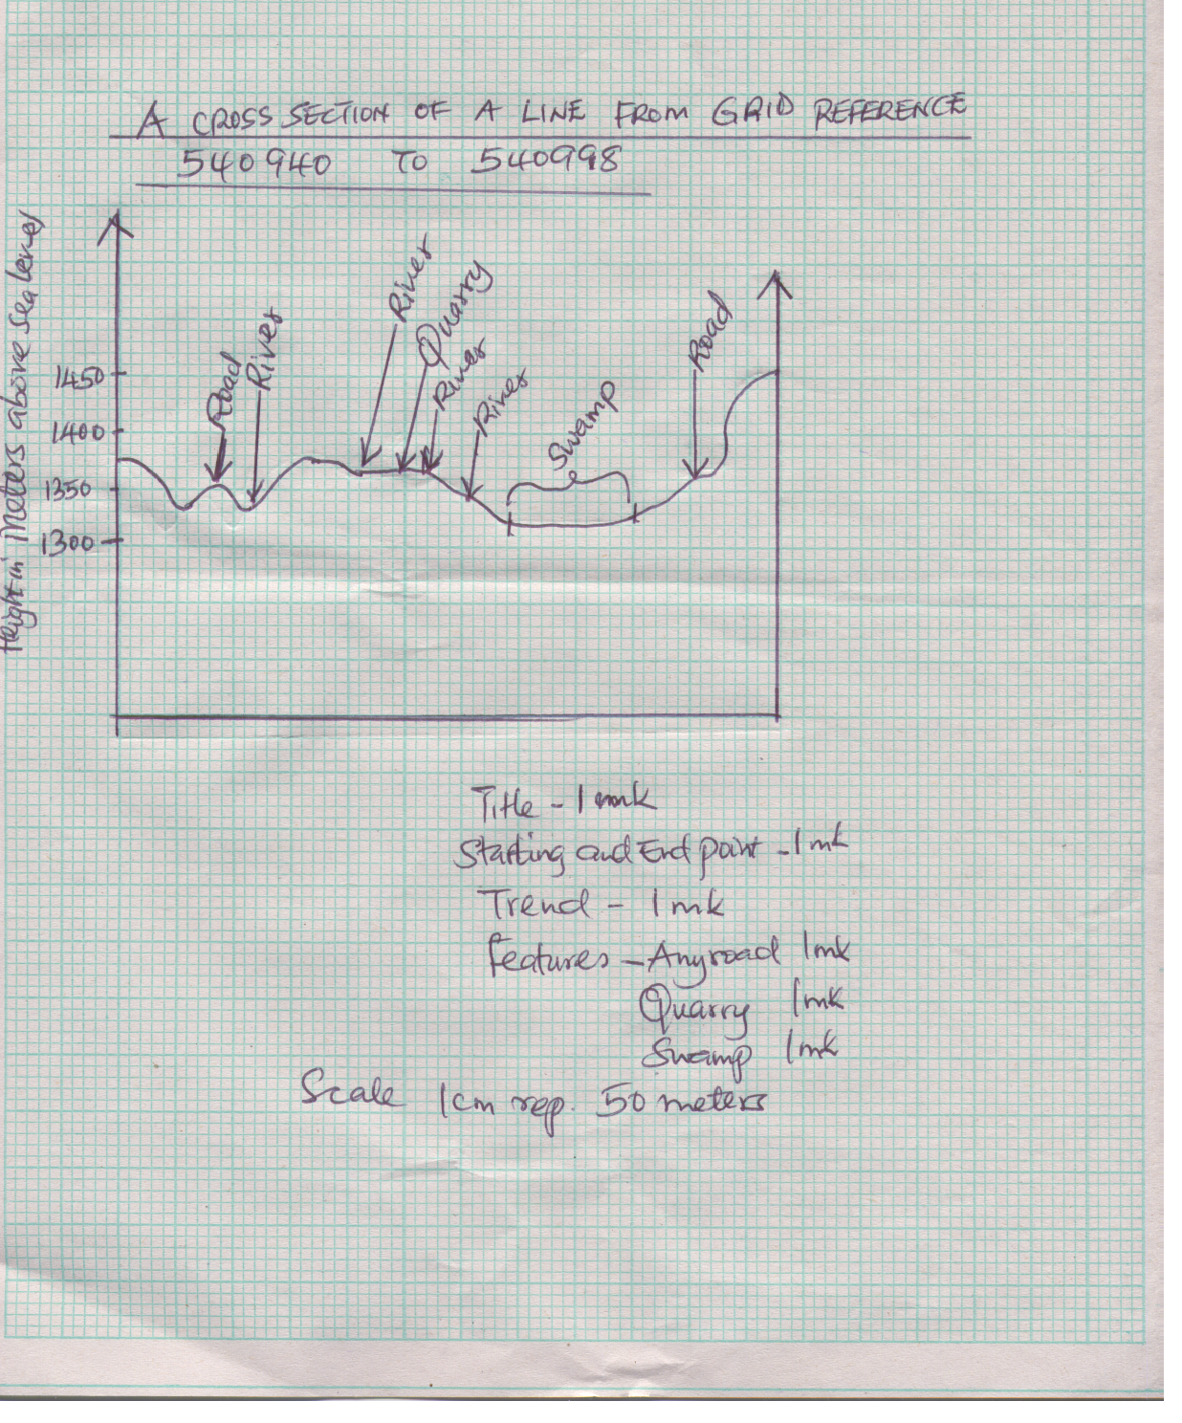

ii) Calculation of vertical exaggeration.
VS i.e 1 ÷ 1
HS 5000 50,000

1 x 50,000 = 10√√
5000 1

Q7. a(i)A rock is a substance made up of mineral/combination of mineral particles cemented together and forms the solid part of the earth’s crust. [2 marks]

(ii)Two reasons why sedimentary rocks are widespread in the coastal plain.

  - The coastal plain was once a extensive part of the continental shelf of the Indian Ocean. Sedimentation took place on this shelf extensively.
  - The shallow continental shelf also provided a conclusive environment for the formation of coral rocks.
  - Upon emergence of he land from the sea, extensive areas with sedimentary rocks and corals were exposed as dry land.
[2 x 1 = 2 marks]

bi) Four changes that occur to sedimentary rocks when they are subjected to intense heat and pressure.
  - New minerals are formed
  - Further recrystallization of minerals occurs
  - Rock particles becomes compacted
  - The Physical appearances/colour changes.
  - The rock becomes metamorphosed
[4 x 1 = 4marks]
ii) Three processes through which sedimentary rocks changes into metamorphic rocks.
  - During the process of mountain formation pressure and heat are generated. They both modify the structure of the original rock. This is known as thermal dynamic metamorphism.
  - Weight of overlying rocks exerts pressure on the lower layers changing the rock structure. This is known as dynamic metamorphism.
  - Hot gases or liquids or magma may intrude into rocks during volcanic eruptions. The heat recrystallize the rock grains changing it structure. This is known as thermol/contact metamorphism/metasomatism.
[3 x 2 = 6 marks]
c) Formation of coral rocks.
- Coral rocks are formed by tiny marine organisms called coral polyps which live in colonies in the sea.
- The polyps extract calcium from the sea water to make their shells.
- When the polyps die, their hard exo-skeletons (the shells) of calcium carbonate accumulate into a solid mass.
- Successive colonies of polyps attach themselves onto the solid mass and onto one another.
- The spaces between the dead coral polyps are cemented by calcareous algae.
- The rock grows in size to become coral rocks.
[any 5 x 1 = 5 marks]
d)i) Three secondary sources of information.
- Textbooks/pamphlets/journals/periodicals/magazines/newspaper/hardouts
- Maps/geological maps
- Photo graphic/pictures/video tapes/slides/film
- Tape recorded information
[any 3 x 1 = 3 marks]
ii) Three activities in the field study.
- Drawing of sketches
- Observations
- Collecting of rock samples
- Making notes
- Taking photographs
- Asking/answering questions
- Study geological map
[any 3 x 1 = 3 marks]
Q8. ai) Climate is the average weather conditions of a place or region which have been observed over a long period of time e.g 20 to 30 years. [2 marks]
ii) Climate
Q – Modified equatorial lake basin
R – Modified tropical
S – Desert climate
[3 x 1 = 3 marks]
iii) Lake K – Lake Turkana [1 mark]

b) Characteristics of the modified equatorial coastal region type of climate.
  - The mean annual temperature ranges between 22ºC and 32ºC.
  - Annual range of temperature is small
  - Rainfall varies between 1000 mm and 1600 mm annually.
  - The rainfall regime is a double maxima
  - Rainfall is of convectional type
  - It falls mainly in the afternoon accompanied by thunderstorms
  - Rain falls all year round
  - There is high humidity
[4 x 1 = 4 marks]

c) Factors influencing climate
i) Altitude÷ Height above sea level influences amount of rainfall and temperature received in an area.
  - High mountains receive high rainfall and experience low temperature
  - Lowland altitude experience low rainfall if the area is in the interiors of the continent and high temperatures.
  - Low altitude areas are warmer than high altitude areas and atmospheric pressure is lower at high altitudes than at low altitudes.
[3 marks]
ii) Continentality
Distance from the sea, when other factors are constant, temperature and rainfall decrease as one moves away from a significant water body.
This effect is greater in temperate lands where extremes of temperature are experienced.
The diurnal range of temperature and annual temperature ranges of such areas are small compared to those experienced in the interiors of continents even though they are at the same latitude and altitude.
[3 marks]

d)i) Cold deserts in the world
  - Patagonian
  - Gobi
  - Turkestan
[3 x 1 = 3]
ii) Explain human activities that contribute to climate change.
Burning fossil fuels
- Combustion of fossil fuels for industry, transportation, space heating by rockets, electricity generation and cooking hence additional carbon dioxide in the atmosphere.
Forest and grassland fires
- Burning vegetation adds carbon-di—oxide into the atmosphere.
- Bush fires are usually set on grassland especially, those of the tropical savannah just before the onset of rains.
- Intentional and accidental fires are set on large tracts of forests hence additional of carbon-di-oxide in the atmosphere.
Deforestation and land use changes
- People clear large tracts of forests and grasslands for farming, industry and settlement they reduce the main disposal system for carbon dioxide from the atmosphere by photosynthesis.
Industrial and agricultural development.
- Gases like methane, nitrous oxides and those containing chlorine, fluorine and bromine are added into the atmosphere through industrial and agriculture activities.
Chlorofluorocarbons
- They are industrial chemicals which are produced through human activities.
- They are used as propellants in aerosols in refrigeration technology as agents in blowing foam in the plastics industry and as solvents in electronics.
- When released into the atmosphere they damage the ozone layer.

9. a)i) A spring is a natural outflow of water from the rocks.
Such water flows naturally from the underground while a well is a hole sunk into permeable rock to reach the water table.
[2 marks]
ii) Four conditions favouring formation of artesian well.
- The acquifer must be of same permeable materials.
- The acquifer must be exposed in an area of sufficient precipitation.
- The acquifer must lie in between two impermeable rocks for it to retain water.
- The basin must dip towards a region where the land surface is lower than it is at the exposed end of the previous formation.
- There must be a partial construction of total blockage of exit sufficient for the water that comes in higher portion of the acquifer to be replaced under pressure. (4 x 1 – 4 marks)
b)i) A Karst scenery is a limestone region where water action has created unique features.
[2 marks]

ii) Five features formed on the surface in a Karst area
- Scarps
- Hills
- Dry valleys
- Gorges
- Gully/grikes
- Clints
- Swallow holes/sink holes
- Dolines
- Uralas
- Polje
- Karst widows
- Karst bridges
[5 x a = 5 marks]
c) Formation of limestone pillar
Limestone pillars are formed when stalactite and stalagmite join

- If a stalagmite forms directly below a stalactite the two features grow towards each other.
- They eventually meet forming a continuous column that resembles a pillar
- This is the limestone pillar.

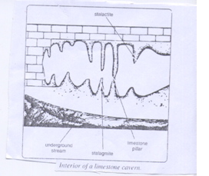
d) Significance of Karst scenery to human economic activities.
- Karst scenery features form good tourist attractions like the caves, gorges, dry valley etc.
- Collapse of dolines into the water table may lead to lakes in the karst areas. Solution lakes occur in poljes.
- These lakes provided permanent water sources in the limestone areas e.g. Lake Ojikoto near Tsumeb, Namibia.
- Karst scenery landscape is characterized with intermitten streams or absence of streams leading to scarcity of water supply in these areas.
- The limestone areas are also characterized by outcrops of bare rock, rugged rock and steep sided dry valleys with gorges which make development of infrastructure especially roads not only difficult but also expensive.
- Limestone is used in iron and steel industry where it is used to separate iron from other impurities.
- Limestone regions are very favourable for grazing purposes, particularly for sheep because the soil is thin and the surface dry.
- Cement used in the building industry is derived from linestone rock, for example in Kenya cement factories are found at Bamburi due to coral limestone and at Athi river near the limestone deposits.
[3 x 2 = 6]
10. a)i) Definition of glaciations
The process by which moving ice erodes, transports and deposits materials on the earth’s surface.
ii) Two types of glaciers
  - Mountain glacier
  - Alphine glacier
  - Valley glaciers
  - Piedmont glacier
  - Continental glacier
  - Cirque glaciers
b)i) State two processes through which glaciers erode.
- Abrasion/grinding
- Plucking/gouging/sapping
bii) Describing how a cirque is formed
- Snow accumulates in a shallow pre-existing depression on the mountain side.
- The ice exerts pressure on the cracks and the hollow beneath.
- As ice moves, it plucks the rocks in the hollow thus allowing more ice to collect in it.
- Plucking steepens the sides and backwall of the depression
- Debris within the glacier deepens the hollow through abrasion process.
- This result in a depression with a concave floor and the shape of an armchair called a cirque.
Diagrams

iii) Example of cirque lakes on Mt. Kenya.
Hidden
- Emerald
- Gallery
- Hanging tarn
- Teleki tarn
- Hohnel tarn
c) Field study on glaciated landscape
i) Importance of a route map
  - Help to identify the direction to follow
  - Help to prepare a work schedule
  - Help to locate features
  - Help to estimate the distances to be covered
  - Help to estimate the time the field study is likely to take

ii) Features formed from a glacial deposition
  - Alluvial fans
  - Terminal moraines
  - Erratics
  - Boulder train
  - Till/boulder train
  - Drumlins
  - Eskers
  - Karnes
  - Outwash plain

iii) Follow up activities
  - Reading more on the topic
  - Displaying photographs
  - Displaying samples
  - Holding discussions
  - Carrying out analysis
  - Confirming or legating the hypotheses
  - Writing the field study report
  - Giving recommendations

PRINTED AND COMPILED BY PERFECT STEPS PUBLISHERS: 0721 745374/0721707626 NAIROBI

C