MUKINDURI MIXED DAY SECONDARY SCHOOL
MIDTERM EXAM TERM 2 2017
GEOGRAPHY FORM 4
NAME……………………………………………………..ADM……………
- a)State three conditions necessary for the development of Karst scenery. (3mks)
b)Give two reasons why there are few settlements in Karst landscapes. (2mks)
- The diagram below shows some features of a Karst scenery. Use it to answer question (a)

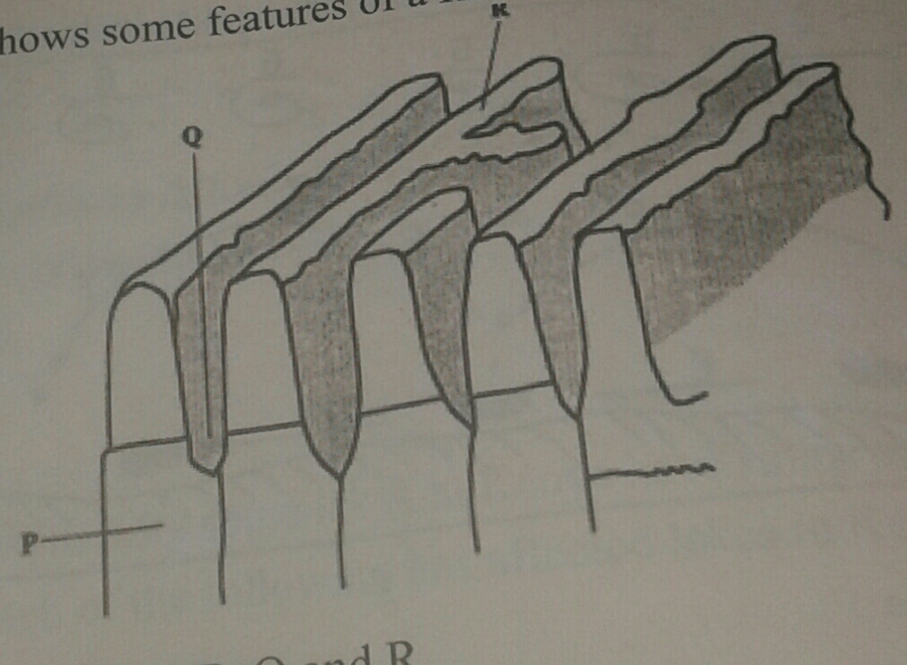
a)Name the features marked P,Q and R (3mks)
b)Describe carbonation as a process of chemical weathering. (3mks)
- The diagram below represents underground features in a limestone area. Use it to answer question (a)

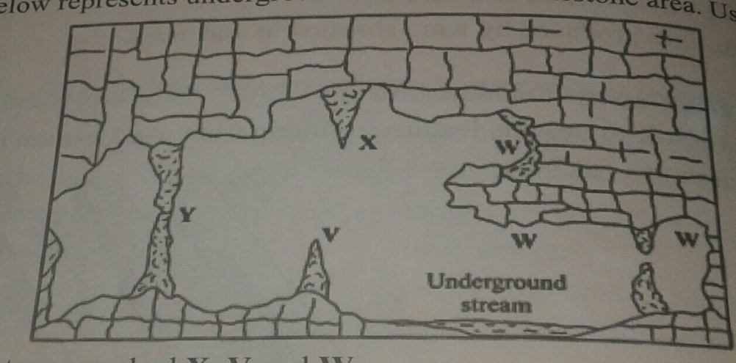

- i)Name the features marked X, V and W. (3mks)
ii)Describe how the feature marked Y is formed. (6mks)
b)i)What is an artesian basin? (2mks)
ii)Explain three factors which influence the formation of features in limestone areas.
(6mks)
c)You are supposed to carry out a field study of an area eroded by water.
i) give three reasons why you would need a map of the area of study. (3mks)
ii)Name two erosional features you are likely to identify during the field study. (2mks
iii)State three recommendations that you would make from your study to assist the
local community to rehabilitate the eroded area. (3mks)
- a)Why is Kenya`s petroleum refinery located at Mombasa? (2mks)
b)State four characteristics of the cottage industry in India. (4mks)
- Use the sketch map of Lake Victoria below to answer question (a)

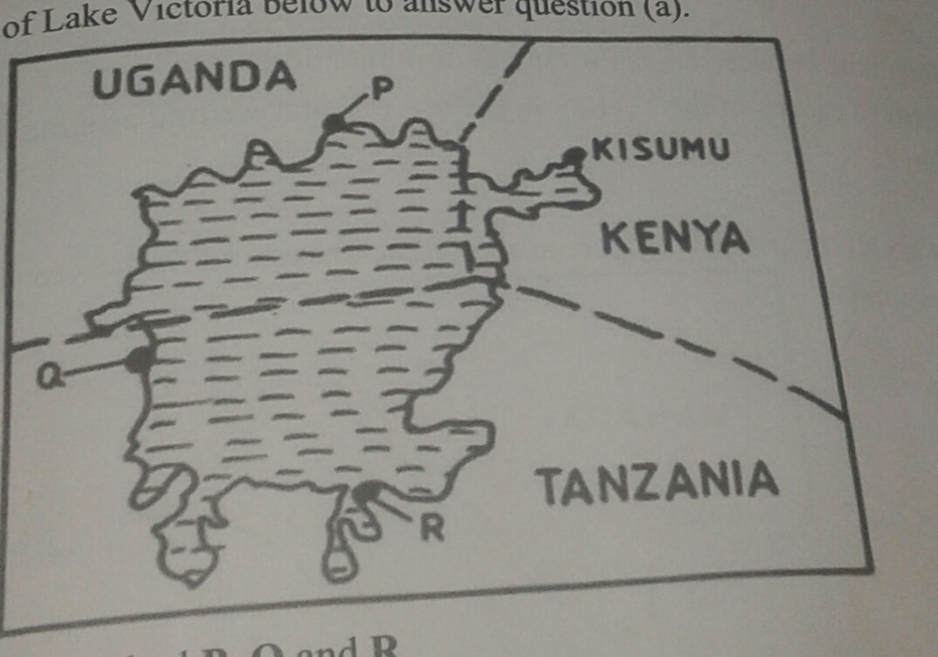

a)Name the lake ports marked P, Q and R. (3mks)
b)Outline two advantages of using containers while handling goods at the port of kisumu.(2mks)
- a)i) Name three international airports in Kenya. (3mks)
ii)Give four advantages of air transport over road transport. (4mks)
- Explain four measures that should be taken to improve road transport in Kenya. (8mks)
- Explain why there are few rail links among African countries. (6mks)
- Give four reasons why there is limited use of river transport in Africa. (4mks)
- a) i) What is visible trade? (2mks)
ii)List three major imports to Kenya from Japan. (3mks)
b)Explain four factors that influence internal trade in Kenya. (8mks)
c)State four ways in which trade is of significance to Kenya. (4mks)
d)explain four benefits which member states of ECOWAS derive from the formation of the trading bloc. (8mks)
- i) Differentiate between internal and region trade. (2mks)
ii) List three major exports from Kenya to the European Union (EU) (3mks)

