MIDTERM EXAM FORM 4 TERM 1 2017
GEOGRAPHY

- a)State 3 measures that have been taken to conserve fisheries in Kenya (3mks)

b) Give 3 reasons why Norway is a great fishing nation. (3mks)

2. Use the map of North America below to answer question (a)

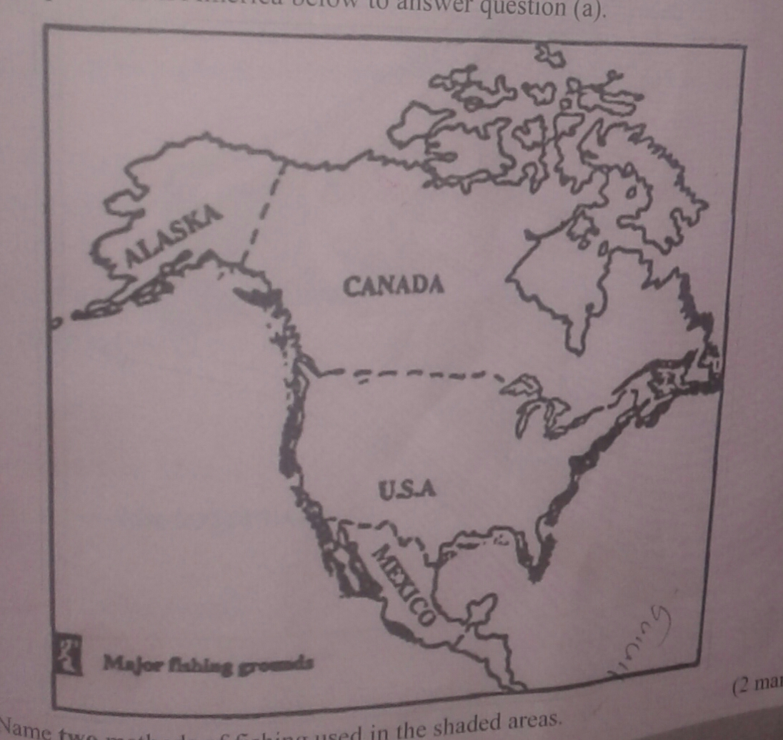

- i) name 2 methods of fishing used in the shaded areas. (2mks)

ii) Name 2 types of fish caught along the west coast of Canada. (2mks)

iii) Explain how the following factors favour fishing in the shaded areas.
Indented coastline

Ocean currents

b) Explain 4 ways in which marine fisheries in Kenya can be conserved. (8mks)

c) i) Give 3 methods used to preserve fish. (3mks)

ii) Explain 3 problems experienced by fishermen while fishing in Lake Victoria. (6mks)

SECTION B
3.a) (i) define the term fisheries. (2mks)

(ii) Name 2 countries in Southern Africa that are important for marine fish production. (2mks

b)Explain 4 factors that favour the fishing industry in japan. (8mks)

(c)describe purse seining as a method of fishing. (6mks)

(d) i) State 4 problems experienced in the marketing of fish in Kenya. (4mks)

(ii) state 3 ways in which the Kenya government is promoting the fishing industry in the
Country. (3mks)

4. a) define the term fishing (2mks)

b) Explain 2 ways in which each of the following factors negatively affects fishing in Kenya.
i) Agriculture (4mks)

ii) Water weeds (4mks)

c) use the map of north- west atlantic ground to answer questions (c) (ii) and (iii)
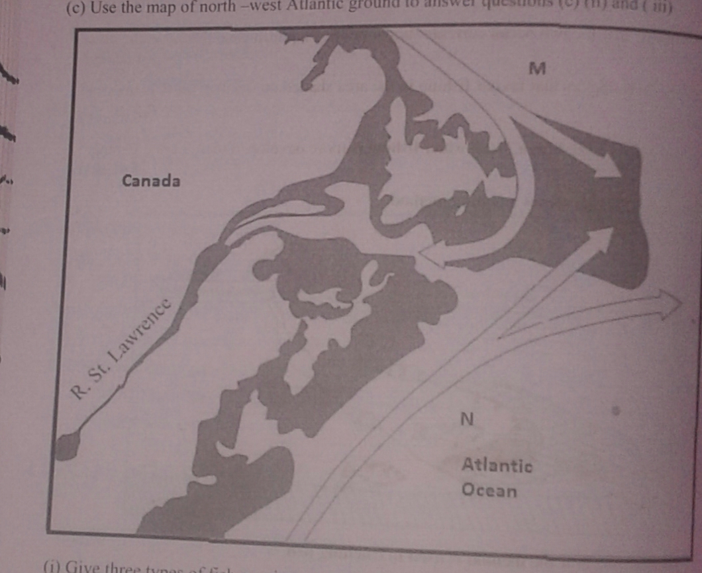

(i) Give 3 types of fish species caught in North – West Atlantic fishing ground. (3mks)

(ii)name the ocean currents marked M and N . (2mks)

(iii) Explain 2 ways in which the convergences of ocean currents marked M and N influence
Fishing. (4mks)

(d) Give 3 differences between fishing in Kenya and Japan. (6mks)

5. a) (i) Distinguish between a game sanctuary and a national park. (2mks)

(ii) Draw a map of Kenya and on it mark and name Sibiloi National Park Maasai mara
National reserve and Tsavo park. (4mks)

b) (i) Give 3 factors that favour the establishment of national parks in the semi arid areas of
East Africa (4mks)

(ii)Explain 2 effects of drought on wildlife in Kenya. (4mks)

c) Explain 4 measures that the government of Kenya has taken to conserve wildlife other than
establishing national parks and reserves. (8mks)

d) State 4 ways in which wild animals are of significance to the economy of Kenya. (4mks)

6. a) What is eco- tourism? (2mks)

b) i) Give 4 tourist attractions found at the coast of Kenya. (4mks)

ii) State 5 problems associated with tourism in Kenya. (4mks)

c) State 4 ways in which game reserves are of benefit to the communities living near them. (4mks)

d) Explain the differences between tourism in Kenya and Switzerland. (10mks)

