END OF TERM ONE MWAKICAN EXAMINATIONS
FORM FOUR PAPER 2 MARKING SCHEME
SECTION A
1. (a) Mining-refers to all attempts required to extract valuable minerals, either solid, liquid or gas from earth’s crust (1mk)
(b)(i)Kwale in Kenya-Titanium (1mk)
(ii)Kilembe in Uganda-Copper (1mk)
c) State two ways in which land derelict can be reclaimed
- creating parks to attract tourists
- landscaping for settlement or farming
- planting trees
-Refilling holes (any 2x1=2mks)

2. (a)List three social factors that influences Agriculture
- traditional and cultural beliefs
- ownership and inheritance beliefs
- religious beliefs
- what people eat and like
- Gender roles (any 3x1= 3mks)
b) State two characteristics of pastoral farming
- animals are kept for subsistence
- Large herds of animals are kept
- Herds are mixed i.e cattle , goats, camel and donkeys
- Low quality animals
- They have no permanent shelter
- The land is communally owned
- Uncontrolled breeding (any 2x1= 2mks)
c) Physical problems experienced in irrigation farming in Kenya
- Flooding if the amount of water is not properly controlled. This spoils crops.
- Flooding leads to sheet erosion.
- Evaporation leads to salination of the top soil.
- Leaching of soil nutrients from the top layer occurs.
- The moist and hot conditions promote breeding of pests and disease outbreak.
- Wastage and uneven distribution of water in the event of overhead irrigation.
- Siltation in canals interrupts distribution of water in the fields. (Any 3x1=3mks)

3. (a) Tourist attractions in Coastal province of Kenya
- Historical sites e.g Fort Jesus, Gedi ruins, Vasco da Gama pillar
- Sand beaches
- Warm climate/tropical sunshine.
- Water sports.
- Shimoni caves
- Museum in Lamu
- Mangrove swamps
- Haller Nature Trail at Bamburi
- Unique culture (song, dance, artifacts, clothing)
- Marine national parks e.g
- Coastal features e.g cliffs (Any 3 x 1 = 3mks)

(b) Problems facing tourism in Kenya
- Insecurity
- Poaching
- Terrorism
- Demand for land
- Human activities like mining, agriculture
- Environmental pollution
- Poor road network in most parts of Kenya (Any 2x 1 =2mks)

4. a) A forest is a continuous growth of trees, shrubs, grasses, herbs, fungi, mosses and lichens covering large tracts of land.
Forestry is the science of developing, managing and protecting existing forests in an effort to conserve them in their original state. (Must define the two terms=2mks)
b) Types of natural forests
- Tropical hardwood forests
- Temperate hardwood forests
- Mediterranean forests
- Mixed forests
- Coniferous forests/temperate softwoods.
- Montane forest ( Any 2x1=2mks)
5. Problems facing farmers in Mwea-Tebere irrigation scheme
- Stagnant water encourages breeding of mosquitoes and snails which causes malaria and bilharzias
- Rapid growth of weeds due to high temperatures and high soil moisture content.
- Fluctuations of river volumes in rivers that provide irrigation water.
- Destruction of rice by quelea birds which lower yields.
- Silting in irrigation canals.
- Shortage of capital to finance farming activities.
- Low quality yields due to use of low quality seeds.
- Poor marketing strategies and activities.
- Delayed payments.

SECTION B
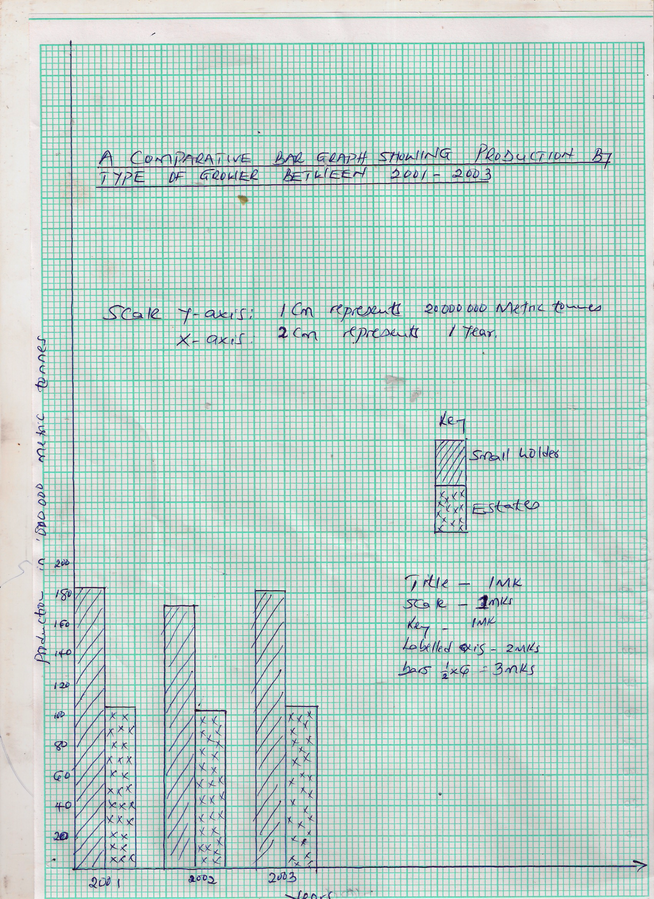
6. a) (i)

(ii) Advantages of using comparative bar graph to present data
- They give a better impression of totality and of the individual contribution made by each of the components parts
- Bar emphasize quantities very well.
- Differences in quantities between bars in each set are easier to see.
- They are easy to construct and read.
- It is easy to compare similar components across the different sets of bars.
(any 2x1=2mks)
b(i) Percentage decline in tea production small holder between 2001 and 2002
113000-111000=2000
$\frac{2000}{113000}×100$ √
0.0177$×$100
1.77 √ (2mks)
c) (i) Processing of tea from picking to the time it is ready for marketing.
- Harvesting is done by picking plucking two leaves and a bud.
- Buying centre where it is weighed and taken to the factory for processing
- Once in the factory weighing is done.
- Withering
- Rolling
- Souring
- Drying/firing/roasting
- Grading
- Winnowing
- Packing

(ii) Two areas in Kenya where tea is grown in large scale.
- Kericho
- Limuru (2mks)

d) Ways in which tea is important to Kenya’s economy.
- Foreign exchange after exporting
- Employment to many people.
- Income to farmers
- Infrastructure
- Saves foreign exchange (3x1=3mks)

7. a) (i) Land reclamation is the practice by which the less useful land is converted into more useful land. while land rehabilitation is the process of recovery/restoration of land which has been misused and destroyed through human activities (2mks)
(ii)Methods of land rehabilitation used in Kenya
- Afforestation and reforestation
- Mulching of soil
- Adding green and animal manure to the soil
- Gabions are built on slopes to prevent soil erosion
- Cut-off drains are dug across slopes to reduce soil erosion
- Tsetse fly control
(any 4x1=4mks)
(b)(i) Aims of setting up of the Pekerra irrigation scheme.
- To utilize the detainee labor
- To develop land for agricultural production
- To settle the pastoralists as farmers (3mks)
(ii) Crops grown in the scheme
- Maize
- Pawpaw
- Onions
- Water melons
- Cotton
- Chillies (3mks)

(c)(i) Achievements of the Pekerra irrigation scheme
- A semi arid area has been turned into productive land
- The scheme is supplying valuable maize seed to the Kenyan market
- It is a source of livelihood for the farmers and their dependants
- Creation of employment for the local population
- Improvement of the local economy. (any 3x2=6mks )

(ii) Benefits of irrigation schemes in Kenya.
- Increased crop production-most of crops like maize, beans and rice have been produced in plenty hence ensuring food security
- Creation of settlement
- Foreign exchange
- Social amenities. (must give examples like schools, hosps)
- Employment-creates job opportunities to people
- Improvement of infrastructure-Roads have developed in areas that produce plenty of food crops
- Industrialization
- Income to the locals.
(any 2 well explained x2=4mks)
(d) How a polder is reclaimed
- A sea, swampy or water body is surrounded by a ring canal and high dyke is built
- Water is then pumped out or drained through ditches and canal
- Drainage pipes are then laid and ditches are dug to dry up the polder
- Experimental crop is planted (3mks. Order must be followed)

8. (a) (i)Pelagic fish is fish which lives close to the surface of the water while Demersal fish is
that which lives close to the bottom of the water body (2mks)
(ii)Traditional methods of fishing
-Fishing baskets
-Barriers across a river
-Lantern and fish nets
-Use of spears (any 2x1=mks)
(b)(i) Major fishing grounds in Atlantic and Pacific ocean
-The north-West Atlantic fishing grounds
-The north-east Atlantic fishing grounds
-The north-west pacific fishing grounds
-The north-east pacific fishing grounds (3mks)
(ii) Factors favoring these fishing grounds
- Availability of plenty of planktons
- Indented coastlines and shallow extensive continental shelves
- The cool climate resulting in cool ocean water
- Availability of capital and advanced technology
- A high population which offers a ready market and labor (4x1=4marks)
(c)(i)Reasons why Marine fishing in East Africa is not well developed
- The warm tropical waters do not favor large-scale breeding of fish species
- The narrow continental shelfs limits widespread growth of planktons for fish
- There is a limit market at the coast due to low purchasing power
- Inadequacy of capital and poor technology hamper development of industries
- Stiff competition from industrialized nations which have better equipment (4x1=4mks)
(ii)Significance of fishing industry in Kenya
- Helps in diversification of the economy
- Fish is a source of food
- Industry creates employment opportunities
- Fish is a source of foreign exchange when exported
- Has lead to the development of infrastructure in some areas
- It is a source of raw materials for other industries (5x1=5marks)
(d)(i) Main problems that are facing fishing in Lake Victoria.
- Presence of water hyacinths that hinders movement of boats
- Spillage of oils from ships engines that affect aquatic lives
- Over fishing
(ii)Similarities between fishing in Kenya and Japan
- Both counties carry out inland and marine fishing
- In both countries the fish caught is consumed both locally and exported
- In both countries the government promotes fishing through legislation, research and conservation
- There is overexploitation of fishers in both countries (2x1=2marks)

9. (i) Agroforestry is the planting of trees, cultivation of crops together with keeping of livestock on the same piece of land. (2mk)

(ii) Three major soft wood forest blocks in Western Kenya
- Londiáni
- Kitale
- Kisumu (3x1=3mks)

(b) (i) Two commercial softwoods grown in Kenya
- Cedar
- Pine
- Wattle
- Cypress
- Fir
(Any2x1=2mks)

(ii) Differences between forestry in Kenya and Canada
- Transport of logs is done mainly by water/river in Canada while in Kenya is mainly by road.
- Grown throughout the country in Canada while in Kenya are grown mainly in the Kenya highlands.
- Softwood forest of Kenya are mainly planted while those of Canada are natural.
- Forestry in Canada is more extensive than forestry in Kenya which is limited.
- Softwood trees in Kenya are mainly exotic while those in Canada are indigenous
- There is a wide variety of softwood species in Canada while in Kenya the number of species is small
- Canada has both local and intemati6iaI markets while Kenya sells her wood locally.
(Any 4x1=4mks)

(c) Importance of forestry to the economy of Kenya
- The industry provides employment opportunities to many Kenyans.
- Provision of wood/timber and wood pro4ucts which are exported to earn foreign exchange.
- Timber and logs are obtained and used in the building and construct iron industry improved road network in the growing areas.
- Have medicinal value
- Raw material for pulp and paper industry . (Any 4 x2= 8mks)

(d) Efforts being made by the Kenyan government to solve the problem of high rate of forest depletion
- Eviction of people who have settled/encroached the forests e.g. Mau
- Employing more forest guards to take care of the forests.
- Enacting laws /Legislation to punish the victims of encroachment and deforestation
- Alternative sources of fuel introduction of energy saving jikos.
- Educating the citizens/people through mass media to understand the importance of forests thus take good care of them.
- Afforestation / reafforestation / planting of trees to ensure tree/forest replacement. Government sets in place tree planting days to give emphasis. (Any3x2= 6mks)

10. a) i) State three physical conditions that may discourage setting up of Game Reserve and Parks.
- Lack of sufficient vegetation
- Existence of very low temperatures
- Occurrence of snow fall
- Presence of very steep and rugged terrain 3x1=3mks)
ii) Name one Game ranche in Kenya
- Giraffe centre
- Bamburi Nature Trail
- Galana Game Ranch
- Ostrich farm
- Mamba village
- Kapkobei Ranch 2x1=2 mks
b) i) State the significance of wildlife to Kenya.
- Wildlife is a major tourist attraction which earns the country foreign exchange.
- Wildlife is confined to marginal lands making such areas economically useful.
- It stimulates the growth of other economic activities such as agriculture as farmers grow food crops to supply to the lodges and hotels.
- Wildlife leads to the opening up of remote areas as hotels, lodges, roads and airstrips are build in these regions.
- Some plants are of medicinal value and are used as herbal medicine or in production of pharmaceuticals. 1x3=3mks
C. i) Differentiate between domestic and international tourism.
- Domestic tourism is the practice of making a trip within ones country while international tourism is the practice of taking a trip away from ones country to a foreign one. (2mks)
ii) Explain four factors that hinder development of domestic tourism
in Kenya.
- High cost of accommodation and transport discourage many local tourists many Kenyans are poor and therefore unable to afford the high costs leading to low numbers of domestic tourist.
- Many roads to the national parks and reserves are very poor and some are impassable during the rainy season. This discourages many locals from visiting these areas.
- Many Kenyans are unaware of the beautiful and attractive features in their own country. This is because very little campaign and advertisement on tourist attractions is done. This leads to few Kenyans visiting the parks.
- Many Kenyans are familiar with the existing tourist attraction like wild animals, plants and other attractive features in their own country. This is because very little campaign and advertisement on tourist attractions is done. This is leads to few Kenyans visiting the parks.
- Many Kenyans are familiar with the existing tourist attraction like wild animals, plants and other attractive features. As such many fail to appreciate the beauty the country offers leading to low numbers of local tourists.
- Many Kenyans have a negative attitude toward local tourism since they consider it a waster of time and money. This limits the number of people who engage in it.
- The frequent attacks of tourists in parks by poachers and bandits scare away people leading to low turnout.
(Any3x2=6mks)
iii) State four problems experienced by the Kenya government in its efforts to conserve wildlife.
  - Illegal hunting/poaching of wild game threatens the conservation efforts/leads to extinction of some species of animals.
  - Overstocking of some wild animals leads to destruction of natural environment through over grazing.
- Frequent drought experienced in some of she national parks and reserves leads to loss of animals through starvation and death.
- Straying wild animals from the parks to settlements leads to destruction
of crops/animals/people, hence high compensation by the government/high cost of fencing.
- Inadequate capital limits the government conservation efforts/over relying on foreign donors.
- Rapid human population growth leads to encroachment of game parks and reserves.
- Pollution of the environment leads to death of wildlife.
- Fires which destroy wildlife. Any 4x1=4mks)

- Explain three reasons why Switzerland receives more tourists than Kenya.
- It is centrally located in Europe which makes it easily accessible to tourists from Europe while Kenya is far away from Europe.
- Some tourists attractions are found in both Switzerland and Kenya hence tourists in Europe prefer existing Switzerland which is nearer.
- Switzerland is politically stable and enjoys a lot of peace which attracts many tourists as opposed to Kenya where occasionally there is political instability like tribal clashes which scare away tourists.
- Switzerland has an efficient well developed transport and communication network which provides easy access to the tourists sites unlike in Kenya where roads have many potholes or are impassable during he rainy season making movement to sites uncomfortable.
- Switzerland has done more advertisement and promotion on tourism in the world than Kenya. This has informed many people of what Switzerland has to offer unlike in Kenya where very little promotion has been done.
- In Switzerland tourists are charged fairly for the services offered while in Kenya the charges are high limiting the numbers visiting it.
Any 3x2=6mks

