GATITU MIXED SECONDARY SCHOOL GEOGRAPHY OPENER FORM FOUR
TERM TWO 2015

Answer all the questions in this section

1. a) Name two types of soil according to texture (2mks)

b) State two ways in which humus improves the quality of soil (2mks)

2. a) What is latitude?

b) What is the time at Hola on 40⁰ E when the time at Tema on 0⁰ longitude is 12.00 noon? (2mks)

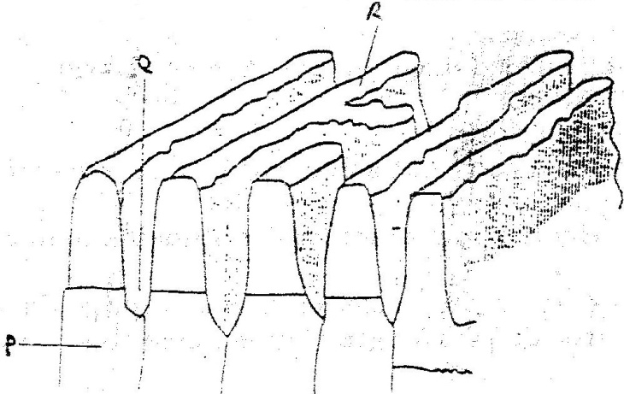
3. The diagram below show some features of a Karst scenery. Use it to answer questions (a)

a) Name the features marked P, Q, and R. (5mks)

b) Describe carbonation as a process of Chemical weathering (3mks)

4 a) What do you understand by:
(i) Microclimate?

(ii) Green house effect?
b) Name three instruments to match three elements of weather that can be measured at a school weather station (3mks)

5 a) What is a lake?

b) State three ways through which lakes are formed? (3mks)

6. a) i) A part from the Rift Valley name two other relief features that
were formed as result of faulting. (2mks)

ii) With the aid of a well labeled diagram, describe how a Rift Valley is formed by tensional forces. (8mks)

b) Explain four effects of faulting (8mks)

c) Students are planning to carry out a field study of an area affected by faulting
i) State four reasons why it is important for the students to have a pre-visit of the area (4mks)

ii) One of the ways they would use to collect data is through direct observation. Give three disadvantages of direct observation in the study of such an area. (3mks)

